Microbial communities associated with the parasitic copepod Lepeophtheirus salmonis.

S. Dalvin¹, K. O. Skaftnesmo¹, K. Malde¹, K. A. Glover^{1,2}, J. S. Leong³, B. F. Koop³, R. B. Edvardsen¹, N. Sandlund^{1*}
¹ Institute of Marine Research, 5817 Bergen, Norway
²Sea Lice Research Centre, University of Bergen, 5006 Bergen, Norway
³Department of Biology, University of Victoria, Victoria V8W 2Y2, BC, Canada
* Corresponding author

Abstract
Lepeophtheirus salmonis is a naturally occurring marine parasite of salmonid fishes in the Northern hemisphere, and a major problem in salmonid aquaculture. In addition to the direct effects on host fish, L. salmonis may act as a vector for diseases. Here, the microbial community of L. salmonis recovered from whole genome shotgun sequencing was compared between lice sampled from both the Atlantic and the Pacific, laboratory-reared and wild lice, in addition to lice displaying resistance towards chemical treatments. The analysis shows clear differences in the metagenomic composition between the Atlantic and the Pacific Ocean, whereas the resistance status of the L. salmonis or the cultivation did not have significant impact.

Keywords: Metagenome, marine bacteria, Atlantic salmon, pathogens, vectors

1. Introduction
The salmon louse (Lepeophtheirus salmonis) is a marine ectoparasite found on salmonid fish in both the Pacific (subspecies: L. salmonis oncorhynchi) and the Atlantic oceans (subspecies: L. salmonis salmonis) [1]. High concentrations of salmon lice are found in regions hosting salmonid aquaculture industry [2], and are a potential threat to wild sea trout (Salmo trutta) and Atlantic salmon (Salmo salar) populations in the North East Atlantic [3, 4]. Management of this pathogen in Norway alone is estimated to cost the aquaculture industry 130-390 US$ million yearly [5]. The salmon lice lifecycle consists of eight life stages separated by molt of the chitinous exoskeleton [6]. Apart from the first two planktonic stages, the salmon louse spends its lifecycle on the surface of the host fish, where it feeds on skin, mucus and blood. Infections with salmon lice can cause morbidity in the host fish due to general and osmotic stress, wounds, and increased susceptibility to secondary infections [7]. The integument of the salmon louse is covered with microorganisms [8] and potential pathogens including Tenacibaculum, Pseudomonas and Vibrio [9] and the microsporidian Paranucleospora theridion [10] has been identified. In addition to the direct effects of grazing on the fish epidermis, an increased exposure to secondary infections may also be a result of immunomodulation of the host fish through secretions from parasite exocrine glands [11-13]. Such secretions may reduce the ability of the fish to resist infections with other pathogens. A recent study has also documented that salmon lice infections change the microbial composition of salmon skin [14]. To obtain an overview of organisms associated with the salmon louse, a metagenomic analysis was performed on sequences extracted from lice from multiple locations in the Pacific and the Atlantic Oceans. In addition to identification of bacterial orders, the data was also analyzed for metagenomic patterns caused by origin and resistance properties of the collected salmon lice.

2. Data description
Sampling
Salmon lice sampled for this dataset belongs to the two subspecies of salmon louse sampled from the Pacific (Lepeophtheirus salmonis oncorhynchi) and the Atlantic (Lepeophtheirus salmonis salmonis), respectively collected in multiple locations (Figure 1).
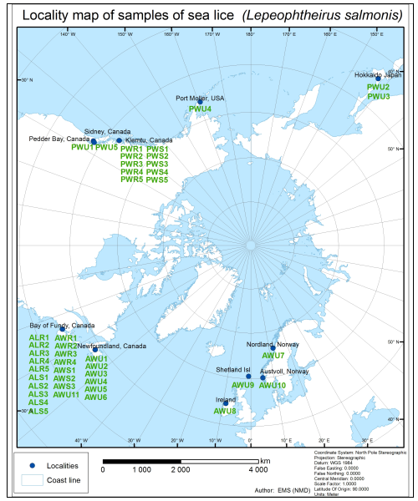
Fig. 1. Geographical distributions of samples. Samples are labelled according to geographical (Atlantic or Pacific), source of lice (laboratory or wild) and resistance status (resistant, sensitive or unknown), see S1.
All samples have previously been described by [15-17]. AWU7-11(S1) contains pooled DNA from multiple individuals in each sample, whereas the remaining samples are from single individuals. Resistance status of the salmon louse has been noted when available. Lice were either collected in the field or cultivated on fish in the laboratory before being submitted to sequencing (S1).
Bioinformatic analysis
MetaPhlAn2 was utilized for taxonomic profiling of whole-metagenome shotgun (WMS) samples. Fastq files were first filtered for the presence of salmon lice genomic sequences (http://metazoa.ensembl.org/Lepeophtheirus_salmonis/Info/Index) using BWA [18]. Libraries contained 10-80 million sequences after filtration. Libraries were then used as input in a MetaPhlAn2 analysis [19] to produce an abundance table of microorganisms present in samples. Sequences assigned to viruses were not included as the sequenced material was based on extraction of DNA only, thus excluding the finding of RNA viruses, resulting therefore in partial data being retrieved. Fastq files were mapped against the MetaPhlAn2 db_v20/mpa_v20_m200.pkl database using bowtie with the “very-sensitive local” setting. The relative abundance of microorganisms was then calculated by Metaphlan2. The resulting abundance file was then used as input for LDA Effect Size (LEfSE) analysis [20] were the alpha value for the factorial Kruskal-Wallis test among classes and the pairwise Wilcoxon tests between subclasses were set to 0.05. Threshold for the logarithmic LDA score for discriminative features were set at the default value of 2. Finally, cladograms were produced setting the root of the tree according to kingdom. Differences in the bacterial metagenome on salmon lice from the Atlantic and Pacific Ocean were assessed using statistical analysis of taxonomic and functional profiles (STAMP) [21]. The Microbiome helper perl script metaphlan_to_stamp.pl (http://msystems.asm.org/content/2/1/e00127-16) was used to convert the abundance file from MetaPhlAn2 to a STAMP compatible format. Extended error bar plots were produced in STAMP by analyzing differences in the mean proportion of sequences using two-sided Welch’s t-test and Storey FDR multiple test correction. The final data were filtered to remove features with small effect sizes by considering only features were the ratio of the proportions were larger than 2 or the difference in proportions were larger than 0.5.
Bacterial communities on L. salmonis
Sequences from Archeae bacteria and eukaryotes were present in the dataset, but very few were recognized by Metaphlan and will not be commented further in this study. The sequences assigned to prokaryotes were initially sorted into 28 phyla, 36 classes and 69 orders. All samples were dominated by two bacterial orders; Flavobacteriales in the Bacteriodetes phylum (30 – 71 %) and Burkholderiales in the Protebacteria phylum (6 – 37 %). The total proportion of Flavobacteriales and Burkholderiales was relatively constant in all samples (average of 58 ± 8 %), however the ratio between the two orders was variable (results not shown). The orders of Flavobacteriales and Burkholderiales contains a great variety of environmental bacteria associated with surface and biofilm in additions to some known pathogenic bacteria that can cause ulcers in fish, e.g. Flavobacterium psychrophilum. [22]. Three other bacterial orders Spirochaetales (1 - 16 %), Alphaproteobacteria (3 - 12 %) and Mycoplasmatales (5 - 11 %) were also found in all samples. Other orders included in the Proteobacteria phylum normally associated with marine environment and fish such as Pseudomondales, Pseudoalteromondales, Alteromondales, Aeromondales, Vibrionales and Rickettsiales, were only sporadically represented. These orders are all well-known from the marine environment both as symbionts, and thus part of the normal micro flora, and as pathogens.
All samples were analyzed to search for differences in the composition of the microbial community depending on the geographic origin of the sample. Most samples could be assigned to the Atlantic or the Pacific Ocean based on the microbial composition (fig. 2).
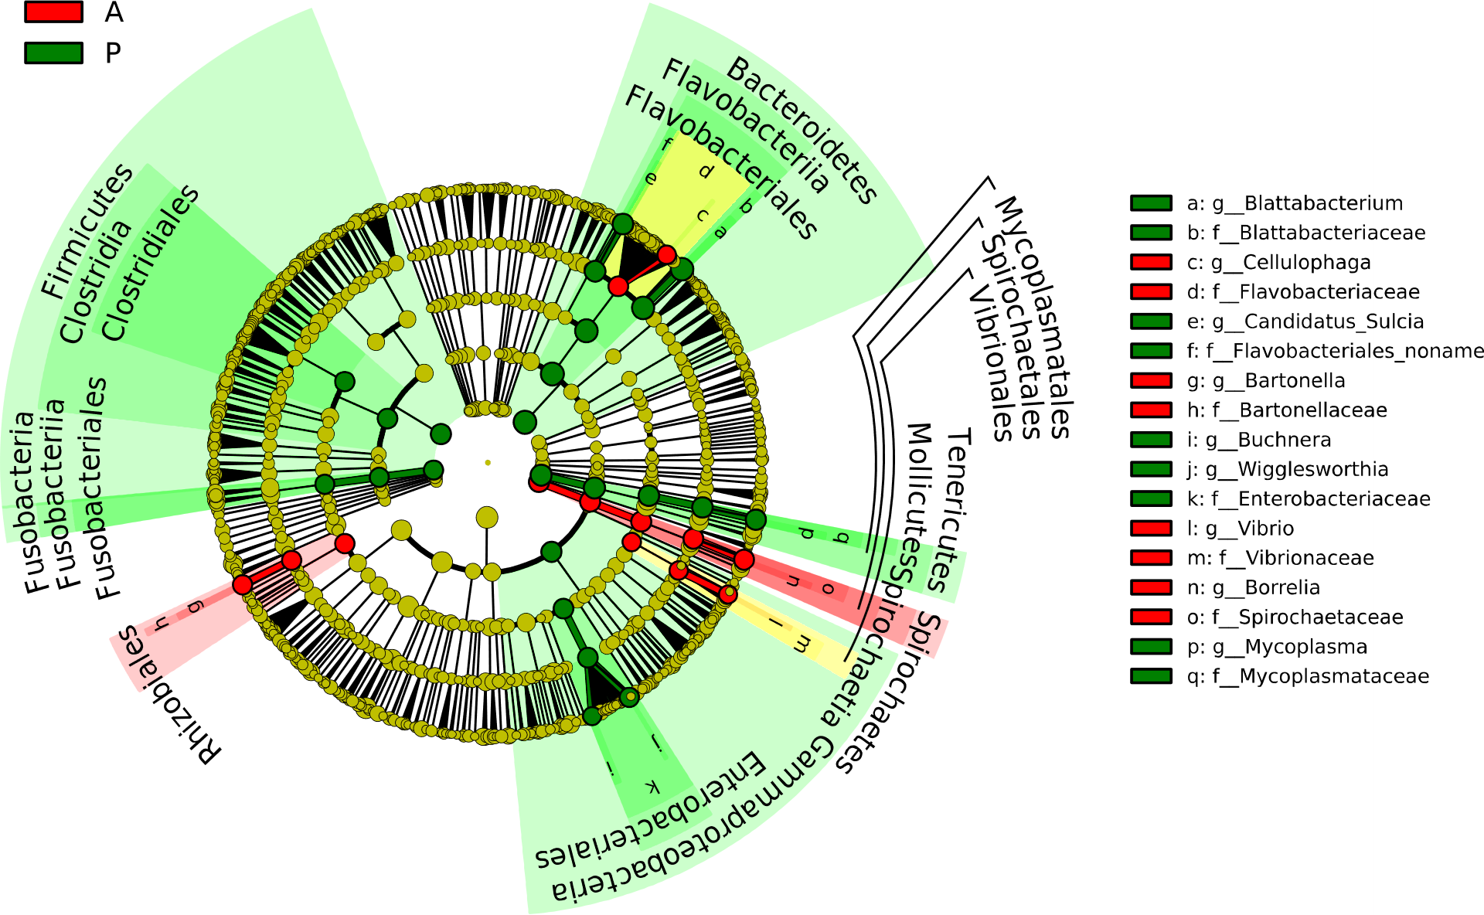
Fig.2. Abundance of bacterial orders. The cladograms report the taxa showing different abundance values (according to LEfSe) in the two geographical areas: Atlantic samples (red) and Pacific samples (green).
It should however be noted that this difference between the two oceans may have been caused by differences in the microbial communities between the Pacific and Atlantic Ocean but could also have been influenced by differences between the two subspecies of L. salmonis. Enterobacteriales were present in significantly higher amounts in samples from the Pacific Ocean, while Spirochaetales, Halanaerobiales, Rhizobiales, Rhodobacterales, Sphingobacteriales and Vibrionales were more abundant in the Atlantic samples (Fig 3).
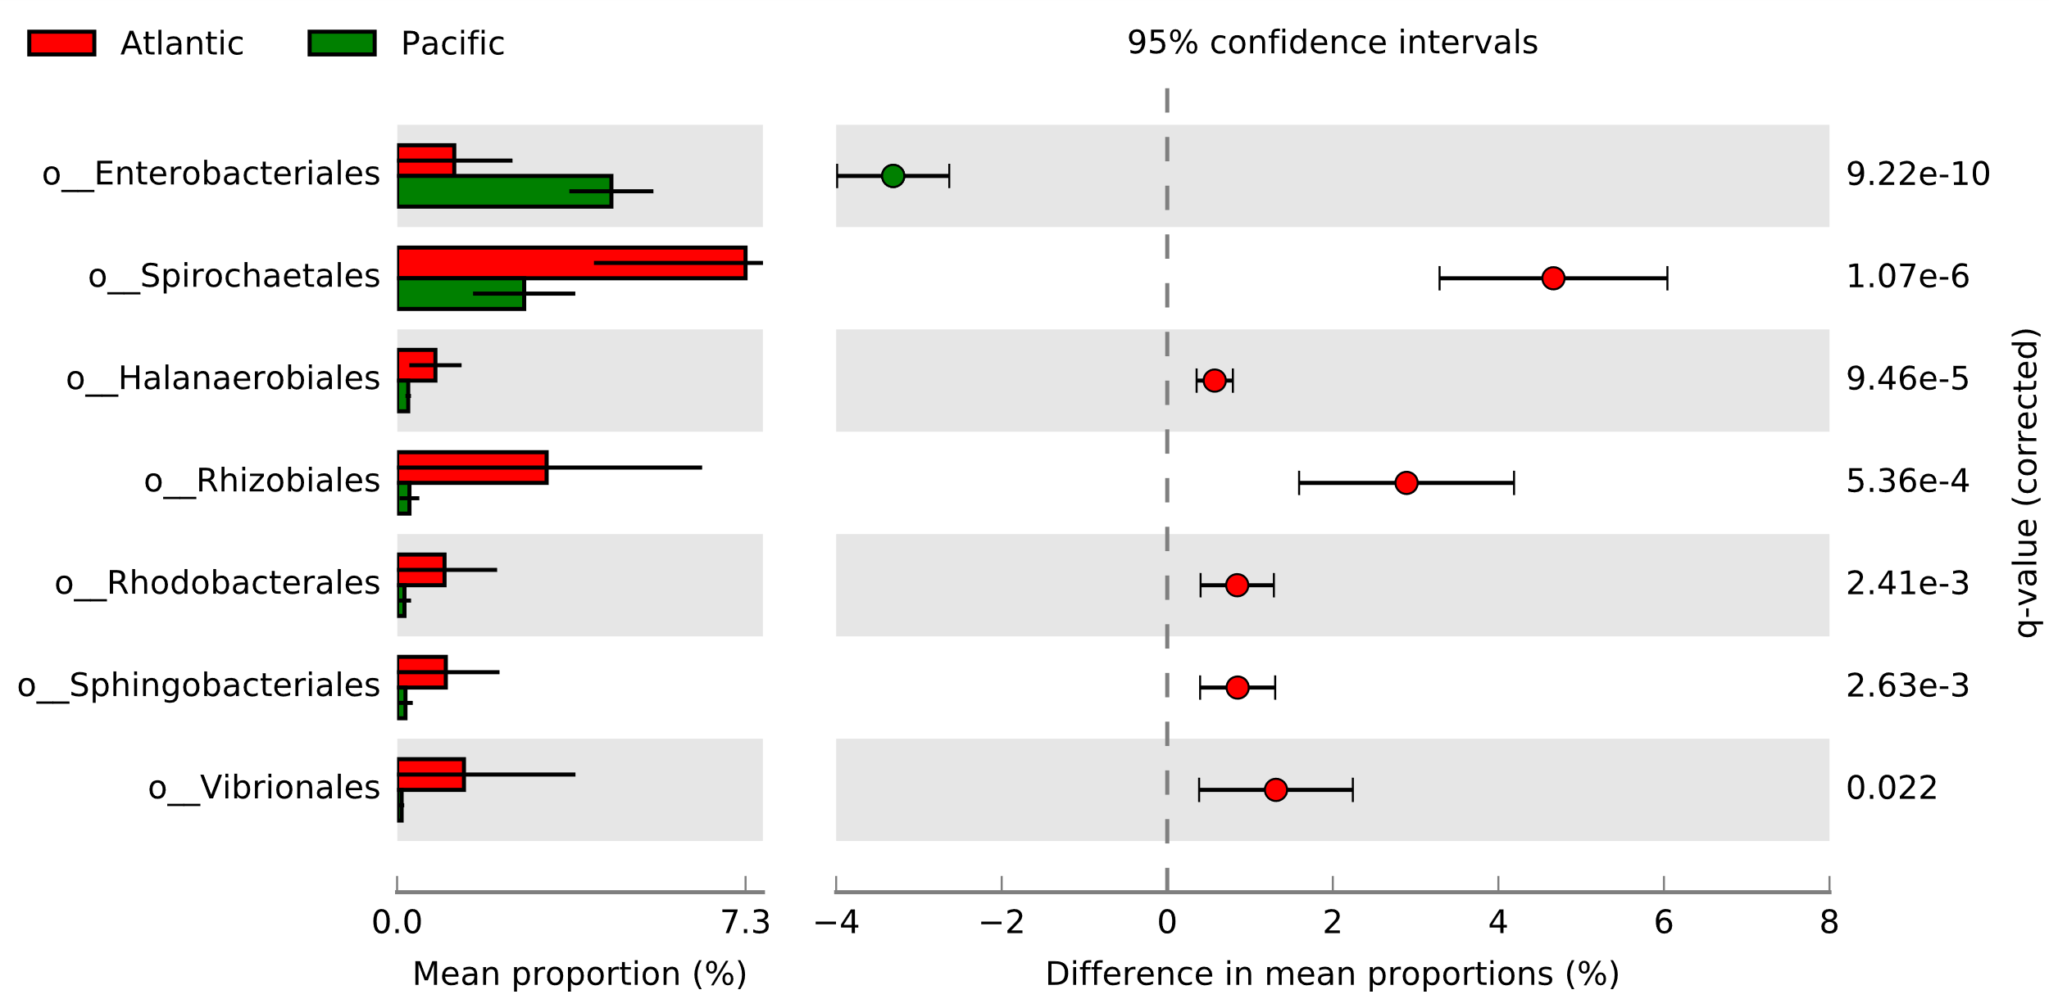
Fig. 3 Extended error bar plot. Bacterial orders with significantly different representation in samples from the Atlantic and Pacific Ocean.
Similar analyses were performed to investigate whether the composition of the microbial community was affected by the resistance status of the salmon louse, or by cultivation in the laboratory. No significant differences were observed. In conclusion, sequences obtained from whole genome sequencing of the parasite L. salmonis provides information about associated bacterial orders. Analysis of the data provided metagenomic profiles distinct between the Atlantic and Pacific Ocean but did not demonstrate presence of well described fish pathogens that L. salmonis may act as vector for. Future studies should also include analysis of virus and eukaryotes.

3. Data Deposition
All sequences utilized in this study can be found in SRA accession PRJNA447894 and PRJNA509381 (ncbi.nlm.nih.gov/bioproject/PRJNA447894 and ncbi.nlm.nih.gov/bioproject/PRJNA509381). For biological information on the samples see supplementary files (S1 and S2).

4. Acknowledgements
The analysis of the metagenome data in this study was funded by the Norwegian department for Trade, Industry and Fisheries as part of its funding for the Institute of Marine Research in the internal project 14501. Atlantic sequence data was acquired from the Norwegian Research Council project PrevenT. Pacific sequence data was supported by a Discovery Grant from NSERC Canada.

5. References
1. Skern-Mauritzen R, Torrissen O, Glover KA: Pacific and Atlantic Lepeophtheirus salmonis (Kroyer, 1838) are allopatric subspecies: Lepeophtheirus salmonis salmonis and L. salmonis oncorhynchi subspecies novo. Bmc Genet 2014, 15.
2. Serra-Llinares RM, Bjorn PA, Finstad B, Nilsen R, Harbitz A, Berg M, Asplin L: Salmon lice infection on wild salmonids in marine protected areas: an evaluation of the Norwegian 'National Salmon Fjords'. Aquacult Env Interac 2014, 5(1):1-16.
3. Arechavala-Lopez P, Thorstad EB, Todd CD, Uglem I, Bjorn PA, Gargan PG, Vollset KW, Halttunen E, Kalas S, Berg M et al: Effects of salmon lice Lepeophtheirus salmonis (Copepoda: Caligidae) on sea trout (Salmo trutta) populations from the NE Atlantic coast. Rev Biol Mar Oceanog 2015, 50(3):411-426.
4. Taranger GL, Karlsen O, Bannister RJ, Glover KA, Husa V, Karlsbakk E, Kvamme BO, Boxaspen KK, Bjorn PA, Finstad B et al: Risk assessment of the environmental impact of Norwegian Atlantic salmon farming. Ices J Mar Sci 2015, 72(3):997-1021.
5. Liu YJ, Bjelland HV: Estimating costs of sea lice control strategy in Norway. Prev Vet Med 2014, 117(3-4):469-477.
6. Hamre LA, Eichner C, Caipang CMA, Dalvin ST, Bron JE, Nilsen F, Boxshall G, Skern-Mauritzen R: The Salmon Louse Lepeophtheirus salmonis (Copepoda: Caligidae) Life Cycle Has Only Two Chalimus Stages. Plos One 2013, 8(9).
7. Boxaspen K: A review of the biology and genetics of sea lice. Ices J Mar Sci 2006, 63(7):1304-1316.
8. Harasimczuk E, Overgard AC, Grotmol S, Nilsen F, Dalvin S: Characterization of three salmon louse (Lepeophtheirus salmonis) genes with fibronectin II domains expressed by tegumental type 1 glands. Mol Biochem Parasit 2018, 219:1-9.
9. Barker DE, Braden LM, Coombs MP, Boyce B: Preliminary studies on the isolation of bacteria from sea lice, Lepeophtheirus salmonis, infecting farmed salmon in British Columbia, Canada. Parasitol Res 2009, 105(4):1173-1177.
10. Nylund S, Nylund A, Watanabe K, Arnesen CE, Karlsbakk E: Paranucleospora theridion n. gen., n. sp (Microsporidia, Enterocytozoonidae) with a Life Cycle in the Salmon Louse (Lepeophtheirus salmonis, Copepoda) and Atlantic Salmon (Salmo salar). J Eukaryot Microbiol 2010, 57(2):95-114.
11. Fast MD, Johnson SC, Eddy TD, Pinto D, Ross NW: Lepeophtheirus salmonis secretory/excretory products and their effects on Atlantic salmon immune gene regulation. Parasite Immunol 2007, 29(4):179-189.
12. Overgard AC, Hamre LA, Harasimczuk E, Dalvin S, Nilsen F, Grotmol S: Exocrine Glands of Lepeophtheirus salmonis (Copepoda: Caligidae): Distribution, Developmental Appearance, and Site of Secretion. J Morphol 2016, 277(12):1616-1630.
13. Skugor S, Glover KA, Nilsen F, Krasnov A: Local and systemic gene expression responses of Atlantic salmon (Salmo salar L.) to infection with the salmon louse (Lepeophtheirus salmonis). Bmc Genomics 2008, 9.
14. Llewellyn MS, Leadbeater S, Garcia C, Sylvain FE, Custodio M, Ang KP, Powell F, Carvalho GR, Creer S, Elliot J et al: Parasitism perturbs the mucosal microbiome of Atlantic Salmon. Sci Rep-Uk 2017, 7.
15. Besnier F, Kent M, Skern-Mauritzen R, Lien S, Malde K, Edvardsen RB, Taylor S, Ljungfeldt LER, Nilsen F, Glover KA: Human-induced evolution caught in action: SNP-array reveals rapid amphi-atlantic spread of pesticide resistance in the salmon ecotoparasite Lepeophtheirus salmonis. Bmc Genomics 2014, 15.
16. Glover KA, Stolen AB, Messmer A, Koop BF, Torrissen O, Nilsen F: Population genetic structure of the parasitic copepod Lepeophtheirus salmonis throughout the Atlantic. Mar Ecol Prog Ser 2011, 427:161-172.
17. Messmer AM, Leong JS, Rondeau EB, Mueller A, Despins CA, Minkley DR, Kent MP, Lien S, Boyce B, Morrison D et al: A 200K SNP chip reveals a novel Pacific salmon louse genotype linked to differential efficacy of emamectin benzoate. Mar Genom 2018, 40:45-57.
18. Li H, Durbin R: Fast and accurate short read alignment with Burrows-Wheeler transform. Bioinformatics 2009, 25(14):1754-1760.
19. Truong DT, Franzosa EA, Tickle TL, Scholz M, Weingart G, Pasolli E, Tett A, Huttenhower C, Segata N: MetaPhlAn2 for enhanced metagenomic taxonomic profiling. Nat Methods 2015, 12(10):902-903.
20. Segata N, Izard J, Waldron L, Gevers D, Miropolsky L, Garrett WS, Huttenhower C: Metagenomic biomarker discovery and explanation. Genome Biol 2011, 12(6).
21. Parks DH, Tyson GW, Hugenholtz P, Beiko RG: STAMP: statistical analysis of taxonomic and functional profiles. Bioinformatics 2014, 30(21):3123-3124.
22. Apablaza P, Loland AD, Brevik OJ, Ilardi P, Battaglia J, Nylund A: Genetic variation among Flavobacterium psychrophilum isolates from wild and farmed salmonids in Norway and Chile. J Appl Microbiol 2013, 114(4):934-946.

