**Abstract**

The growing demand for aquaculture products can only be maintained by increasing the production of lower trophic species such as bivalves and tunicates. Low trophic species avoid the energy losses during trophic transfers to build animal protein, making them ideal candidates to exploit available resources in coastal waters. In the particular case of fjords, forced upwelling of deep nutrient-rich waters can promote phytoplankton growth, or in other words, the growth of bivalve and tunicate food. However, the density at which bivalves and tunicates are cultured can compromise phytoplankton populations and consequently, marine food chains. A highly configurable environmental model was constructed to study the ecosystem effects and potential biomass production of hypothetical bivalve and tunicate aquaculture scenarios in a Norwegian fjord under forced upwelling conditions. The simulations objectively determined the level of aquaculture development that maximizes the sustainable utilization of resources towards bivalves and tunicates biomass production. The model also highlighted the positive effect of the forced upwelling on both cultured production and phytoplankton abundance under aquaculture scenarios. Finally, the model predicted that tunicates would be more efficient than mussels at extracting resources due to their lower metabolic cost and higher filtration capacity. Although a full economic analysis would be required to decide on the preferred species to be cultured, these results encourage current pilot studies in which tunicates are explored as a sustainable way to efficiently exploit marine resources for aquafeed production.

**Key Words:** Aquaculture; Ecosystem model; Carrying Capacity; Mussel; Tunicate; Fjord

**1 Introduction**

Aquaculture is the fastest growing food-producing sector, providing 101.1 million tonnes of seafood in 2013 (FAO, 2016). Cultured species cover a broad spectrum, ranging from seaweeds to bivalves and fish. Cultured carnivorous fishes contribute a relatively small proportion to the total production in terms of tonnage, although the contribution is significantly in economic terms due to the high value of these species in global markets (FAO, 2016). When cultured, carnivorous fishes have to be fed to cover the nutritional needs that guarantee fish health and optimal growth. Currently, the production of aquafeed relies on capture fisheries that are converted to fishmeal and fish oil, which provide a nutritional profile very close to the requirements of carnivorous fishes (Tacon et al., 2009). Although scientific advances in feed technology (Ytrestøyl et al., 2015) and breeding programmes (Quinton et al., 2007) have decreased reliance on fishmeal and fish oil from wild capture, the continued increase in aquaculture production will keep these commodities in high demand (Fry et al., 2016). In fact, fishmeal biomass production is seen as the most significant bottleneck to the expansion of fed-aquaculture (Olsen and Hasan, 2012).

The pressure of aquafeeds on capture fisheries calls for new, healthy and sustainable sources of fishmeal. Some marine suspension feeding organisms foraging low in the food web, namely bivalves and tunicates, have a large production potential due to: 1) their capacity to efficiently exploit the largest trophic resource in the marine environment (detrital matter and phytoplankton) (Cranford et al., 2016); 2) the minimization of energy loss in trophic transfers to build animal protein; 3) their nutritional value (King et al., 1990); 4) the possibility of high-density cultivation in a three-dimensional environment (e.g. Cubillo et al., 2012); 5) well-tested culture technologies, and; 6) an existing worldwide market and facilities. The Blue mussel *Mytilus edulis* exemplifies these qualities. Recently, the vase tunicate *Ciona intestinalis* has also been proposed as a candidate for incorporation into aquafeeds due to its high protein content (~50% of the whole animal ash free dry weight, Troedsson (Personal communication)). Via inclusion in aquafeeds or for direct consumption, the cultivation of lower trophic level species is the most sustainable way to obtain significantly more food and biomass from the ocean (SAPEA, 2017). Thus, an exploration of the potential biomass production of these species under sustainable aquaculture settings is vital.

Establishing the maximum potential for biomass production of farmed suspension-feeders in the context of an industrial and sustainable production requires: 1) adequate characterization of environmental conditions and trophic resources in the farming area; 2) determination of ecophysiological efficiencies that describe the uptake, utilization and transfer of food resources into biomass and ultimately farming production; and 3) understanding potential negative feedback processes that the species impose on the environment. These steps can be addressed in the analysis of production and ecological carrying capacities (CC). Although these concepts can have various meanings (see Filgueira et al., 2015), production CC is usually defined as the maximum level of production in terms of biomass (Inglis, 2000); and ecological CC as the biomass that can be produced without leading to unacceptable changes in the environment (Byron and Costa-Pierce, 2013). Given that ecological CC is more limiting than production CC, most management approaches to suspension feeding farming focus on ecological CC, embracing the precautionary principle.

Ecological CC is commonly explored in terms of the trophic interaction between suspension-feeder and phytoplankton due to the potential effects of the cultured species on the base of the trophic web (Filgueira et al., 2015). These trophic interactions can be explored with ecosystem modelling by comparing scenarios with and without cultured suspension-feeders. Ecosystem models allow for the analysis of the different required steps described above by integrating 1) classical nutrient-phytoplankton-zooplankton dynamics (Kremer and Nixon, 1978), which defines trophic resources for the culture; 2) energy flows within the cultured species (e.g. Sarà et al., 2013), which ultimately define growth and biomass production (e.g. Maar et al., 2015), and; 3) feedbacks of the cultured populations on nutrient and phytoplankton compartments (e.g. Jansen et al., 2011). The latter determine the ecosystem interactions of the culture and are critical for setting up thresholds of sustainable production. In addition, ecosystem models allow for the calculation of energy fluxes, which are key to evaluate exploitation efficiency of the cultured species. Accordingly, ecosystem models have been commonly used in the estimation of ecological CC (reviewed in Filgueira et al., 2015) and ultimately in marine spatial planning exercises for suspension-feeder aquaculture farming (e.g. Bricker et al., 2016).

Norway is the largest producer of the Atlantic salmon *Salmo salar*, the most cultured carnivorous fish worldwide (FAO, 2016). Blue mussels are also cultured in some areas of the vast network of Norwegian fjords. However, the production of suspension-feeders in fjords is naturally limited by the stratification of the water column during summer, which limits nutrient availability and new primary production in surface waters, concomitantly reducing the available resources for suspension-feeders (Aure et al., 2007). This bottleneck can be circumvented to an extent by forcing the upwelling of deep nutrient-rich waters to the euphotic zone of the water column by injection of brackish surface water into deeper, nutrient-rich layers of the water column (Aure et al., 2007). The increased vertical mixing caused by differences in density between brackish and saline waters enhances nutrient availability and promotes new primary production in surface waters (Aure et al., 2007), generating improved conditions for the growth of suspension-feeders (Strohmeier et al., 2015). Under these conditions and in the specific testing ground of Lysefjord, ecosystem models have been used to explore the potential for growing Blue mussels using ecological carrying capacity as a framework for sustainability (Filgueira et al., 2014). However, this approach has not been applied to explore the production potential for the tunicate *C. intestinalis*. In fact, to the best of our knowledge, the potential production of a tunicate such as *C. intestinalis* has never been explored in the context of sustainable biomass production using ecological carrying capacity as a benchmark.

In the current study, the ecosystem model published by Filgueira et al. (2010) has been updated to include a Dynamic Energy Budget (DEB, Kooijman, 2010) for *M. edulis* and *C. intestinalis*, which allows for a mechanistic exploration of individual bioenergetics and growth, constituting an ideal approach for testing different hypothetical aquaculture scenarios. The model has been used with the ultimate goal of comparing the exploitation efficiency, production biomass and ecosystem interactions of these two candidate species to be cultured for aquafeed production. This pioneer study, with focus on the culture of non-conventional species such as *C. intestinalis* for biomass production in aquaculture settings, aims to maximize the efficiency of low-trophic species in capturing upwelled nutrient-rich waters, which could result in a sustainable way to increase aquaculture production while minimizing waste production and environmental impacts.

**2 Material and Methods**

*2.1 Study site*

Lysefjord is located in southwestern Norway (59°0’N 6°16’E). The fjord is 40 km in length and 0.5-2 km wide. The maximum depth is 460 m and the surface area is 44 km2. A summer pycnocline separates the brackish water (<25‰) from saltier waters at ~5 m depth. The study site surface area is 5 km2 and extends ~6 km from the head of the fjord (Figure 1). The site is divided into four boxes with an average depth of 140, 160, 150, and 100 m, in Box 1, 2, 3, and 4, respectively. Freshwater input to the study site arrives from the river at the head of the fjord, emptying into Box 4, and from hydroelectric discharge into Box 3. Water exchange occurs between the study area and the rest of the fjord at a rate of 260 m3 s-1 (Filgueira et al., 2010). A forced water upwelling system is parameterized in Box 3 and simulates the effect of an electric pump forcing brackish surface water (0-3 m depth) through a pipe down to 30 m depth (Aure et al., 2007). A detailed explanation of the physical processes associated with the upwelling system is described in Aure et al. (2007).

*2.2 Ecosystem model*

The structure and general parameterization of the ecosystem model follow the multi-box format described by Filgueira et al. (2010). This model was created in Simile GUI-based software (Simile v6.7p7 http://www.simulistics.com) and follows a classical NPZ model format which includes Nutrients (N), Phytoplankton (P) and Zooplankton (Z), with the addition of Suspension-Feeder (SF) and Detritus (D) sub-models. The Zooplankton submodel was turned off due to the negligible impact on model performance. All sub-models are expressed in terms of carbon except for dissolved nutrients which are in terms of nitrogen. Chlorophyll concentration was converted to carbon units assuming a carbon to chlorophyll ratio of 50:1. Detrital carbon was calculated by multiplying the particulate organic matter value by 0.5 and subtracting the phytoplankton carbon. The original mussel Scope For Growth (SFG) model used in Filgueira et al. (2010) was replaced with a DEB model parameterized for mussels and tunicates (see below). The following equations represent the main processes among the NPD submodels:

In addition to the differences in the DEB model to characterize the suspension-feeders, the forced upwelling was set up in a slightly different way in this updated version compared to Filgueira et al. (2010). The forced upwelling in Filgueira et al. (2010) was activated when chlorophyll concentration in Box 4 dropped below 5 µg l-1. In this new version of the model this threshold is expressed in terms of nutrient concentration and the threshold to activate the forced upwelling established at 15 mg N m-3. This configuration aims to minimize the use of deep nutrients and their downstream transport. The current parameterization of the ecosystem model under non-aquaculture conditions follows verbatim the previously validated version (see Figure 2 in Filgueira et al. 2010).

*2.3 Dynamic Energy Budget model*

Dynamic Energy Budget theory (DEB, Kooijman, 2010) describes the organization of metabolism of any individual organism. DEB describes the energy fluxes from assimilation to use of energy by an organism using three state variables: reserve(s), structure, and maturity/reproduction. A brief description of the model is presented in Table A1 (Appendix A) and a more thorough presentation of the model is given in Rosland et al. (2009). In the case of *M. edulis*, the parameterization (Table 1) follows the validated version from Rosland et al. (2009), with the exception of [*EG*] and [*Em*], which follow Saraiva et al. (2011), and *XK*, which was calibrated. The performance of the mussel-DEB model was compared with the mussel-SFG model used in Filgueira et al. (2010). The comparison yielded similar results in terms of shell length (Figure S1a), and chlorophyll concentration (Figure S1b), which permits a direct comparison of this study with Filgueira et al. (2010).

In the case of *C. intestinalis*, a new set of DEB parameters has been defined (Table 1). The parametrization was carried out by using *in situ* (Rastrick, Unpublished results) and laboratory data (Rastrick et al., 2018), as well as literature data to constrain the range of the parameters (Appendix A). Subsequently, a mathematical optimization was performed to calibrate the model. The mathematical optimization generated 100,000 randomized sets of parameters within the predefined range, followed by an analysis of the agreement between simulations using those parameters and a specific dataset chosen for calibration (e.g. Sonier et al., 2016). Following Rosland et al. (2009), the set of parameters that produced the best fit was defined as the smallest deviation (*D*) between simulated and observed values calculated following:

where *j* is the observation index for a given dataset, *J* the total number of observations for a given dataset, and *Ms* and *Mo* are simulated and observed values, respectively. In this case, *Ms* and *Mo* include values of length and tissue dry weight. The observed values used for calibration come from a growth curve measured in a natural population of *C. intestinalis* from Lysefjord that was tracked from July 27th 2015 until November 1st 2015 (Figure 2a). A total of 30 individuals per sampling date were measured and weighed. Environmental data, namely temperature and chlorophyll concentration, were collected in the vicinity (~10s m) of the natural population. An independent dataset consisting of measures of the length of 10 individuals every other day over a period of ~3 weeks was used for validation purposes (Figure 2b). These individuals were held in flow-through experimental chambers under controlled conditions of temperature and chlorophyll concentration.

*2.4 Boundary conditions*

Forcing time series data of chlorophyll, total particulate matter, surface nutrients, deep nutrients, and temperature were collected from outside of the study site (Stn 17, Figure 1). The multi-year datasets of chlorophyll, total particulate matter and temperature used in Filgueira et al. (2010), covering from March 25th until September 21st,2007, were combined with additional datasets collected during 2010 and 2011 (Strohmeier et al., 2015), to generate average conditions in the fjord. This inclusion allowed for extension of the covered period up to October 1st. Surface and deep nutrients datasets from Aure et al. (1993) were used to extend the original nutrient time series used in Filgueira et al. (2010) up to October 1st. Linear interpolation was used to reconstruct the time series between sampling dates. The combined time series were trimmed to capture the period between July 26th and October 1st, which was used in this study to represent the potential period between seeding and harvesting of *C. intestinalis*. This short period of time is related to the life cycle of *C. intestinalis* in high latitudes under low water temperatures, which restricts the reproductive season to warm periods (Yamaguchi, 1975).

*2.5 Aquaculture scenarios*

All farming scenarios were initialized with individuals of the same size, chosen based on the characteristics of natural populations in mid July in Lysefjord. Accordingly, *M. edulis* of 3.1 cm and 1.66 g in terms of wet weight and *C. intestinalis* of 3.6 cm and 0.75 g of wet weight were selected as the starting point in the ecosystem model. The density of *M. edulis* per m3 was chosen based on current aquaculture practices in Norway, that is, 70 individuals m-3 (Strohmeier, Personal communication). The density of *C. intestinalis* was calculated to match the same starting wet weight biomass within the fjord as in the scenarios with *M. edulis*, which resulted in 155 individuals m-3. Based on Filgueira et al. (2010), the ideal farming area is located in Box 4 of the model domain (Figure 1). A series of 7 farming scenarios were defined (Table 2), which resulted from the combination of a different degree of aquaculture development, characterized in terms of area of Box 4, that would be occupied with farms (2.5, 10, 20, 30 and 50% of Box 4), and the possibility of activating/deactivating the forced upwelling (only in 2.5 and 30% scenarios).

Following Guyondet et al. (2013), the effects of farming scenarios on phytoplankton populations has been evaluated in terms of chlorophyll depletion using the following calculation:

where *Chlbackground* and *Chlfarming* are the chlorophyll concentrations in background and farming scenarios, respectively. This approach assumes that chlorophyll concentration is a good proxy for phytoplankton abundance. Positive values of this index suggest a reduction or depletion of phytoplankton in the farming scenario compared to the background. Similarly, negative values indicate an enrichment in phytoplankton.

**3 Results**

*3.1 Ciona intestinalis Dynamic Energy Budget (DEB) model*

To calibrate the DEB model *for* *C. intestinalis*, the potential range of parameters was constrained, followed by a mathematical protocol for *C. intestinalis* (Table 1). The optimal set of parameters forced with daily values of chlorophyll concentration and temperature resulted in simulated values that match observations in both length and wet weight (Figure 2a). A type II linear regression analysis between observations and simulations reported slopes of 0.75±0.28 and 0.94±0.07, and intercepts of 0.88±2.40 and -0.38±0.82, with r2 of 0.96 and 0.96, for length and wet weight, respectively. These values are statistically similar to 1 and 0 for slopes and intercepts, respectively, suggesting that the DEB model is able to simulate observed values. The independent dataset consisting of average tunicate growth in terms of length of 10 individuals over a period of ~3 weeks was used for validation. Using the calibrated set of parameters and daily forcing of chlorophyll concentration and temperature, the simulation fits within the standard deviation of the observed average length (Figure 2b), validating the set of DEB parameters for *C. intestinalis*.

*3.2 Farming scenarios*

The analysis of farming scenarios focused on the effects on phytoplankton populations of the three main drivers involved in aquaculture development: 1) cultured species, 2) the percentage of occupied area with farms in Box 4, and 3) the activation/deactivation of the forced upwelling. In the case of mussels (Figure 3), the simulations suggest that the activation of the forced upwelling plays a significant role in the temporal pattern of chlorophyll concentration (Figure 3a). While chlorophyll concentration in the two scenarios in which upwelling is deactivated (Figure 3a) follow a parallel pattern to the background scenario without aquaculture (continuous black line, Figure 3a), all the other scenarios with forced upwelling (coloured continuous lines, Figure 3a) follow a different pattern, a direct consequence of adding deep nutrients to surface waters. The enrichment of chlorophyll caused by the addition of deep nutrients to surface waters can be observed by comparing two scenarios with the same development area (Figure 3a). For example, the activation of the forced upwelling in the 30% development scenario causes an increase in chlorophyll that can reach 0.9 µg l-1 (Figure 3a). The effects of farming on phytoplankton populations can be summarized using the concept of chlorophyll depletion. For example, the 2.5% development scenario without forced upwelling results in a fairly constant depletion over time (Figure 3b), averaging 3±0.6% (Table 2). Activation of the forced upwelling in the same development scenario decreases depletion up to -48±22% (Table 2), suggesting that the activation of the upwelling increases phytoplankton abundance to a level that mussels cannot fully exploit. The full exploitation of the phytoplankton stimulated by the forced upwelling occurs in the 30% development scenario, which results in a depletion of 1±15% (Table 2). Although this depletion is not constant over time (Figure 3b), the average is close to 0%, which is the point at which the chlorophyll concentration in the farming scenario is the same as in the background scenario without aquaculture. The same development scenario without forced upwelling would increase the depletion up to 32±5% (Table 2), highlighting the impact of the forced upwelling on phytoplankton abundance.

The coupling of the individual DEB model to the ecosystem model allows for the calculation of the impact of different farming scenarios on mussel growth and consequently farm productivity. Mussel growth is strongly linked to phytoplankton abundance. Accordingly, the higher the chlorophyll (Figure 3a) the heavier and longer the mussels are at the end of the simulation (Figure 3c and 3d for wet weight and length, respectively). The scenario resulting in the highest growth, 2.5% upwelling, was used as a reference to calculate the impact on growth of increasing cultured biomass or eliminating the effect of the forced upwelling (Figure 3c and 3d). For example, the 30% upwelling scenario, which is the closest to zero chlorophyll depletion, would penalize mussel growth by 5 and 2% for wet weight and length, respectively (Figure 3c and 3d). The impact on growth could increase up to 10% in terms of wet weight when 30% of the area of Box 4 is occupied with mussel farms and the forced upwelling is deactivated. This reduction in mussel growth affects the production per individual and consequently the characteristics of the marketable product; however, in terms of production at the fjord scale, the reduction in individual growth is not significant enough to affect the total production triggered by a larger cultivation area. In other words, despite the lower individual growth in highly developed scenarios, the total final biomass extracted in these scenarios is greater than in the less developed scenarios (Table 2).

The same simulations with tunicates (Figure 4) revealed clear differences with mussels in terms of magnitude of phytoplankton dynamics. A direct comparison of the seven aquaculture scenarios by species suggest that tunicates exert a higher impact on phytoplankton populations than mussels (Figure 3a vs 4a, respectively). In other words, the filtration pressure per square meter is higher in a tunicate than in a mussel farm according to the suggested aquaculture practices. This higher filtration pressure also affects the general temporal patterns. For example, for chlorophyll concentration under forced upwelling, the three farming scenarios with lowest development, 2.5, 10 and 20%, follow a similar temporal pattern, but when the occupied area reaches 30 and 50%, the strong top-down control of the tunicate populations maintains chlorophyll concentration at levels approximately below 0.5µg l-1 (Figure 4a). As for mussel culture, the addition of upwelled nutrients results in an increase in chlorophyll concentration as observed by comparing two scenarios with the same development area (Figure 4a). Contrarily, for tunicates, the magnitude of this effect is also dependent on the degree of farming development. For example, the impact of the forced upwelling in the 30% development scenario is negligible at the end of the simulation due to the strong top-down pressure exerted by the tunicates, which prevents the growth of phytoplankton populations despite the presence of nutrients in the water column (Figure 4a). In the case of tunicates, and due to the highest filtration pressure, the scenario that meets the zero-depletion threshold under forced upwelling conditions is between 2.5 and 10% development (Table 2). This suggest that under the described aquaculture practices, the area available for mussels could be triple the area for tunicates with the equivalent effect on phytoplankton populations (Figure 3b and 4b for mussels and tunicates, respectively).

Similarly to mussels, the higher the chlorophyll the higher the tunicate growth; however, given the strong top-down control of phytoplankton populations in tunicate farming scenarios, the impact on individual growth is higher than for the equivalent mussel farming scenarios. For example, in the case of the 30% upwelling scenario, switching from mussels to tunicates would increase the penalty in growth from 5 to 43% (Figure 3c and 3d) and from 2 to 7% (Figure 4c and 4d) for wet weight and length, respectively. The negative impact on growth could increase up to 60% in terms of wet weight when 50% of the area of Box 4 is occupied with mussel farms and the forced upwelling is activated. This impact would reduce the production per square meter of farming area but still the total production in Box 4 would increase with farming area (Table 2).

*3.3 Mussel and tunicate ecophysiology*

The trophic interaction phytoplankton - suspension-feeder that determines the dynamics of phytoplankton populations in aquaculture scenarios is driven by the clearance rate of mussels and tunicates. The clearance rate per gram of tunicate is higher than for mussel (Figure 5a), which results in a higher filtration pressure on phytoplankton populations for tunicates compared to mussels under the same development scenarios (Figure 5b). The higher clearance capacity of tunicates is also observed when comparing scenarios with and without forced upwelling. Under the scenarios without upwelling, the suspension-feeders need to increase clearance rate to maximize energy acquisition. While tunicates can increase their clearance rate by 42% when the forced upwelling is turned off, mussels can only do so by 30% (Figure 5a), suggesting a larger capacity for tunicates to modulate ingestion rate under equivalent environmental conditions.

The higher clearance rate for tunicates compared to mussels (Figure 5a) and the same absorption efficiency for both species (Table 1) results in higher assimilation rate per gram for tunicates than for mussels (Figure 5c). The simulations reveal that although both species compensate the decrease in food availability with an increase in clearance rate when the forced upwelling is deactivated (Figure 5a), this compensation is not enough to maintain the same assimilation rate under both scenarios (Figure 5c). Regarding metabolic cost, the models predict that under these environmental conditions, mussels exhibited higher costs per gram of tissue than tunicates (Figure 5d). The higher assimilation (Figure 5c), triggered by the higher clearance rate (Figure 5a), and lower metabolic cost (Figure 5d) result in a higher growth rate for tunicates than for mussels, with consequent impact at the fjord-scale production. While the production of the 2.5% development scenario with forced upwelling results in a total production of 11.25 tons in terms of wet weight of tissue for mussels, the same level of development would produce 61.68 tons for tunicates. This difference would decrease in terms of dry weight of tissue due to the different water content in both species (Table 2), resulting in 0.66 and 2.69 tons for mussels and tunicates, respectively. Assuming that protein constitutes ~59% of *M. edulis* dry weight (Dare and Edwards, 1975) and ~39% of *C. intestinalis* (according to ~50% protein in ash free dry weight, Troedsson (Personal communication), and the percentage of ashes observed in this study), the difference in production between species would be further decreased in terms of protein, reaching approximately 0.39 and 1.05 tons for mussels and tunicates, respectively. Note that the protein content of both *M. edulis* and *C. intestinalis* is expected to change with the gametogenic cycle and consequently these values could change depending on when the harvest is carried out.

*3.4 Maximum sustainable exploitation*

Considering the precautionary criterion for carrying capacity, average 0% chlorophyll depletion, and the described aquaculture practices, the cultivation area could be developed up to 29.45% and 8.45% for mussels and tunicates, respectively. These scenarios would result in a total production of 6.49 and 8.24 tons of dry weight, or 3.83 and 3.21 tons of protein, for mussels and tunicates, respectively. This suggests that tunicates are ~27% more efficient than mussels in terms of dry weight but contrarily, mussels are ~19% more efficient than tunicates in terms of protein production.

**4 Discussion**

The increase in seafood demand calls for an efficient and sustainable use of resources, which ultimately relies on the presence of dissolved nutrients to stimulate the production of phytoplankton, the base of the trophic web. Nutrient-rich deep waters in fjords have the potential to be incorporated into phytoplankton biomass by means of forced upwelling systems that bring these deep nutrients to surface layers stimulating phytoplankton production (Aure et al., 2007). Subsequently, suspension-feeders such as the Blue mussel *M. edulis* and the tunicate *C. intestinalis* could convert that phytoplankton into animal protein and lipids that could be further used for human consumption or animal feed (Strohmeier et al., 2015). Although the technology to culture suspension-feeders is already available at the commercial scale for mussels, it is still in the research and development stage for tunicates. However, tunicates present an alternative to increase the efficiency in trophic energy transfer, resulting in a concomitant increase in biomass production. Despite the focus on production, the culture of suspension-feeders needs to be carried out in a way that guarantees a long-term sustainable use of existing resources. In this study, an ecosystem model was constructed to explore the sustainable production of mussels and tunicates in a Norwegian fjord with and without the presence of forced upwelling. The sustainability of this aquaculture activity has been evaluated using ecological carrying capacity (CC) as a benchmark. To the best of our knowledge, this study is the first one in which the culture of a tunicate is explored in the context of ecological carrying capacity, with the goal of exploring novel, sustainable, and efficient methods of seafood biomass production.

*4.1 Ecosystem and Dynamic Energy Budget models*

Ecosystem models with focus on the interaction between nutrients, phytoplankton and suspension-feeders have been widely used to explore production and ecological CC (Bacher et al., 1998). Although this reduction in model complexity could be a challenge for predicting the impact of the aquaculture activity on high trophic levels (e.g. Kluger et al., 2017), the approach is suitable when the scope of the model focuses on nutrients and phytoplankton dynamics at the local-scale. Given that both the flux of upwelled nutrients and suspension-feeder biomass can be human-controlled under this specific aquaculture setting by regulating the forced upwelling and the leased area, respectively, the simplified trophic structure of the model meets the requirements to address the research questions while minimizing complexity.

The performance of an ecosystem model as a whole relies on the performance of the different submodels, and in this case the suspension-feeder submodel is key for phytoplankton dynamics but also aquaculture production. Dynamic Energy Budget (DEB) theory (Kooijman, 2010) has been widely validated to simulate the growth of mussels in aquaculture sites, including Norwegian coastal waters (Rosland et al., 2009). Regarding *C. intestinalis*, and to the best of our knowledge, only Guyondet et al. (2016) has used DEB to simulate its growth. The parameters calibrated in this study differ from Guyondet et al. (2016), which is based on the parameters for this species published in 'Add-my-Pet' (https://www.bio.vu.nl/thb/deb/deblab/add_my_pet/), a multi-species database for DEB parameters. The good performance of both sets of parameters could be explained by the fact that DEB belong to a multidimensional space in which the combination of different parameters could result in similar solutions (Chica et al., 2017). In this study, in addition to constraining the range of parameters using literature data and validating the model using independent observations of tunicate growth, clearance and metabolic rates were derived from DEB and compared to field observations and literature data. In the case of clearance rate, the simulated average values of 5.7-8.1 l h-1 for a 1-gram individual (Figure 5) fit with observed values previously published in the literature (see Figure 1 in Rastrick et al., 2018; see Table 1 in Petersen, 2007). Regarding metabolic rates, the mode fits within the range of metabolic rates recorded in adult *C. intestinalis* from the same population collected in October (4.3 J h-1g-1 DW), February (2.1 J h-1g-1 DW) and March (5.4 J h-1g-1 DW) before their annual die-off (Rastrick, Unpublished results) and from laboratory incubations (1.1 J h-1g-1 DW; Rastrick et al., 2018). However, more work is needed to understand sessional variations in metabolic costs (which are not just a function of temperature and body size and so not fully described by the model) and metabolic costs in juveniles (that appear to be higher than in adults when mass adjusted) to better parameterize the model. Accordingly, the relatively good agreement between observations and simulations in terms of both growth and overall physiological rates reduces the uncertainty caused by the multimodal space, strengthening the model parameterization.

*4.2 Ecological Carrying Capacity and aquaculture scenarios*

The definition of an ecological benchmark to determine ecological carrying capacity in suspension-feeder aquaculture is challenging (Duarte et al., 2003). Although some studies have focused on benthic variables (see McKindsey, 2013), most of them have focused on the top-down control that suspension-feeders can exert on phytoplankton populations (e.g. Dame and Prins, 1998). Accordingly, the term phytoplankton (or chlorophyll) depletion has been commonly used to study ecological CC (e.g. Bricker et al., 2016). Based on the assumption that phytoplankton abundance could be reduced to a certain limit without negatively affecting the functioning of the system (Filgueira and Grant, 2009), the standing stock biomass of suspension-feeders that meets this limit is considered the ecological CC. Under the particular conditions of culturing suspension-feeders using the potential of the forced upwelling, and the consequent dual control mechanisms, bottom-up and top-down, Filgueira et al. (2010) proposed no change in phytoplankton abundance as a CC threshold. This precautionary approach implies that the cultured biomass would consume only the new phytoplankton production stimulated by the upwelling, maintaining phytoplankton abundance at a similar level to background conditions without aquaculture.

The ecosystem model was used to explore the ecological effects of both cultured species on phytoplankton under different scenarios in terms of activation/deactivation of the forced upwelling and standing stock biomass defined as leased area. The most relevant outcome is the differential effect of the cultured species on phytoplankton abundance and total production (Table 2). Despite having the same initial biomass, the higher clearance and growth rate of tunicates result in a greater top-down pressure on phytoplankton populations compared to the scenarios with cultured mussels. This response is related to the life cycle of *C. intestinalis*, a short life span species whose reproductive cycle in high latitudes is limited by water temperatures, restricting the reproductive season to warm periods compared to populations from warmer waters that breed more or less continuously throughout the year (Yamaguchi, 1975). This matches the field observations on the development of *C. intestinalis* populations in Lysefjord, which increase exponentially during the late summer/autumn before massive mortalities by the middle of the winter (Jansen et al., 2011). The observed development of the population matches the physiological rates predicted with DEB, which suggest a high clearance rate and a preferential investment of assimilated energy in growth rather than reproduction (κ=0.93, Table 1). The combination of a higher clearance rate, lower metabolic rate, and higher investment in growth results in a higher production at the end of the simulated period for tunicates compared to mussels, suggesting that tunicates would optimize nutrient uptake. An important aspect to be considered when choosing the species to be farmed is the final purpose of the cultured biomass, which is closely linked to the biochemical composition of both species. For example, under the maximum sustainable exploitation conditions, tunicates would produce more biomass than mussels, but mussels would overcome tunicates in terms of protein production, acknowledging the uncertainty in the conversion factors used in this study, which rely on few field observations.

Another aspect to consider when scaling to the commercial scale is the annual dynamics of the tunicate population. Though mussels could maintain a steady growth year-round in the cultivation area (Strohmeier et al., 2015), the cultivation of tunicates would rely on a strong seasonal growth, based on observations of availability of natural populations in Lysefjord. However, this is highly dependent on the local environmental conditions, which could affect the number of crops of *C. intestinalis* that could be cultivated per year. The co-culture of both species could be an option to maximize resource exploitation. This approach would imply a year-round culture of mussels supplemented with a short-term culture of tunicates. Although this approach could maximize resource exploitation, the co-culture of two species implies additional technical challenges. Therefore, both technical and economic aspects would require consideration under this co-culture scenario.

The culture of suspension-feeders in the study area would benefit from the activation of the forced upwelling for two reasons. Firstly, the higher phytoplankton abundance under forced upwelling conditions would promote a higher growth of the cultured species, as was empirically demonstrated by Strohmeier et al. (2015), consequently increasing the production CC. Secondly, the forced upwelling would minimize the depletion of phytoplankton caused by the filtration activity, consequently increasing ecological CC. For example, the closest aquaculture scenario that meets the ecological CC (0% depletion) in the case of mussel aquaculture is 30% leased area with upwelling (0.9±14.9% depletion), which without upwelling would cause a 31.9±5.2% depletion (Table 2). Regarding production CC, the presence of the upwelling in the same aquaculture scenario would increase the productivity of cultured mussels by ~25% (Table 2). The presence of upwelling stimulates the bottom-up control of phytoplankton, dominating the dynamics of the system even with the presence of the cultured biomass. The bottom-up control prevails with increasing cultured biomass up to a point at which top-down control via filtration dominates. At that point, the low abundance of phytoplankton rather than the low abundance of nutrients becomes the limiting factor for phytoplankton production. In fact, some of the simulated scenarios, especially tunicate scenarios with depletion higher than 30%, maintain phytoplankton abundance at a minimum level over time. The lack of a temporal trend in phytoplankton abundance (Figure 4a) suggests that the consumption of phytoplankton has reached a point in which the natural dynamics of the system are overridden by the aquaculture activity. In other words, at this level of depletion, the resilience of the system could be compromised, and consequently ecological CC could be exceeded.

**5 Conclusions**

The ecosystem model constructed in this study allows for the exploration of the production, resource extraction efficiency, and ecological effects of hypothetical aquaculture scenarios in a fjord where deep waters could be forced to upwell to stimulate primary production and concomitantly suspension-feeder production. It is important to note that this model simulates hypothetical aquaculture scenarios. Despite the independent validation of the different components of the model, there is no available data for a full validation at the ecosystem level. Future large-scale field studies will be needed to address this validation, and until then, the modelling outcomes should be interpreted from a precautionary perspective. The simulations revealed the positive impact of the forced upwelling in both production and ecological carrying capacities of the fjord for suspension-feeder biomass production. This impact is driven by the stimulation of primary production and the dominance of a bottom-up control of phytoplankton populations. This benefit is strongly linked to the aquaculture activity, given that at a certain degree of development the biomass of suspension-feeders would dominate the dynamics of the system by exerting a strong top-down control of phytoplankton populations. This is even more relevant in the case of tunicate culture due to their higher filtration capacity compared to mussels. During the study period, this high filtration capacity together with the lower metabolic costs make tunicates the ideal species to culture in the system when the main goal is the efficient extraction of biomass for aquafeeds, although this could change if the goal is to grow protein. In addition to technical aspects related to the culture of tunicates, which is in the research and development stage, given that the cultivation would contribute to the production of aquafeeds, a robust economic assessment building upon the outcomes of this modelling exercise would be indispensable. In summary, the ecological model developed in this study constitutes the logical first step in a potential innovative change in aquaculture practices to efficiently extract resources from the water column using tunicates to sustainably produce seafood biomass to be used in aquafeed production.

**Data statement**

Data is available upon request.

**Acknowledgements**

The work was carried out as part of the project ‘Carrying capacity of native low trophic resources for fish feed ingredients-the potential of tunicate and mussel farming’ (CARLO) funded by the Research Council of Norway (Project No. 234128).

**References**

Aure, J., Føyn, L., Pettersen, R., 1993. Miljøundersøkelser i norske fjorder 1975-1993. 1. Rogaland: Lysefjorden, Høgsfjorden, Hillefjorden og Boknfjorden. Havforskningsinstituttet. Fisken og Havet, Nr. 12. <http://hdl.handle.net/11250/113351> (last accessed 16 December 2018).

Aure, J., Strand, Ø., Erga, S.R., Strohmeier, T., 2007. Primary production enhancement by artificial upwelling in a western Norwegian fjord. Mar. Ecol. Prog. Ser. 352, 39-52. https://doi.org/10.3354/meps07139.

Bacher, C., Duarte, P., Ferreira, J.G., Héral, M., Raillard, O., 1998. Assessment and comparison of the Marennes-Oléron Bay (France) and Carlingford Lough (Ireland) carrying capacity with ecosystem models. Aquat. Ecol. 31, 379-394. https://doi.org/10.1023/A:1009925228308.

Bricker, S.B., Getchis, T.L., Chadwick, C.B., Rose, C.M., Rose, J.M., 2016. Integration of ecosystem-based models into an existing interactive web-based tool for improved aquaculture decision-making. Aquaculture 453, 135-146. https://doi.org/10.1016/j.aquaculture.2015.11.036.

Byron, C.J., Costa-Pierce, B.A., 2013. Carrying capacity tools for use in the implementation of an ecosystems approach to aquaculture, in: Ross, L.G., Telfer, T.C., Falconer, L., Soto, D., Aguilar-Manjarrez, J. (Eds.), Site selection and carrying capacities for inland and coastal aquaculture. Food and Agriculture Organization of the United Nations, Rome, pp. 87–101. ISBN 978-92-5-107715-3.

Chica, M., Barranquero, J., Kajdanowicz, T., Damas, S., Cordón, Ó., 2017. Multimodal optimization: an effective framework for model calibration. Inf. Sci. 375, 79-97. https://doi.org/10.1016/j.ins.2016.09.048.

Cranford, P.J., Strohmeier, T., Filgueira, R., Strand, Ø., 2016. Potential methodological

influences on the determination of particle retention efficiency by suspension

feeders: *Mytilus edulis*and *Ciona intestinalis*. Aquat. Biol. 25, 61-73. https://doi.org/10.3354/ab00660.

Cubillo, A.M, Peteiro, L.G., Fernández-Reiriz, M.J., Labarta, U., 2012. Density-dependent effects on morphological plasticity of *Mytilus gallloprovincialis* in suspended culture. Aquaculture 338-341, 246-252. https://doi.org/10.1016/j.aquaculture.2012.01.028.

Dame, R.F., Prins, T.C., 1998. Bivalve carrying capacity in coastal ecosystems. Aquat. Ecol. 31, 409-421. https://doi.org/10.1023/A:1009997011583.

Dare, P.J., Edwards, D.B., 1975. Seasonal changes in flesh weight and biochemical composition of mussels (*Mytilus edulis* L.) in the Conwy Estuary, North Wales. J. Exp. Mar. Biol. Ecol. 18(2), 89-97. https://doi.org/10.1016/0022-0981(75)90066-0.

Duarte, P., Meneses, R., Hawkins, A.J.S., Zhu, M., Fang, J., Grant, J., 2003. Mathematical modelling to assess the carrying capacity for multi-species culture within coastal waters. Ecol. Model. 168, 109-143. <https://doi.org/10.1016/S0304-3800(03)00205-9>.

FAO., 2016. The state of the world fisheries and aquaculture 2016: contributing to food security and nutrition for all. Food and Agriculture Organization of the United Nations, Rome. ISBN 978-92-5-109185-2.

Filgueira, R., Grant, J., 2009. A box model for ecosystem-level management of mussel culture carrying capacity in a coastal bay. Ecosystems 12, 1222-1233. <https://doi.org/10.1007/s10021-009-9289-6>.

Filgueira, R., Grant, J., Strand, Ø., Asplin, L., Aure, J., 2010. A simulation model of carrying capacity for mussel culture in a Norwegian fjord: role of induced upwelling. Aquaculture 308, 20-27. https://doi.org/10.1016/j.aquaculture.2010.08.005.

Filgueira, R., Grant. J., Strand, Ø., 2014. Implementation of marine spatial planning in shellfish aquaculture management: modelling studies in a Norwegian fjord. Ecol. Appl. 24(4), 832-843. https://doi.org/10.1890/13-0479.1.

Filgueira, R., Comeau, L.A., Guyondet, T., McKindsey, C.W., Byron, C.J., 2015. Modelling carrying capacity of bivalve aquaculture: a review of definitions and methods, in: Meyers, R. (Ed.), Encyclopedia of Sustainability Science and Technology. Springer, New York, pp. 1-33. https://doi.org/10.1007/978-1-4939-2493-6_945-1.

Fry, J.P., Love, D.C., MacDonald, G.K., West, P.C., Engstrom, P.M., Nachman, K.E., Lawrence, R.S., 2016. Environmental health impacts of feeding crops to farmed fish. Environ. Int. 91, 201–214. <https://doi.org/10.1016/j.envint.2016.02.022>.

Guyondet, T., Sonier, R., Comeau, L.A., 2013. Spatially explicit seston depletion index to optimize shellfish culture. Aquac. Environ. Interact. 4, 175-186. https://doi.org/10.3354/aei00083.

Guyondet, T., Patanasatienkul, T., Comeau, L.A., Landry, T., Davidson, J., 2016. Preliminary model of tunicate infestation impacts on seston availability and organic sedimentation in longline mussel farms. Aquaculture 465, 387-394. https://doi.org/10.1016/j.aquaculture.2016.09.026.

Inglis, G., Hayden, B.J., Ross A.H., 2000. An overview of factors affecting the carrying Capacity of coastal embayments for mussel culture. National institute of Water & Atmospheric Research Ltd. CHC00/69. <http://docs.niwa.co.nz/library/public/CHC2000-069.pdf> (last accessed 16 December 2018)

Jansen, H.M., Strand, Ø., Strohmeier, T., Krogness, C., Verdegem, M., Smaal, A., 2011. Seasonal variability in nutrient regeneration by mussel *Mytilus edulis* rope culture in oligotrophic systems. Mar. Ecol. Prog. Ser. 431, 137-149. https://doi.org/10.3354/meps09095.

King, I., Childs, M.T., Dorsett, C., Ostrander, J.G., Monsen, E.R., 1990. Shellfish: proximate composition, minerals, fatty acids, and sterols. J. Am. Diet. Assoc. 90(5), 677-685.

Kluger, L.C., Filgueira, R., Wolff, M., 2017. Integrating the concept of resilience into the ecosystem approach to bivalve aquaculture management. Ecosystems 20(7), 1364-1382. https://doi.org/10.1007/s10021-017-0118-z.

Kooijman, S.A.L.M., 2010. Dynamic energy budget theory for metabolic organisation, third ed. Cambridge University Press, New York. ISBN 0-521-786088.

Kremer, J., Nixon, S.W., 1978. A coastal marine ecosystem: simulation and analysis,

first ed. Springer, Berlin. https://doi.org/10.1007/978-3-642-66717-6.

Maar, M., Saurel, C., Landes, A., Dolmer, P., Petersen, J.K., 2015. Growth potential of blue mussels (*M. edulis*) exposed to different salinities evaluated by a Dynamic Energy Budget model. J. Mar. Syst*.* 148, 48-55. https://doi.org/10.1016/j.jmarsys.2015.02.003.

McKindsey, C.W., 2013. Carrying capacity for sustainable bivalve aquaculture, in: Christou, P., Savin, R., Costa-Pierce, B.A., Misztal, I., Whitelaw, C.B.A., (Eds.), Sustainable Food Production, Springer, Science+Business Media, New York, pp. 449-466. https://doi.org/10.1007%2F978-1-4614-5797-8_179.

Olsen, R.L., Hasan M.R., 2012. A limited supply of fishmeal: Impact on future increases in global aquaculture production. Trends Food Sci. Technol. 27, 120-128. https://doi.org/10.1016/j.tifs.2012.06.003.

Petersen, J.K., 2007. Ascidian suspension feeding. J. Exp. Mar. Biol. Ecol. 342(1), 127-137. https://doi.org/10.1016/j.jembe.2006.10.023.

Quinton, C.D., Kause, A., Koskela, J., Ritola, O., 2007. Breeding salmonids for feed efficiency in current fishmeal and future plant-based diet environments. Genet. Sel. Evol. 39(4), 431-446. https://doi.org/10.1186/1297-9686-39-4-431.

Rastrick, S.P.S., Collier, V., Graham, H., Strohmeier, T., Whiteley, N.M., Strand, Ø., 2018. Feeding plasticity more than metabolic rate drives the productivity of economically important filter feeders in response to elevated CO2 and reduced salinity. ICES J. Mar. Sci. 75(6), 2117-2128. https://doi.org/10.1093/icesjms/fsy079.

Rosland, R., Strand, Ø., Alunno-Bruscia, M., Bacher, C., Strohmeier, T., 2009. Applying Dynamic Energy Budget (DEB) theory to simulate growth and bio-energetics of blue mussels under low seston conditions. J. Sea Res. 62, 49−61. https://doi.org/10.1016/j.seares.2009.02.007.

SAPEA, Science Advice for Policy by European Academies, 2017. How can more food and biomass be obtained from the oceans in a way that does not deprive future generations of their benefits? Evidence Review Report No. 1. SAPEA, Berlin. ISBN 978-3-9819415-1-7.

Sarà, G., Palmeri, V., Montalto, V., Rinaldi, A., Widdows, J., 2013. Parameterisation of bivalve functional traits for mechanistic eco-physiological dynamic energy budget (DEB) models. Mar. Ecol. Prog. Ser. 480, 99-117. https://doi.org/10.3354/meps10195.

Saraiva, S., van der Meer, J., Kooijman, S.A.L.M., Sousa, T., 2011. DEB parameters estimation for *Mytilus edulis*. J. Sea Res. 66(4), 289-296. https://doi.org/10.1016/j.seares.2011.06.002.

Sonier, R., Filgueira, R., Guyondet, T., Tremblay, R., Olivier, F., Meziane, T., Starr, M., LeBlanc, A.R., Comeau, L.A., 2016. Picophytoplankton contribution to *Mytilus edulis* growth in an intensive culture environment. Mar. Biol. 163(4), 73. https://doi.org/10.1007/s00227-016-2845-7.

Strohmeier, T., Strand, O., Alunno-Bruscia, M., Duinker, A., Rosland, R., Aure, J., Erga, S.R., Naustvoll, L.J., Jansen, H.M., Cranford, P.J., 2015. Response of *Mytilus edulis* to enhanced phytoplankton availability by controlled upwelling in an oligotrophic fjord. Mar. Ecol. Prog. Ser. 518, 139–152. https://doi.org/10.3354/meps11036.

Tacon, A.G.J., Metian, M., Hasan, M.R., 2009. Feed ingredients and fertilizers for farmed aquatic animals: sources and composition. FAO Fisheries and Aquaculture Technical Paper, No. 540. FAO, Rome. ISBN 978-92-5-106421-4.

Yamaguchi, M., 1975. Growth and reproductive cycles of the marine fouling ascidians *Ciona intestinalis*, *Styela plicata*, *Botrylloides violaceus*, and *Leptoclinum mitsukurii* at Aburatsubo-Moroiso Inlet (central Japan). Mar. Biol. 29(3), 253-259. https://doi.org/10.1007/BF00391851.

Ytrestøyl, T., Aas, T.S., Åsgård, T., 2015. Utilisation of feed resources in production of Atlantic salmon (*Salmo salar*) in Norway. Aquaculture 448, 365–374. https://doi.org/10.1016/j.aquaculture.2015.06.023.

**Figure legend**

**Figure 1.** Box model structure in Lysefjord (SW Norway). Boundary conditions were obtained at Station 17.

**Figure 2.** Predicted and observed length (cm) and wet weight (g) of *Ciona intestinalis* in calibration (A) and validation (B) datasets. Vertical bars represent the standard deviation observed values.

**Figure 3.** Predicted chlorophyll concentration (µg l-1, A); chlorophyll depletion (%, B); individual final wet weight (g) and percentage change of final wet weight compared to 2.5 upwelling scenario (%, C); and individual final length (cm) and percentage change of final length compared to 2.5 upwelling scenario (%, C) for all mussel aquaculture development scenarios.

**Figure 4.** Predicted chlorophyll concentration (µg l-1, A); chlorophyll depletion (%, B); individual final wet weight (g) and percentage change of final wet weight compared to 2.5 upwelling scenario (%, C); and individual final length (cm) and percentage change of final length compared to 2.5 upwelling scenario (%, C) for all tunicate aquaculture development scenarios.

**Figure 5.** Standardized clearance rate (l h-1 per gram of dry tissue), average depletion (%), standardized assimilation rate (J h-1 per gram of dry tissue), and standardized metabolic rate (J h-1 per gram of dry tissue) for mussels and tunicates in 2.5% development scenario with and without upwelling. Note that standardized metabolic rate of tunicates overlaps for both scenarios.

**Table 1:** *Mytilus edulis* and *Ciona intestinalis* DEB parameters.

|  |  |  |  |  |
| --- | --- | --- | --- | --- |
| Parameter | *Mytilus edulis* | *Ciona intestinalis* | Units | Definition |
| δM | 0.231 | 0.1405 |  | Shape coefficient |
| {*ṗXm*} | 273 | 357.7 | Jcm-2 d-1 | Maximum surface area-specific ingestion rate |
| [*ṗM*] | 27.8 | 7.6 | Jcm-3 d-1 | Volume-specific somatic maintenance rate |
| [*EG*] | 5993 | 1495 | Jcm-3 | Volume-specific cost for structure |
| [*Em*] | 1438 | 2800 | Jcm-3 | Maximum reserve density |
| κ | 0.45 | 0.93 |  | Fraction of reserves to growth/reproduction |
| *XK* | 1 | 0.4 | µg l-1 | Half-saturation coefficient |
| *TA* | 5800 | 9959 | K | Arrhenius temperature |
| *TL* | 273 | - | K | Low boundary tolerance range |
| *TH* | 296 | - | K | Upper boundary tolerance range |
| *TAL* | 45430 | - | K | Rate of decrease at the lower boundary |
| *TAH* | 31376 | - | K | Rate of decrease at the upper boundary |
| *AE* | 0.75 | 0.78 |  | Assimilation efficiency |
| *DW:WW* | 0.2 | 0.05 |  | Dry weight : wet weight |

**Table 2:** Biomass allocation (t), final wet biomass (t), total production (t) and chlorophyll depletion (%) in aquaculture scenarios.

|  |  |  |  |  |  |  |
| --- | --- | --- | --- | --- | --- | --- |
| Species | Area (%) | Upwelling | Initial wet biomass (t) | Final wet biomass (t) | Production dry weight(t) | Chlorophyll depletion (%) |
| Mussels | 2.5 | Up | 7.95 | 11.25 | 0.66 | -47.7±22.2 |
| Mussels | 10 | Up | 31.80 | 44.43 | 2.53 | -32.7±19.3 |
| Mussels | 20 | Up | 63.61 | 87.23 | 4.72 | -15.1±17.0 |
| Mussels | 30 | Up | 95.41 | 128.20 | 6.56 | 0.9±14.9 |
| Mussels | 50 | Up | 159.02 | 204.95 | 9.19 | 25.9±12.5 |
| Mussels | 2.5 | NoUp | 7.95 | 10.67 | 0.54 | 3.1±0.6 |
| Mussels | 30 | NoUp | 95.41 | 121.65 | 5.25 | 31.9±5.2 |
| Tunicates | 2.5 | Up | 7.95 | 61.68 | 2.69 | -36.1±22.6 |
| Tunicates | 10 | Up | 31.80 | 219.66 | 9.39 | 7.9±31.0 |
| Tunicates | 20 | Up | 63.61 | 348.91 | 14.27 | 43.5±32.6 |
| Tunicates | 30 | Up | 95.41 | 419.55 | 16.21 | 61.9±27.2 |
| Tunicates | 50 | Up | 159.02 | 499.10 | 17.00 | 78.7±17.9 |
| Tunicates | 2.5 | NoUp | 7.95 | 56.06 | 2.41 | 11.2±4.7 |
| Tunicates | 30 | NoUp | 95.41 | 371.72 | 13.82 | 73.1±15.7 |

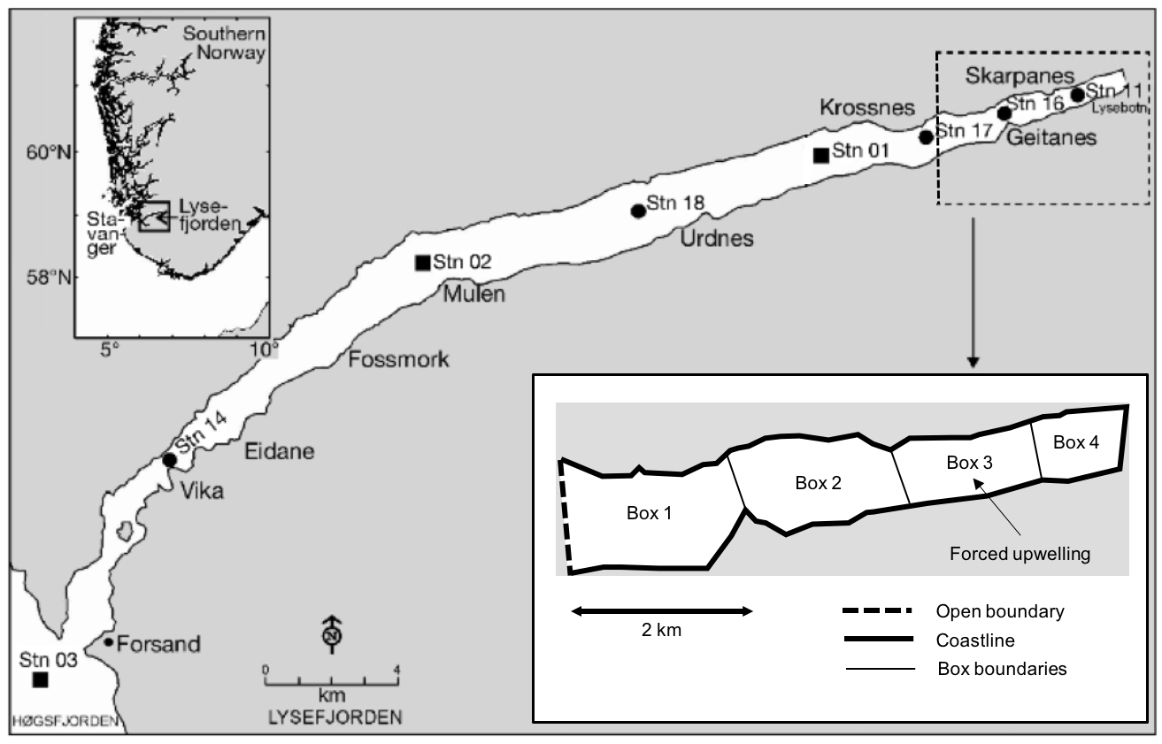

**Figure 1**

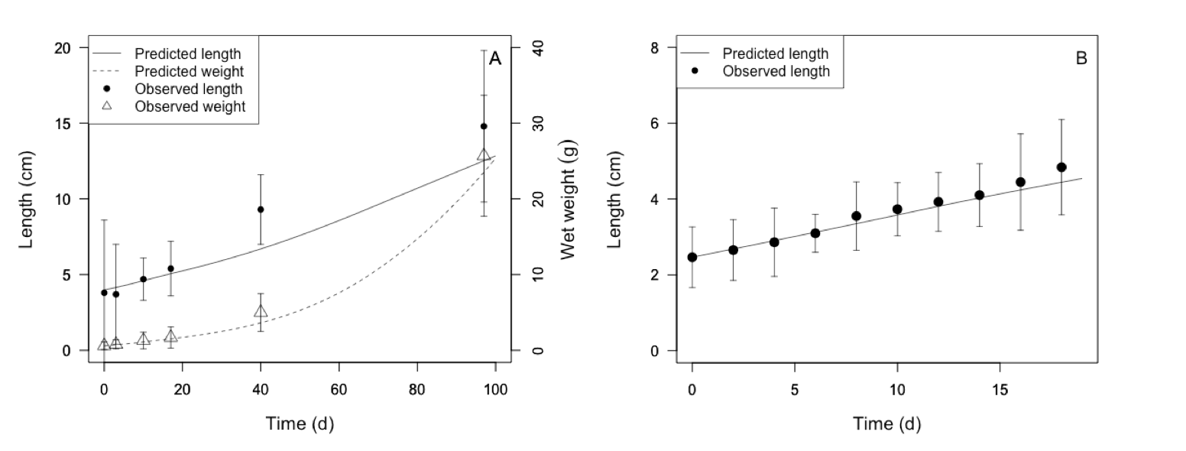**Figure 2**

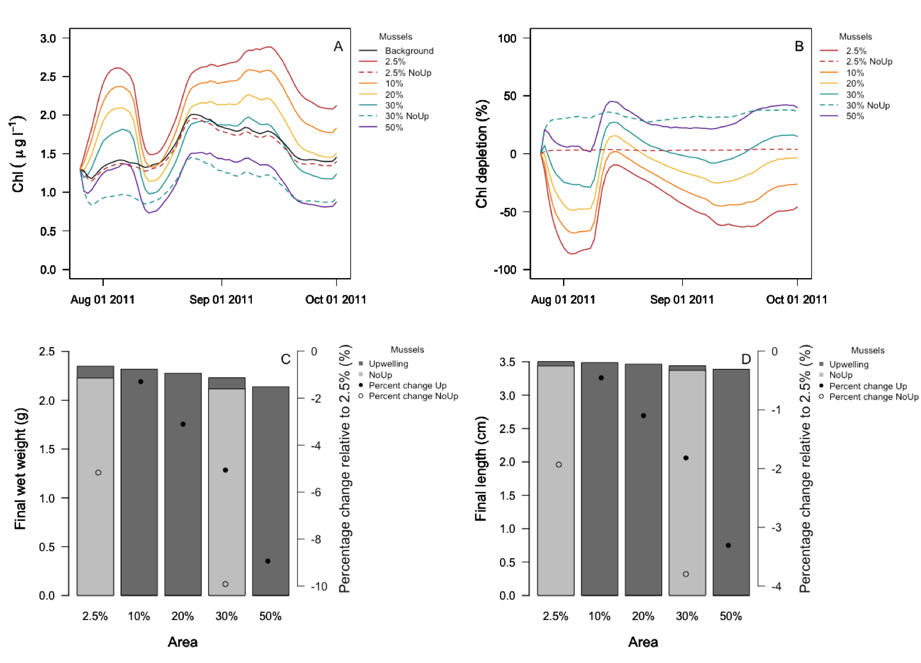**Figure 3**

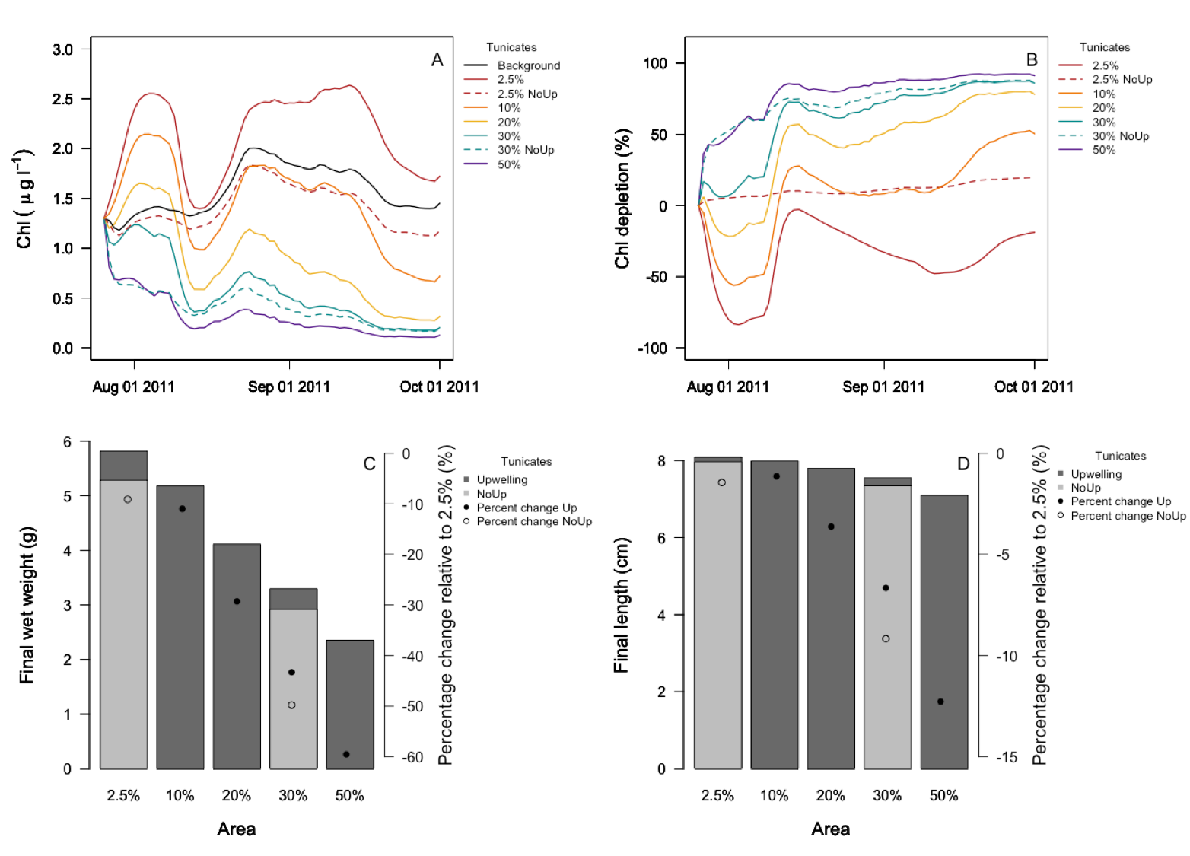

**Figure 4**

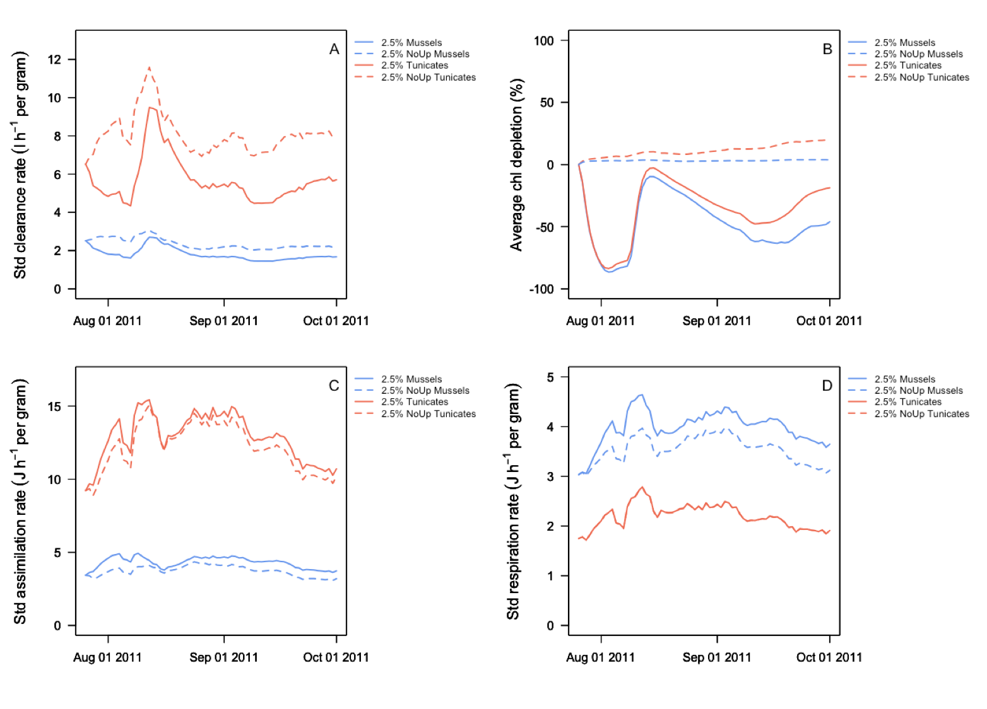

**Figure 5**

**Appendix A. Dynamic Energy Budget model**

The DEB model (Table A1) for *C. intestinalis* was parameterized in a two-step process. Firstly, a range of values were defined for each parameter (Table A2) based on laboratory and *in situ* data (Rastrick et al., 2018; Rastrick, Unpublished results) as well as literature data. In some cases, a range was not possible to determine. In these situations, a range was defined around a single value obtained from the literature, or an educated guess based on similar species. The shape coefficient (δM), which determines how a specific length measurement relates to structural body mass, was calculated for 839 individuals using morphometric measurements, namely length and wet weight (Rastrick, Unpublished results). The dataset was subsampled by selecting those tunicates that are 5% lighter for a given length, following Rosland et al. (2009) and Dabrowski et al. (2013). The subsampled dataset was used to estimate the shape coefficient, 0.158 (Figure A1). The maximum surface area-specific ingestion rate ({*ṗXm*}) was estimated based on a range of clearance rates obtained from Petersen et al. (2007) and the average environmental conditions in terms of J m-3 in Norwegian waters (see Rosland et al. (2009) for conversion factors). The volume-specific somatic maintenance rate ([*ṗM*]), the volume-specific cost for structure ([*EG*]), the maximum reserve energy ([*Em*]), and the ratio dry:wet weight were estimated from starvation experiments and monitoring data (Rastrick, Unpublished results). The range for the Arrhenius temperature (*TA*) was obtained from Petersen and Riisgård (1992) and a series of experiments at different temperatures carried out in Austevoll (Rastrick, Unpublished results). The range of the remaining parameters, the fraction of reserves to growth/reproduction (κ), half-saturation coefficient (*XK*), and assimilation efficiency (*AE*), were set based on the comparison with similar species. Given the uncertainty, a broader range of values was allowed for these parameters.

Secondly, a mathematical optimization generated 100,000 randomized sets of parameters within the predefined range, which was followed by an analysis of the agreement between simulations using those parameters and a specific dataset chosen for calibration (e.g. Duarte et al., 2010; Sonier et al., 2016). The set of parameters that resulted in the best agreement was selected as the calibrated set of parameters.

**References**

Dabrowski, T., Lyons, K., Curé, M., Berry, A., Nolan, G., 2013. Numerical modelling of spatio-temporal variability of growth of *Mytilus edulis* (L.) and influence of its cultivation on ecosystem functioning. J. Sea Res. 76, 5–21. https://doi.org/10.1016/j.seares.2012.10.012.

Duarte, P., Fernández-Reiriz, M.J., Filgueira, R., Labarta, U., 2010. Modelling mussel growth in ecosystems with low suspended matter loads. J. Sea Res. 64, 273-286. https://doi.org/10.1016/j.seares.2010.03.006.

Kooijman, S.A.L.M., 2010. Dynamic energy budget theory for metabolic organisation, Third ed. Cambridge University Press, New York. ISBN 0-521-786088.

Petersen, J.K., 2007. Ascidian suspension feeding. J. Exp. Mar. Biol. Ecol. 342(1), 127-137. https://doi.org/10.1016/j.jembe.2006.10.023.

Petersen, J. K., Riisgård, H.U., 1992. Filtration capacity of the ascidian *Ciona intestinalis* and its grazing impact in a shallow fjord. Mar. Ecol. Prog. Ser. 88, 9-17. https://doi.org/10.3354/meps088009.

Rastrick, S.P.S., Collier, V., Graham, H., Strohmeier, T., Whiteley, N.M., Strand, Ø., 2018. Feeding plasticity more than metabolic rate drives the productivity of economically important filter feeders in response to elevated CO2 and reduced salinity. ICES J. Mar. Sci. 75(6), 2117-2128. https://doi.org/10.1093/icesjms/fsy079.

Rosland, R., Strand, Ø., Alunno-Bruscia, M., Bacher, C., and Strohmeier, T., 2009. Applying Dynamic Energy Budget (DEB) theory to simulate growth and bio-energetics of blue mussels under low seston conditions. J. Sea Res. 62, 49−61. https://doi.org/10.1016/j.seares.2009.02.007.

Sonier, R., Filgueira, R., Guyondet, T., Tremblay, R., Olivier, F., Meziane, T., Starr, M., LeBlanc, A.R., Comeau, L.A., 2016. Picophytoplankton contribution to *Mytilus edulis* growth in an intensive culture environment. Mar. Biol. 163(4), 73. https://doi.org/10.1007/s00227-016-2845-7.

**Table A1.** Equations of the Dynamic Energy Budget (DEB) model. This model follows the original notation outlined in Kooijman (2010), quantities represented by [] are per unit structural volume, {} are per unit surface area of structural volume, and quantities with a dot above them represent a rate or dimension per time.

|  |  |  |
| --- | --- | --- |
| **Equation** | **Terms and parameters** | |
|  | *E* | Reserve (J)  assimilation rate (J d-1)  mobilization rate of reserve energy (J d-1) | |
|  | *V*  *TD* | maximum surface-area-specific assimilation rate (J cm-2 d-1)  Functional response  structural volume (cm3)  Arrhenius temperature function | |
|  | *X*  *XK* | Chlorophyll concentration (µg l-1)  Half-saturation constant (µg l-1) | |
|  | [*EG*]  [*Em*] | fraction of utilized energy to somatic maintenance and growth  volume-specific costs for structure  (J cm-3)  maximum energy density (J cm-3) | |
|  |  | maintenance rate (J d-1)  volume-specific maintenance costs  (J cm-3 d-1) | |
|  |  |  | |
|  | *ER* | energy allocated to reproduction buffer (J) | |
|  |  | reproduction buffer dynamics when energy storage is too low | |
|  | *L*  δM | suspension-feeder length (cm)  dimensionless shape coefficient | |
|  | *TA*  *T1*  *T*  *TL*  *TH*  *TAL*  *TAH* | Arrhenius temperature  reference temperature  absolute temperature  lower tolerance range  upper tolerance range  physiological rate decrease at TL  physiological rate decrease at TH | |

**Table A2:** Range of DEB parameters tested for *Ciona intestinalis* parameterization.

|  |  |  |  |  |
| --- | --- | --- | --- | --- |
| Parameter | Low | High | Units | Definition |
| δM | 0.135 | 0.175 |  | Shape coefficient |
| {*ṗXm*} | 200 | 500 | Jcm-2 d-1 | Maximum surface area-specific ingestion rate |
| [*ṗM*] | 5 | 15 | Jcm-3 d-1 | Volume-specific somatic maintenance rate |
| [*EG*] | 800 | 1600 | Jcm-3 | Volume-specific cost for structure |
| [*Em*] | 2500 | 3500 | Jcm-3 | Maximum reserve density |
| κ | 0.5 | 0.95 |  | Fraction of reserves to growth/reproduction |
| *XK* | 0 | 5 | µg l-1 | Half-saturation coefficient |
| *TA* | 8000 | 11000 | K | Arrhenius temperature |
| *AE* | 0.6 | 0.9 |  | Assimilation efficiency |
| *DW:WW* | 0.05 | 0.07 |  | Dry weight : wet weight |

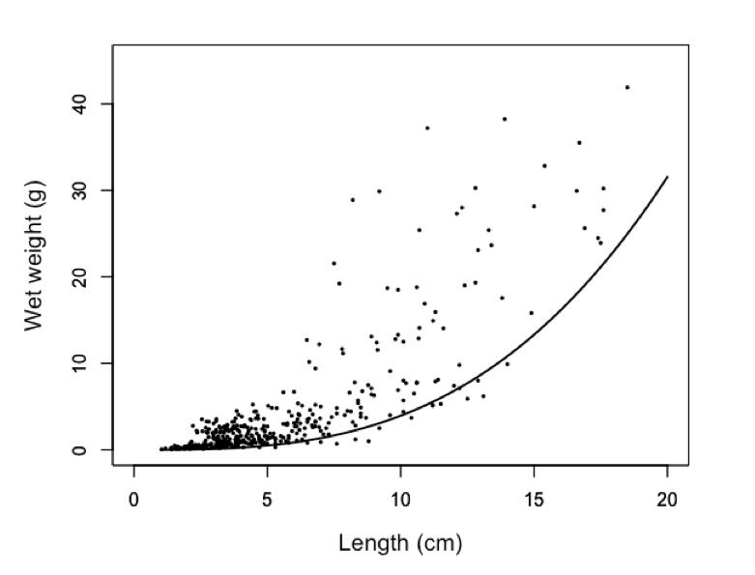

**Figure A1.** Length vs wet weight of *Ciona intestinalis* (dots) and potential regression using only the tunicates that are 5% lighter for a given length.

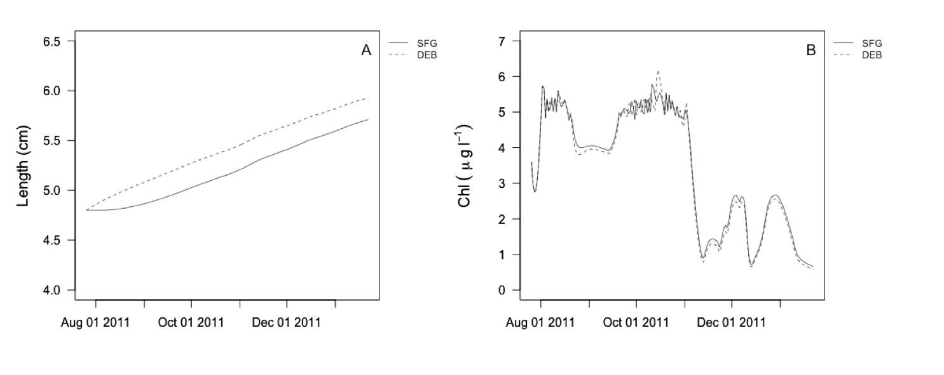

**Figure S1**. Simulation of mussel length (A) and chlorophyll concentration (B) under the same aquaculture scenario using the Scope For Growth (SFG) model develop by Filgueira et al. (2010) and the Dynamic Energy Budget (DEB) model constructed in this study.