Barents Sea cod (Gadus morhua) diet composition: Long-term interannual, seasonal and ontogenetic patterns

Rebecca E. Holt^{1*}, Bjarte Bogstad², Joël M. Durant¹ and Geir Ottersen ^{1,2}
¹Centre for Ecological and Evolutionary Synthesis, Department of Biosciences, University of Oslo, P.O. Box 1066 Blindern, 0316 Oslo, Norway
²Institute of Marine Research, P.O. Box 1870 Nordnes, 5817 Bergen, Norway
*Corresponding Author: e-mail: r.e.holt@ibv.uio.no

Abstract
Atlantic cod (Gadus morhua) is an ecologically and commercially important species in the North-Atlantic region. Cod is a top predator and information on its trophic ecology is integral for understanding predator-prey relationships and food-web dynamics. We present an analysis of the trophic patterns of Barents Sea cod using a unique 33-year time-series of stomach-content data from 1984-2016. We assessed patterns in diet (prey) composition across years, between seasons, as well as ontogenetic trends in diet, including predator-prey size relationships. Ontogenetic shifts in diet were observed, with fish becoming more important prey with increasing cod size. A very early onset of piscivory was found in <20cm cod. Cannibalism was found in cod > 20 cm and increased with size. Juvenile cod exhibit a tendency toward consuming prey up to 33% of their body length, whereas larger cod feed on all prey sizes, resulting in asymmetric predator-prey size distributions. Diet varied significantly during 1984-2016, consistent with changes in both prey, cod abundance and distribution. Seasonal differences were observed; capelin dominated the winter diet, whereas cod, polar cod, and other fish species were prevalent in summer/autumn months. This work represents an important step towards understanding trophic linkages that determine Barents Sea ecosystem dynamics.
Key words: Cod, time series, diet, predator, prey, Barents Sea

Introduction
Trophic ecology is an integral component of food-web dynamics and ecosystem studies, providing a key framework for understanding how the biological components in an ecosystem are connected (Link, 2002). Detailed information on the predation dynamics of ecologically important species, based upon the analysis of individual stomach-contents, is vital for such an understanding (Hyslop, 1980). Stomach-content data can provide detailed information on the diet of a species at a particular point in time and space. When conducted over long temporal scales and across size classes, high-resolution stomach-content data can provide information that is key to understanding trophic interactions in marine ecosystems.
Detailed diet data is important for understanding complex predation patterns, which can vary over time and space, both within and across years (Boyd, 1996), as well as with ontogeny. The body size of both predator and prey for example, are attributes that have been linked directly to the degree of foraging i.e. capture success, and thus predation dynamics (Brose, 2010; Blanchard, 2011). Furthermore, morphology and size both change with ontogeny; predators become more successful with size due to a variety of factors, including increased swimming ability, improved visual acuity and increased gape size (Scharf et al., 2000; Barnes et al., 2010). On the other hand, prey also benefit from increasing size, becoming better at escapement swimming behaviour, as reaction distances and swimming performance increase (Barnes et al., 2010).
Long-term high-quality diet data with good spatio-temporal coverage for fish populations are rare, as the effort and resources required to collect and analyse stomach-contents at this scale is considerable. Fortunately, for Atlantic cod (Gadus morhua), considerable amounts of diet data exist for, e.g., the Baltic (Neuenfeldt and Beyer, 2006), on Georges Bank (Tsou and Collie 2001), the Gulf of Maine US (Willis et al., 2013), and Icelandic waters (Pálsson and Björnsson, 2011). Still, the most comprehensive cod diet data are for Barents Sea (BS) cod. These data are termed the joint Norwegian-Russian stomach database (Dolgov et al. 2011; described briefly in our Materials and Methods section) and a version prolonged and thoroughly quality controlled by us is the fundament for the present paper.
Atlantic cod is a commercially and ecologically important generalist predator, present in most northern North Atlantic shelf ecosystems (Bogstad et al., 2000; Link et al., 2009; Pálsson and Björnsson, 2011). Cod are a central food-web component in several ecosystems (Link and Garrison, 2002; Yaragina et al., 2011) with the potential capacity to shape the prey community and ecosystem functioning through predation (e.g. Frank et al. 2005, van Leeuwen et al. 2008; Johannesen et al. 2012). Fishing pressure has been high for many cod stocks over a prolonged period. Consequently, many areas have shown pronounced declines in cod abundance and thus their ecological importance in recent decades (Dolgov, 2009; Link et al. 2009), particularly off the coast of eastern Canada (Myers et al. 1996). However, the BS cod is thriving and has for some time been the largest stock of Atlantic cod (Johannesen et al. 2012; Kjesbu et al. 2014).
The dominance of cod in the demersal fish community, in terms of both numbers and biomass, is even more pronounced in the BS than most other North Atlantic shelf ecosystems. In the BS, adult cod make up more than half of the total biomass of demersal fish (Dolgov, 2009) and, in addition to minke whales and harp seals, they are the most important predators on fish (Bogstad et al., 2000, Dolgov et al. 2011; Bogstad et al. 2015). The species composition and abundance of cod prey varies over time in relation to environmental conditions and prey population dynamics (Durant et al., 2014). This prey variability can determine the calorific density of cod diet, influencing biological characteristics such as fish condition, growth and maturation and as such regulate stock productivity (Marshall et al., 2000).
The BS (also called Northeast Arctic) cod stock is data-rich and well-studied. The main features of BS cod diet have been described, e.g., Dolgov et al. (2011), and more specific studies have been made, e.g., on diet of cod juveniles (Dalpadado and Bogstad, 2004) or cannibalism (Bogstad et al., 1994; Yaragina et al., 2009). Still significant holes remain in our knowledge of BS cod prey consumption, relating to how the diet of cod varies interannually, seasonally and ontogenetically. Furthermore, the increase in abundance of large cod in recent years (Kjesbu et al. 2014) has increased the amount of stomach samples from large cod considerably, providing more information on the diet of those size groups.
The objective of this study is to describe and evaluate patterns in BS cod diet, in particular long-term interannual trends, differences between seasons, cod-prey size relationships and ontogenetic shifts in cod diet composition. To do so we use an extended version of the Norwegian-Russian cod stomach time series, which spans from 1984-2016, 33 years. This unique time-series is the most comprehensive available cod diet available to date. The broad temporal extent, size class and seasonal resolution of the data set provide a comprehensive characterisation of cod predation dynamics over time; we thus consider the stomach content composition to be representative of BS cod diet. Extending the knowledge on BS cod predation patterns is important to resolve information on the trophic dynamics of cod within the BS ecosystem, further enhancing the foundation for sound management.

Materials and Methods
Stomach-content data
The joint Norwegian-Russian stomach-content database origins from a study on the diet and food consumption of BS fish, with cod as the main study species, initiated in the mid-1980s as a joint endeavour between IMR (Institute of Marine Research) and PINRO (Knipovich Polar Research Institute of Marine Fisheries and Oceanography) (Mehl 1986, Mehl and Yaragina, 1992, Dolgov et al. 2011). This encompassed methods for sampling, analysing stomach-contents, and the storing, processing and exchange of data (Mehl and Yaragina 1992). An average of 8153 stomachs were analysed each year. For each individual sampled, the cod length (size range 5-160 cm; Table S3; sample size information) and weight, together with prey weight, species (identified to the lowest possible taxonomic level), and size composition were recorded. Data are available for nearly all months each year, however a large proportion of stomach samples are concentrated on 2 seasons; winter from the Norwegian demersal fish survey (January to March) and summer/autumn, from various Norwegian and joint Norwegian-Russian surveys from July to October (Table S2; sample size information). Data were sampled across the BS, predominantly from these scientific surveys, but including some additional data from commercial vessels (for a comprehensive description of methodology, please see Mehl and Yaragina, 1992).

Data delimitation and processing
Cod stomachs sampled south of 70°N and west of 18°E (Lofoten and nearby areas), were excluded from our analyses, as spawning cod is mainly found in this coastal area (Michalsen et al., 2008). The data in the stomach database were thoroughly quality controlled and outliers with inconsistencies between cod size and prey weight/prey size removed (Table S1; sample size information).

Prey categories
Due to the diversity of prey consumed, all identifiable prey were aggregated and categorised into 18 broader taxonomic groups for analysis. Prey categories constituted, 1: capelin (Mallotus villosus), 2: herring (Clupea harengus), 3: polar cod (Boreogadus saida), 4: blue whiting (Micromesistius poutassou), 5: cod (Gadus morhua), 6: haddock (Melanogrammus aeglefinus), 7: other gadoids, (Eleginus nawaga, Gadiculus argenteus, Merlangius merlangus, Merlucciidae sp., Trisopterus sp.), 8: redfish (Sebastes sp.), 9: long rough dab (Hippoglossoides platessoides), 10: other flatfish, 11: arctic fishes, 12: other fishes (e.g. Agonidae sp. Ammodytes sp. Anarhichadidae sp.), 13: shrimp (Pandalus borealis), 14: euphausiids, 15: hyperiids, 16: snow crab (Chionoecetes opilio) 17: other food, (mainly contains invertebrates, crustaceans, Polychaeta and Cephalopoda), and 18: unidentified prey, which constitutes heavily digested prey that could not be identified to species. (Please see supplementary material Table S4 for full list of species for all prey categories). Data for each prey category were converted to relative values (percentage of diet by weight) for analysis. Prey weights for the main fish species (Prey categories: 1-6, 8 and 9) were converted to length values (Mehl and Yaragina, 1992).

Data analysis
Least squares linear regression (OLS) was used to analyse the overall relationship between mean fish prey length and predator length,, where a is the intercept, b is the slope and x is fish prey length (cm). Quantile regression was then used to examine the upper and lower bounds of the distribution, (i.e. how minimum and maximum fish prey lengths scale with cod predator length), going beyond examination of the average of the Gaussian distribution. Lower and upper bounds were represented by 0.01 and 0.99 quantiles, appropriate for large sample sizes, n>1000 (Scharf et al., 1998; Juanes 2016). All analyses were conducted in R V3.3.3 (R Core Team 2017), using the ‘stats’, and ‘quantreg’ (Koenker, 2017) packages for OLS and quantile regression respectively.
Percentage frequency of occurrence was calculated for each prey category across size classes and survey years, where is the number of stomachs containing the prey category i and N is the number of stomachs in a given sample, i.e. size class or survey year (not including empty stomachs). Frequency of occurrence was further utilised to illustrate the frequency of occurrence of empty stomachs in a given sample i.e. size class or survey year. Shifts in cod diet composition with increasing size were further examined using the Shannon-Wiener Index (Shannon, 1948),, where represents the prey category (weight, g) for each size class i of cod. A larger H’ value indicates more prey size groups contributing more equally to the diet; higher prey species diversity. All analyses were conducted in R V3.3.3 (R Core Team 2017), using the ‘plyr’ package (Hadley, 2011).

Results
Shifts in cod diet composition with increasing size
Large changes in relative contributions of different prey items to the cod diet were observed across the range of cod length (5-160 cm). The diet of small cod (5-20 cm) consists mainly of euphausiids, as well as the ‘other fishes’ and ‘other food’ prey categories. The results indicate that euphausiids are important prey for cod up until a length of 30 cm, thereafter their percentage of the total prey weight decreases with increasing cod length. The importance of shrimp in the diet increases with cod length up to about 25 cm and then decreases. As cod length increases, their prey shifts away from invertebrates, first to small pelagic fish. Capelin constitutes a significant component of the cod’s diet over much of the predator’s length range, representing on average 33% of the total prey weight for cod from 20-90 cm (Fig. 1a). Capelin enter the diet when cod are approximately 10 cm (Fig. 1a). The percentage of capelin in the cod diet then increases up to nearly 40 % in the 40-50 cm cod group, gradually declining with further increasing cod size, and is not present in the diet of 140 cm cod and larger individuals (Fig. 1a).
Large cod (> 100 cm) switch diet to a higher proportion of larger demersal fish species (Fig. 1a). Haddock alone represents 25% of the diet biomass of cod > 110 cm. While cannibalism is observed in cod as small as the 20-30 cm size class, the percentage increases with cod predator length. For the largest cod (140-160 cm) conspecifics constitute over 60% of the diet in biomass (Fig. 1a). The frequency of occurrence of empty stomachs declines with increasing size (Fig. 1b), with few if any empty stomachs found for large cod (>90cm) (Fig. 1b). For these very large cod, the results suggest that cod and haddock totally dominate the diet, accounting for nearly 90% of the total prey weight. However, it should be noted that the sample size for these very large individuals is comparatively limited (n=105; Fig. 1c; Table S3).
Percentage frequency occurrence of prey (Fig. 2) further reveal shifts in diet composition, illustrating ontogenetic changes, from generalist to fish specialist predators with increasing cod length (Fig. 2). As cod length increases, results indicate a shift away from invertebrate prey via pelagic fish to a higher proportion of demersal fish species, such as cod, haddock, long rough dab, ‘other flatfish’ and ‘other fishes’ prey categories (Fig. 2).
The Shannon-Wiener diversity index initially increases with increasing size (up to 90cm), but declined with increasing size for large cod (>90cm); with larger size classes having lower species diversity present within their diet, further illustrating ontogenetic shifts in diet composition (Fig. 3).

Predator-prey size relationship
We demonstrate that cod prey on a wide range of fish prey sizes. As expected, a positive association between fish prey and predator length was found (Table 1). However, the relation was less pronounced for capelin and polar cod as these fish reach maximum sizes lower than that of the other fish prey (Capelin: 22 cm; Gjøsæter et al., 2011, Polar cod: 30 cm; Hop and Gjøsæter, 2013), as well as blue whiting and herring, which in the BS are rarely found above 30 cm and 25 cm, respectively, due to outward migration (Belikov et al., 2011; Krysov and Røttingen 2011) and cod consume all sizes of these species. Therefore, the prey size limit is not controlled by the cod’s lack of capacity for taking larger prey, but that there are no larger capelin/polar cod/blue whiting/herring available in the environment (Fig. 4).
A classic wedge shaped pattern was found across fish prey species with minimum prey sizes increasing slower than maximum prey sizes for all species except for capelin (Table 2; Fig. 4). Both lower and upper bound quantile slopes differed from the mean slopes (Table 2). Additionally, there was a continued inclusion of small prey in the diet of cod >30 cm, resulting in asymmetric predator-prey size distributions for all fish prey species (Fig. 4). Juvenile cod < 30 cm preyed upon fish species < 33 % of their own body length, apart from blue whiting, which juvenile cod did not consume (Fig. 4). Medium sized cod (30-60 cm) consumed fish species on average 30 % of their own body size (Fig. 4), whereas large cod (60-120 cm) consumed nearly all fish prey lengths (Fig. 4). Results suggest that very large cod, > 120 cm preyed upon both haddock and cod nearly 50 % of their body size (Fig. 4). Their prey size ranged from 6.6 to 44 % of their own body size, further demonstrating asymmetric predator-prey size distributions. The smallest potential fish prey (early juveniles to 0-group of various species) are not found in cod stomachs, which is as expected as their distribution does not overlap vertically with larger, predatory cod. The mean length of 0-group cod, haddock and herring in August-September is 7-8 cm (Ottersen and Loeng, 2000), and 0-group of other species is smaller. Blue whiting do not enter the BS until late autumn in the first year of life when they are > 10 cm (Belikov et al. 2011, Mehl et al. 2018), which explains the absence of small blue whiting in the cod diet.

Long-term interannual variation in cod diet
Average diet composition and frequency of occurrence of prey categories across all size-classes of cod varied from 1984 to 2016 (Fig. 5a, 6). The percentage of cod and capelin fluctuated, exhibiting a semi-cyclic pattern from 1984 to 2016. Cod diet data suggest that redfish was a prominent component of the diet from 1984-1989 (18.8 - 26.7%), beyond which redfish account only for <5% of the annual cod diet (Fig. 5a). Similarly the prey category ‘other fishes’ comprised a larger proportion of the diet from 1984-1991 compared with later years. It decreased somewhat in 1991-1993, but subsequently remained at a stable level. Haddock in particular became a more prominent component of the diet of cod from 2002 onwards (Fig. 5a). Snow crab (Chionoecetes opilio), a new species in the BS (Alvsvåg et al. 2009), was not present in the cod diet prior to 2003 but in recent years it has steadily increased from 0.03% in 2003 to 5.19% in 2016. The proportion of shrimp in the diet decreased from 26% in 1984 to 5% in 2016 averaged across all size classes. Cannibalism, i.e., cod consumed by cod, was at its highest level from 1995 to 1998 (Fig. 5a, 6). Whereas, the prey category ‘other food’ steadily increased from 1991; representing <1% of cod diet in 1991 to more than 20% from 2007 to 2016 (Fig. 5a). Ctenophora, within the ‘other food’ categories has steadily increased during this observation period (Eriksen et al. 2017b). The frequency of empty stomachs fluctuated through the time-series, but was particularly low from 1988-1991 (Fig. 5b).

Long-term seasonal variation in cod diet
Long-term seasonal differences were observed between winter and summer/autumn periods. Our data suggest that, on average, across all size-classes, capelin dominate the diet of cod in winter (Fig. 7). Although still present in the summer/autumn season, capelin was consumed proportionally to a lesser extent; whereas cod, polar cod, and other small fish species were more prevalent (Fig. 7). Furthermore, a higher percentage of hyperiids, shrimp and ‘other food’ were consumed in the summer/autumn period, compared with winter months (Fig. 7).

Discussion
Our results document that BS cod have a diverse diet, varying with ontogeny, season and between years. This supports and builds further upon the findings of previous work on this stock (Zatsepin and Petrova, 1939, Bogstad et al., 2000; Dalpadado and Bogstad, 2004; Yaragina et al., 2011; Durant et al., 2014; Bogstad et al., 2015). A varied diet has also been documented for other Atlantic cod stocks and populations (Link et al., 2009), including the Baltic (Neuenfeldt and Beyer, 2006), in Icelandic waters (Pálsson and Björnsson, 2011), and on the northeastern shelf of the US (Link and Garrison, 2002; Willis et al., 2013). Despite the diversity in prey items found in BS cod stomachs, we observed a clear preference for fish prey; consistent with cod being an active predator, preferring actively moving organisms (Yaragina et al., 2011). In this paper, we have identified ontogenetic shifts as well as patterns in prey-size selectivity and long-term annual and seasonal variability in BS cod diet. Note that to correctly represent the diet composition at the population level, stomach content data should be scaled by the abundance of BS cod for each length group. However, given the comprehensive and unique stomach content dataset used in this study, which encompasses over 269 000 stomachs, we provide invaluable long-term interannual, seasonal and ontogenetic information on BS cod diet, without the need for scaling.
Shifts in cod diet composition with increasing size
BS cod exhibit clear shifts in diet with fish size. From juvenile to adult cod, the diet shifted from euphausiids, ‘other food’ and shrimp to a fish dominated diet (Fig. 1, 2, 3). This is consistent with other studies on BS demersal fish. For example, Dolgov (2009) states that considerable ontogenetic changes in diet composition are typical of many fish in the area, including cod and haddock as well as other abundant species. It was observed that as BS fish grow, there is both an increase in the size of consumed prey of the same species and a switch from smaller prey species to larger organisms (Dolgov, 2009). Furthermore, in predatory fish (cod (Gadus morhua), redfish, thorny skate (Amblyraja radiata), long rough dab (Hippoglossoides platessoides), young fish feed mainly on plankton while older fish prey mainly on larger decapods and smaller fish species (Dolgov 2009). It should also be noted that the diet of BS cod in the spawning areas, which is not included in our analysis, and mainly consists of herring and Norway pout (Trisopterus esmarkii) (Michalsen et al. 2008), reflecting the prey availability in those areas during the spawning period.
Our result of increasing piscivory with increasing cod size is consistent with other cod stocks (e.g. Icelandic; Pálsson and Björnsson, 2011); however, this ontogenetic shift appears to occur earlier, in smaller cod (20cm) within the BS. Fish, specifically capelin, encompass over 10% of the diet of this size class (>10-20cm), this early onset of piscivory for cod is unique to the BS system. We find that the diet of BS cod >20cm length is dominated by fish, which constitutes over 60% of the diet (Fig. 1). This differs somewhat from cod on the Flemish cap (Konstantinov et al., 1985; Casas and Paz, 1994) and continental shelf waters of northeast US more generally (Durbin et al., 1983; Bowman and Michaels, 1984; Link and Garrison, 2002), where the shift towards piscivory was found at a larger size (cod >50cm). Generally, the proportion of different fish species consumed changes in conjunction with fish size, which may reflect changes in prey abundance or spatial distribution, as cod are opportunistic feeders (Link and Garrison, 2002).
Cannibalism is found in cod as small as 20 cm in length in the BS, and for very large cod (140-160 cm) conspecifics comprise over 60% of the diet. This is counter to cod in US waters, where cannibalism is found, but only in larger individuals (>100 cm; Link and Garrison, 2002). Furthermore, the occurrence of cannibalism level is an order of magnitude higher in the BS than that reported for the Baltic Sea (Uzars and Plikshs, 2000) and Icelandic cod (Pálsson and Björnsson, 2011).
Predator-prey size relationships
Results show that juvenile cod (<30 cm) are more size-selective with regards to fish prey compared with their larger, older conspecifics. Cod >30 cm not only consume large prey sizes up to 50% of their body length but also all small prey size classes (Fig. 4), resulting in asymmetric predator-prey size distributions. Like other marine fish species, the size of prey consumed generally increases with predator size (Scharf et al., 2000) and cod possess size-based feeding strategies, where predator diets are concentrated within ranges of prey size (van Denderen and van Kooten, 2013; De Roos et al., 2008; Scharf et al., 2000). When individuals are small, feeding strategies are likely limited by gape size (Scharf et al., 2000). Results indicate that the maximum fish prey size is about 50% of cod length for cod of all sizes (Fig. 4). Furthermore, small juveniles are at a greater risk of cannibalism, eliciting foraging behaviour trade-offs with survival (McGurk, 1986; Gislason et al., 2010). The morphology of cod and their prey changes with ontogeny as predator gape size increases and prey become faster and more efficient escapists (Scharf et al., 2000). Large predators such as the big cod evaluated in this study may have an intra-specific competitive advantage by feeding on small prey sizes whilst also being able to feed on large prey that are unavailable to smaller conspecifics. There is a slight truncation of the smaller prey size for large cod suggesting a preference for bigger prey (Fig. 4). However, there is no increase in the prey concentration along the highest quantiles, suggesting that there is no preference of prey size besides the anatomical maximum size limit for large cod. Asymmetric patterns in the distribution of predator-prey size have previously been described in marine fish (Scharf et al., 2000), including Georges Bank cod (Tsou and Collie 2001), for which evidence of asymmetric relationships was observed. This is, however, the first study that explicitly shows evidence for asymmetric predator-prey size distributions in BS cod for all main fish prey species, and is important for understanding and quantifying interactions among species in this region.

Long-term interannual variation in cod diet
Long-term dietary trends for BS cod have been identified (Fig. 5, 6). Average diet composition and frequency of occurrence of prey categories across all size-classes of cod varied from 1984 to 2016 (Fig. 5a, 6). Comparison of specific prey categories suggest that BS cod consume capelin in semi-cyclic patterns from 1984 to 2016 (Fig. 5), reflective of changes in capelin stock size (ICES, 2016; Durant et al. 2014; Eriksen et al., 2017a) and consistent with known capelin stock collapses (given a 1-2 year lag) (Capelin collapses: 1985-1989, 1993-1997, 2003-2006; Gjøsæter et al., 2009). There was an increase in the frequency of empty stomachs after 1990.. Additionally there was a small peak in cod cannibalism in 1996-1997, again consistent with the capelin collapse during this time. These results illustrate how cod diet data can be utilised to trace this particular capelin collapse. Redfish were a more prominent component of the BS cod diet from 1984-1989 (on average 10% of cod diet), beyond which redfish accounted for <5% of the annual diet (Fig. 5, 6). The decline in redfish abundance in cod diet from the early 1990s onwards is consistent with the decreased abundance of redfish in the BS in that period (ICES, 2016). However, the increased abundance of redfish from 2007 onwards was only to a small extent reflected in the BS cod diet. Haddock encompass a considerably larger proportion of the cod diet from 2002 onwards, which is consistent with an increase in stock size observed for this species over the same period (ICES, 2016).
Polar cod is present in the cod diet in most years studied (Fig. 6), although the fraction of the total prey consumed varies from year to year (Fig. 5). With the expansion of the cod feeding area towards the north and east in recent years (e.g., Fossheim et al., 2015), with increased overlap with the traditional polar cod habitat one would expect increased importance of polar cod in the cod diet. Our data does not support this. To the contrary, polar cod constitute a lower percentage of the consumed prey in 2011 onwards than in the preceding years (Fig. 5). However, the abundance of polar cod decreased considerably from 2010 to 2015, while a sharp increase was observed in 2016 (ICES 2017).
On average the percentage of herring within the cod diet was low (<5% annual diet), and appears only partly reflective of temporal differences in stock biomass for this prey species in the BS (ICES, 2016). However, years with extremely few herring in cod stomachs also represented very low herring abundance years (ICES, 2016). This is in agreement with other studies where no effect of herring abundance was found on feeding success (Johannesen et al., 2012). It is suggested that despite spatial overlap, herring may be able to escape predation through local avoidance mechanisms, e.g., vertical separation (Orlova et al., 2005; Johannesen et al., 2012). Snow crab has increased in recent years within the cod diet (0.03 to 5.19% annual diet in 2003 and 2016 respectively), a direct consequence of the increased availability resulting from the westward expansion of this species, as well as the expansion of BS cod toward the southeast. It has been suggested that the snow crab is now adapted to the BS and that this now has become part of their permanent habitat (Alvsvåg et al. 2009).

Long-term seasonal variation in cod diet
Long-term seasonal differences, from 1984-2016, in BS cod diet were found. A higher proportion of capelin was on average consumed in the winter season (January-March); this is consistent with capelin spawning migrations during this time to the Norwegian and Murman coasts (Ajiad et al., 1992; Gjøsæter et al., 2011). Data suggest that the diet of cod is more diverse in summer/autumn seasons compared with winter; polar cod, cod, haddock, herring and ‘other fishes’ prey categories were more readily consumed in the warmer months. Cod consumed a higher percentage of polar cod in the summer/autumn months, consistent with other literature (Yaragina et al., 2011).

Conclusion
BS cod is considered the most important predator in the BS. The composition of the diet of this stock has varied considerably interannually from 1984-2016 as well as between seasons within the same year, confirming opportunistic behaviour. They are active predators, with a tendency towards piscivory established earlier in life than for comparable cod stocks and increasing further with age. We provide evidence for asymmetric predator-prey size distributions as well as ontogenetic shifts in diet composition. Cod abundance has increased in the BS, reaching unprecedentedly high levels in recent years. As such, the relationship between cod diet and the abundance of cod may have increased impact on important prey populations, particularly pelagic fish stocks that encompasses a high proportion of their diet. This will likely have consequences for the BS food-web structure and ecosystem function. This study represents a further step towards understanding the trophic ecology and predator-prey relationships that determine food-web and ecosystem dynamics within the BS.

Acknowledgements
This research was supported by The Research Council of Norway (RCN), through a MARINFORSK grant “CoDINA – Cod: DIet and food web dyNAmics (Project No: 255460). JMD is supported by the RCN through the project: SUSTAIN (Project No: 244647/E10). We further thank everyone involved in initiating, establishing and updating the joint Norwegian-Russian stomach-content database, not least the colleagues undertaking the enormous practical task of identifying the stomach-contents.

References
Ajiad, A.M., Mehl, S., Korsbrekke, K., Dolgov, A.V., Korzhev, V.A., Tretyak, V.L., and Yaragina, N.A. 1992. Trophic relationships and feeding-dependent growth in the Northeast Arctic cod. Proceedings of the Fifth PINRO-IMR Symposium, Murmansk, August 1991. Institute of Marine Research, Bergen, pp 45-58.
Alvsvåg, J., Agnalt, A.L., and Jørstad, K.E. 2009. Evidence for a permanent establishment of the snow crab (Chionoecetes opilio) in the Barents Sea. Biological Invasions, 11: 587-595.
Barnes, C., Maxwell, D., Reuman, D.C., and Jennings, S. 2010. Global patterns in predator–prey size relationships reveal size dependency of trophic transfer efficiency. Ecology, 91: 222-232.
Belikov, S.V., Oganin, I.A., and Høines, Å. 2011. Blue whiting. In: The Barents Sea. Ecosystem, Resources, management. Half a century of Russian-Norwegian cooperation, pp. 355-362. Ed. By T. Jakobsen, and V.K. Ozhigin. Tapir Academic Press, Trondheim Norway.
Blanchard, J.L. 2011. Body size and ecosystem dynamics: an introduction. Oikos 120: 481–482.
Bogstad, B, Lilly, G.R., Mehl, S., Pálsson, Ó.K., and Stefánsson, G. 1994. Cannibalism and year-class strength in Atlantic cod (Gadus morhua L.) in Arcto-boreal ecosystems (Barents Sea, Iceland, and eastern Newfoundland). ICES Marine Science Symposium, 198: 576-599.
Bogstad, B., Gjøsæter, H., Haug, T., and Lindstrøm, U. 2015. A review of the battle for food in the Barents Sea: cod vs. marine mammals. Frontiers in Ecology and Evolution, 3:1-17.
Bogstad, B., Haug, T., and Mehl S. 2000. Who eats whom in the Barents Sea? NAMMCO Scientific Publications, 2: 98-119.
Bowman, R.E., and Michaels, W.L. 1984. Food of seventeen species of northwest Atlantic fish. NOAA Tech Memo NMFSF/NEC-28
Boyd, I.L. 1996. Temporal scales of foraging in a marine predator. Ecology, 77: 426-434.
Brose, U. 2010. Body-mass constraints on foraging behaviour determine population and food-web dynamics. Functional Ecology, 24, 28–3410.
Casas, J.M., and Paz, J. 1994. Diet of Flemish Cap cod with particular reference to predation on redfish: 1988–1993. Scientific Council Research Document NAFO 94–24.
Dalpadado, P., and Bogstad, B. 2004. Diet of juvenile cod (age 0-2) in the Barents Sea in relation to food availability and cod growth. Polar Biology, 27: 140-154.
De Roos, A.M., Schellekens, T., Van Kooten, T., and Persson, L. 2008. Stage-specific predator species help each other to persist while competing for a single prey. Proceedings of the National Academy of Sciences, 37: 13930-13935.
Dolgov, A. V., Orlova, E. L., Johannesen, E., and Bogstad, B. 2011. Piscivorous fish. In: The Barents Sea. Ecosystem, Resources, management. Half a century of Russian-Norwegian cooperation, pp. 466-484. Ed. By T. Jakobsen, and V.K. Ozhigin. Tapir Academic Press, Trondheim Norway.
Dolgov, A.V. 2009. Trophic structure of the Barents Sea fish assemblage with special reference to the cod stock recoverability. Progress in Oceanography 81: 165-173.
Durant, J.M., Skern-Mauritzen, M., Krasnov, Y.V., Nikolaeva, N.G., Lindstrøm, U., and Dolgov, A. 2014. Temporal dynamics of top predator’s interactions in the Barents Sea. PLoS One, 9:e110933.
Durbin, E.G., Durbin, A.G., Langton, R.W., and Bowman, R.E. 1983. Stomach contents of silver hake, Merluccius bilinearis, and Atlantic cod, Gadus morhua, and estimation of their daily rations. Fisheries Bulletin US, 81:437–454.
Eriksen, E., Bogstad, B., Dolgov, A. V. and Beck, I. M. 2017b. Cod diet as an indicator of Ctenophora abundance dynamics in the Barents Sea. Marine Ecology Progress Series 591: 87-100.
Eriksen, E., Skjoldal, H.R., Gjøsæter, H., and Primicerio, R. 2017a. Spatial and temporal changes in the Barents Sea pelagic compartment during the recent warming. Progress in Oceanography, 151:206-226.
Fossheim, M., Primicerio, R., Johannesen, E., Ingvaldsen, R.B., Aschan, M.M., and Dolgov, A.V. 2015. Recent warming leads to a rapid borealization of fish communities in the Arctic. Nature Climate Change, 5: 673-677.
Frank, K. T., Petrie, B., Choi, J.S., and Leggett, W.C. 2005. Trophic cascades in a formerly cod-dominated ecosystem. Science 308:1621−1623.
Gislason, H., Daan, N., Rice, J.C., and Pope, J.G. 2010. Size, growth, temperature and the natural mortality of marine fish. Fish and Fisheries, 11: 149–158.
Gjøsæter, H., Bogstad, B., and Tjelmeland, S. 2009. Ecosystem effects of the three capelin stock collapses in the Barents Sea. Marine Biology Research, 5:40-53.
Gjøsæter, H., Ushakov, N.G., and Prozorkevich, D.V. 2011. Capelin. In: The Barents Sea. Ecosystem, Resources, management. Half a century of Russian-Norwegian cooperation, pp. 201-214. Ed. By T. Jakobsen, and V.K. Ozhigin. Tapir Academic Press, Trondheim Norway.
Hadley, W. 2011. The split-apply-combine strategy for data analysis. Journal of Statistical Software 40: 1-29.
Hop, H., and Gjøsæter, H., 2013. Polar cod (Boreogadus saida) and capelin (Mallotus villosus) as key species in marine food webs of the Arctic and the Barents Sea. Marine Biology Research 9: 878-894.
Hyslop, E.J. 1980. Stomach content analysis – a review of methods and their application. Journal of Fish Biology, 17: 411-429.
ICES 2016. Report of the Arctic Fisheries Working Group 2016 (AFWG), 19-25 April 2016, ICES Headquarters, Copenhagen. ICES CM 2016/ ACOM:06. 621 pp.
ICES 2017. Report of the Working Group on the Integrated Assessments of the Barents Sea. WGIBAR 2017 Report, 16-18 March 2017. Murmansk, Russia. ICES CM 2017/SSGIEA:04. 186 pp.
Johannesen, E., Lindstrøm, U., Michalsen, K., Skern-Mauritzen, M., Fauchald, P., Bogstad, B., and Dolgov, A. 2012. Feeding in a heterogeneous environment: spatial dynamics in summer foraging Barents Sea cod. Marine Ecology Progress Series, 458: 181-197.
Juanes, F. 2016. A length-based approach to predator-prey relationships in marine predators. Canadian Journal of Fisheries and Aquatic Sciences, 73: 677-684.
Kjesbu, O.S., Bogstad, B., Devine, J.A., Gjøsæter, H., Howell, D., Ingvaldsen, R.B., Nash, R.D.M., and Skjæraasen, J.E. 2014. Synergies between climate and management for Atlantic cod fisheries at high latitudes. Proceedings of the National Academy of Sciences USA, 111: 3478–3483.
Koenker, R. 2017. quantreg: Quantile Regression. R package version 5.33. https://CRAN.R-Project.org/package=quantreg
Konstantinov, K.G., Turuk, T.N., and Plekhanova, N.A. 1985. Food links of some fishes and invertebrates on Flemish Cap. Scientific Council Studies NAFO, 8:39–48.
Krysov, A. I., and Røttingen, I. 2011. Herring. In: The Barents Sea. Ecosystem, Resources, management. Half a century of Russian-Norwegian cooperation, pp. 215-224. Ed. By T. Jakobsen, and V.K. Ozhigin. Tapir Academic Press, Trondheim Norway.
Link, J.S. 2002. Does food web theory work for marine ecosystems? Marine Ecology Progress Series, 230: 1-9.
Link, J.S., and Garrison, L.P. 2002. Trophic ecology of Atlantic cod Gadus morhua on the northeast US continental shelf. Marine Ecology Progress Series, 227: 109-123.
Link, J.S., Bogstad, B., Sparholt, H., and Lilly, G.R. 2009. Trophic role of Atlantic cod in the ecosystem. Fish and Fisheries, 10: 58-87.
Marshall, C.T., Yaragina, N.A., Ådlandsvik, B., and Dolgov, A.V. 2000. Reconstructing the stock-recruit relationship for Northeast Arctic cod using a bioenergetic index of reproductive potential. Canadian Journal of Fisheries and Aquatic Sciences, 57: 2433-2442.
McGurk, M.D. 1986. Natural mortality of marine pelagic fish eggs and larvae: the role of spatial patchiness. Marine Ecology Progress Series, 34: 227–242.
Mehl, S. 1986. Stomach contents of North-East Arctic cod and possible changes in the diet the last years. ICES C.M. 1986/G:29, 26 pp.
Mehl, S. Aglen, A., Gjøsæter, H., Godiksen, J. A, Staby, A., Wenneck, T., Wienerroither, R., Russkikh, A., and Tretyakov, I. 2018. Fish investigations in the Barents Sea winter 2018. IMR-PINRO Report series 1-2018, 82 pp. Available at https://www.hi.no/filarkiv/2018/05/imr-pinro_winter_survey_report_2018_pdf.pdf/nb-no
Mehl, S., and Yaragina, N.A. 1992. Methods and results in the joint PINRO-IMR stomach sampling program. In: Bogstad B, Tjelmeland S, editors. Interrelations between Fish Populations in the Barents Sea. Proceedings of the 5th Soviet-Norwegian Symposium. Murmansk, 12-16 August 1991, pp. 5-16. Institute of Marine Research, Bergen, Norway.
Michalsen, K., Johannesen, E., and Bogstad, B. 2008. Feeding of mature cod (Gadus morhua) on the spawning grounds in Lofoten. ICES Journal of Marine Science, 65: 571-580.
Myers, R.A., Hutchings, J.A., and Barrowman, N.J., 1996. Hypotheses for the decline of cod in the North Atlantic. Marine Ecology Progress Series 138: 293–308.
Neuenfeldt, S., and Beyer, J.E. 2006. Environmentally driven predator-prey overlaps determine the aggregate diet of the cod Gadus morhua in the Baltic Sea. Marine Ecology Progress Series, 310: 151-163.
Orlova, E.L., Dolgov, A.V., Rudneva, G.B., and Nesterova, V.N. 2005. The effect of abiotic and biotic factors on the importance of macroplankton in the diet of Northeast Arctic cod in recent years. ICES Journal of Marine Science, 62: 1463−1474.
Ottersen, G., and Loeng, H. 2000. Covariability in early growth and year-class strength of Barents Sea cod, haddock, and herring: the environmental link. ICES Journal of Marine Science 57: 339-348.
Pálsson, Ó.K., and Björnsson, H. 2011. Long-term changes in trophic patterns of Iceland cod and linkages to main prey stock sizes. ICES Journal of Marine Science, 68: 1488-1499.
R Core Team. 2017. R: A language and environment for statistical computing. R Foundation for Statistical Computing, Vienna, Austria. URL: https://www.R-project.org/.
Scharf, F.S., Juanes, F., and Rountree, R.A. 2000. Predator size-prey size relationships of marine fish predators: interspecific variation and effects of ontogeny and body size on trophic-niche breadth. Marine Ecology Progress Series, 208: 229-248.
Scharf, F.S., Juanes, F., and Sutherland, M. 1998. Inferring ecological relationships from the edges of scatter diagrams: comparison of regression techniques. Ecology, 79: 448-460.
Shannon, C.E. 1948. A mathematical theory of communication. Bell Systems Technical Journal. 27: 379-423.
Tsou, T.S., and Collie, J.S. 2001. Estimating predation mortality in the Georges Bank fish community. Canadian Journal of Fisheries and Aquatic Sciences 58: 908-922.
Uzars, D., and Plikshs, M. 2000. Cod (Gadus morhua L.) cannibalism in the central Baltic: interannual variability and influence of recruit abundance and distribution. ICES Journal of Marine Science, 57: 324-329.
Van Denderen, P.D., and Van Kooten, T. 2013. Size-based species interactions shape herring and cod population dynamics in the face of exploitation. Ecosphere, 4:1-15.
Van Leeuwen, A., De Roos. A.M., and Persson, L. 2008. How cod shapes its world. Journal of Sea Research 60:89−104.
Willis, T.V., Wilson, K.A., Alexander, K.E., and Leavenworth, W.B. 2013. Tracking cod diet preference over a century in the northern Gulf of Maine: historic data and modern analysis. Marine Ecology Progress Series, 474: 263-276.
Yaragina, N.A., Aglen, A., and Sokolov, K.M. 2011. Cod. In: The Barents Sea. Ecosystem, Resources, management. Half a century of Russian-Norwegian cooperation, pp. 225-270. Ed. By T. Jakobsen, and V.K. Ozhigin. Tapir Academic Press, Trondheim Norway.
Yaragina, N.A., Bogstad, B., and Kovalev, Y.A. 2009. Variability in cannibalism in northeast Arctic cod (Gadus morhua) during the period 1947-2006. Marine Biology Research, 5:75-85.
Zatsepin, V.I. and Petrova, N.S. 1939. The food of the commercial stocks of cod in the southern part of the Barents Sea (from observations made 1934-1938). Fish. Res. Bd. Can. Trans. Ser. No. 498. 1964.

Table 1. Least squares regression (OLS) of prey length (cm) versus predator length (cm) for each fish prey, where a is intercept and b is the slope.
Prey Species | Intercept (±SE) | Slope (±SE) | Adj. r² | P | n
Capelin | 12.244 (0.065) | 0.016 (0.001) | 0.010 | *** | 68936
Herring | 7.870 (0.373) | 0.122 (0.005) | 0.220 | *** | 3766
Polar cod | 8.886 (0.201) | 0.040 (0.003) | 0.033 | *** | 12069
Blue whiting | 14.572 (0.803) | 0.090 (0.011) | 0.061 | *** | 2131
Cod | 2.109 (0.320) | 0.198 (0.004) | 0.215 | *** | 13586
Haddock | 3.641 (0.465) | 0.201 (0.006) | 0.245 | *** | 6750
Redfish | 0.495 (0.188) | 0.145 (0.003) | 0.252 | *** | 8758
Long rough dab | -2.807 (0.377) | 0.239 (0.005) | 0.435 | *** | 4965
NS= Not significant, P>0.05. Significance level: P>0.05, *P<0.05, **<0.01, ***0.001.

Table 2. Quantile Regression of prey length (cm) versus predator length (cm) for each fish prey: lower (1%), and upper (99%) quantile slopes, intercepts (±SE), and sample sizes.
Prey Species | Lower |  | Upper
 | Intercept (±SE) | Slope (±SE) |  | Intercept (±SE) | Slope (±SE) | n
Capelin | 4.600 (0.261) | 0.033 (0.004) |  | 18.500 (0.285) | 0.000 (0.003) | 68936
Herring | 6.375 (0.655) | -0.007 (0.009) |  | 7.777 (1.266) | 0.324 (0.021) | 3766
Polar cod | 3.500 (0.614) | 0.000 (0.010) |  | 16.152 (1.290) | 0.065 (0.017) | 12069
Blue whiting | 10.500 (2.934) | 0.000 (0.035) |  | 25.615 (4.452) | 0.115 (0.047) | 2131
Cod | 5.500 (0.263) | 0.000 (0.002) |  | -0.815 (1.221) | 0.526 (0.021) | 13586
Haddock | 6.800 (0.884) | 0.016 (0.009) |  | 1.959 (2.501) | 0.483 (0.037) | 6750
Redfish | 3.500 (0.307) | 0.000 (0.004) |  | 1.185 (0.966) | 0.314 (0.017) | 8758
Long rough dab | -0.576 (0.166) | 0.057 (0.004) |  | 1.018 (1.384) | 0.370 (0.019) | 4965

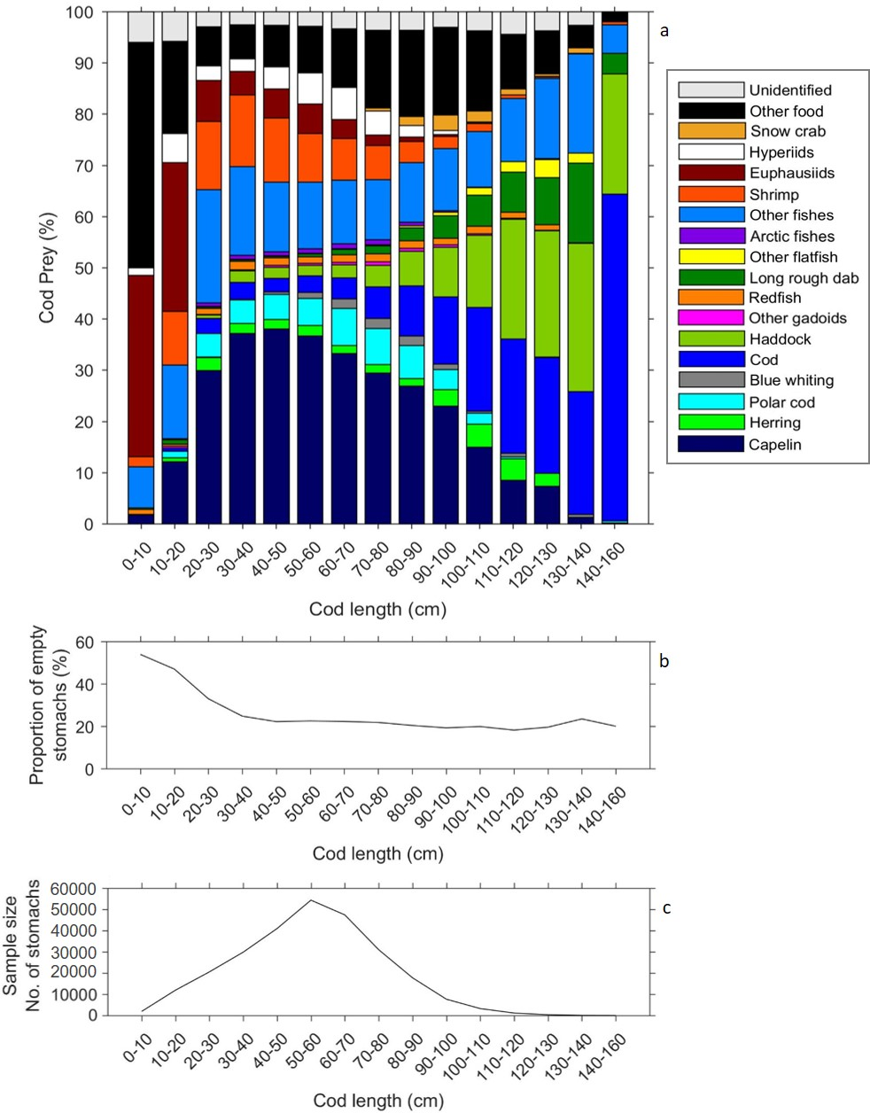

Figure 1. a) Cod predator length (cm) and percentage of total prey weight per species/ species group. Cod length given in 10 cm bins except for those >140-160 cm, which are in one bin due to comparatively fewer individuals. b) Frequency of occurrence of empty stomachs for each cod length group. c) Sample size (no. of stomachs) 1984-2016 for each cod length group (not including empty stomachs).

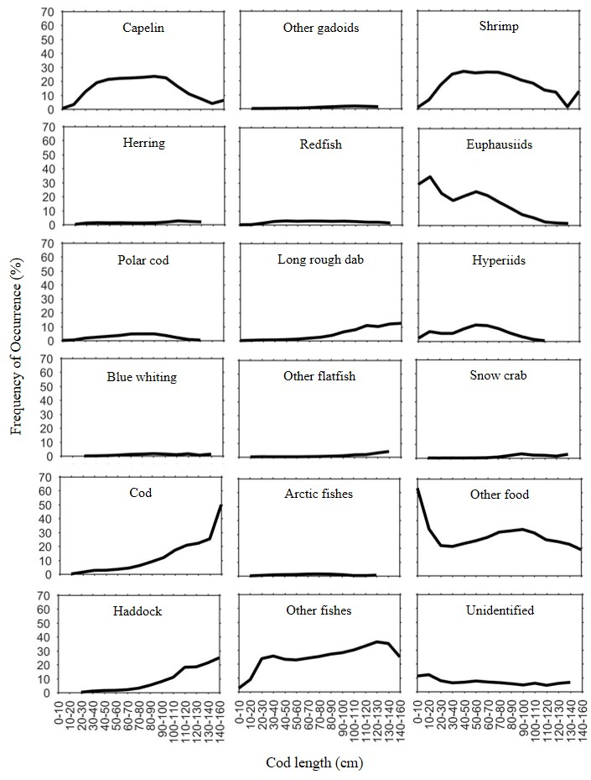
Figure 2. Percentage frequency of occurrence per species/ species group consumed across all years (1984-2016) for each cod length group.

Figure 3. Cod lengths vs Shannon-Wiener diversity index (H’) of prey composition. A larger H’ indicates higher prey species diversity in diet.
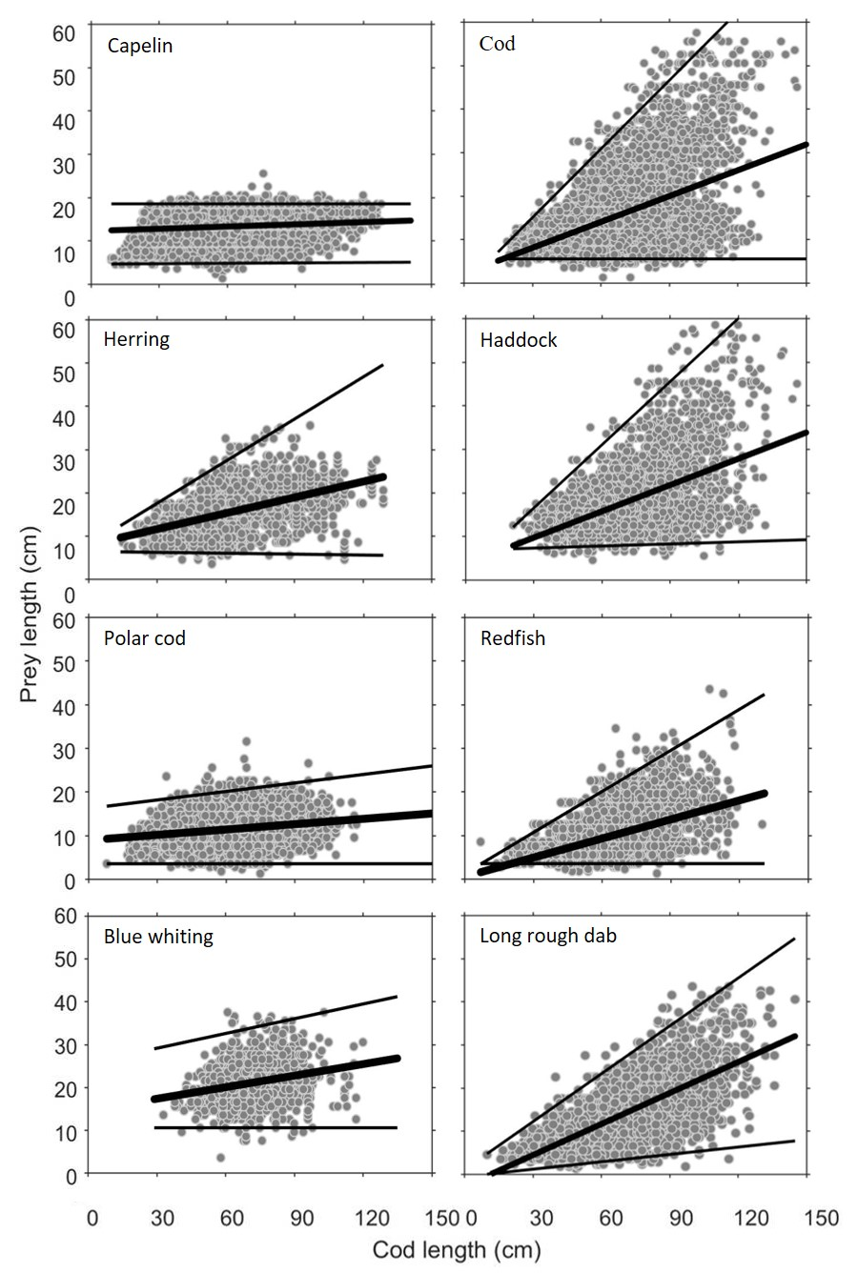
Figure 4. Cod lengths vs prey lengths (cm). Regression lines: OLS mean (thick black) and upper and lower bound quantile regressions (thin black).

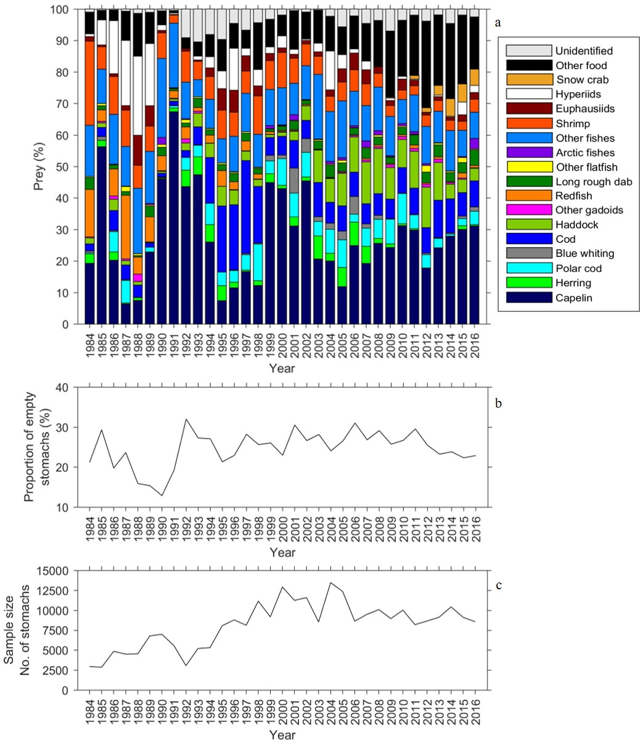
Figure 5. a) Percentage of total prey weight per species/ species group consumed by cod (all size classes) by year 1984-2016. b) Frequency of occurrence of empty stomachs per year. c) Sample size (no. of stomachs) per year (not including empty stomachs).

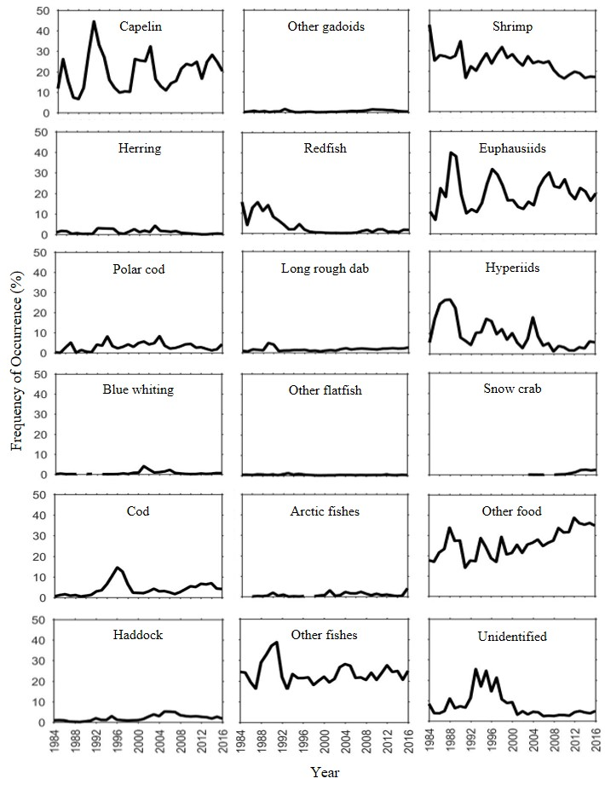
Figure 6. Percentage frequency of occurrence per species/ species group consumed by cod (all size classes) for each year 1984-2016.
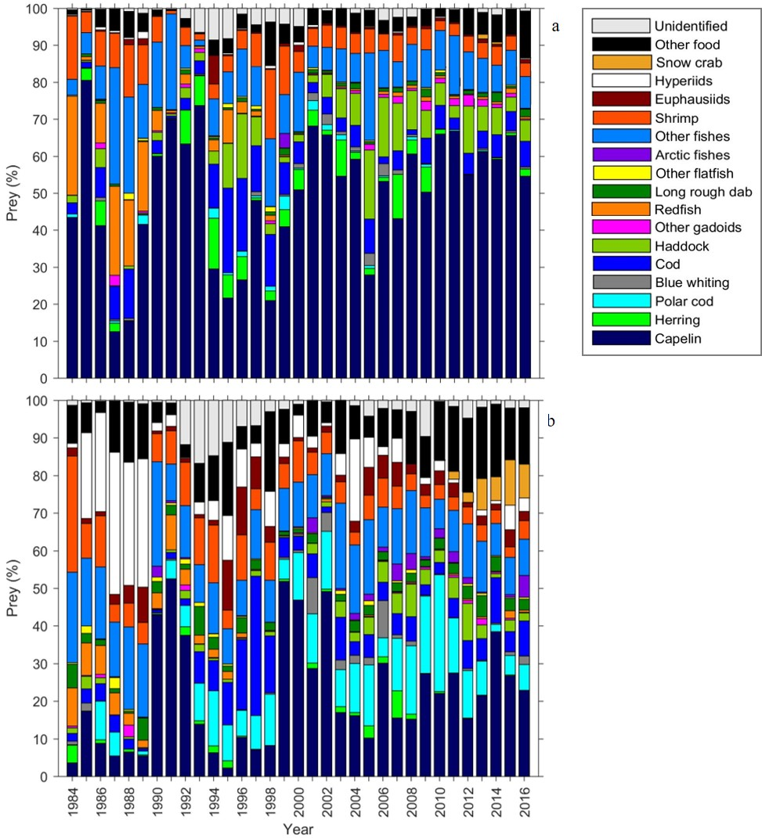

Figure 7. Percentage of total prey weight per species/ species group consumed by cod (all size classes) by year 1984-2016, in a) winter season (January to March) and b) summer/autumn season (July to October).

