Co-exposure of phenanthrene and the cyp-inducer 3-methylchrysene lead to altered biotransformation and increased toxicity in fish egg and larvae
Carey E. Donald* (a), Elin Sørhus (a), Prescilla Perrichon (b), Charlotte L. Nakken (c), Anders Goksøyr (d), Kåre B. Jørgensen (e), Philipp Mayer (f), Denis A.M. da Silva (g), Sonnich Meier (a)

* Corresponding author, carey.donald@hi.no

a Marine Toxicology, Institute of Marine Research, 5004 Bergen, Norway
b Reproduction and Developmental Biology, Institute of Marine Research, Austevoll Research Station, 5392 Storebø, Norway
c Department of Chemistry, University of Bergen, 5007 Bergen, Norway
d Department of Biological Sciences, University of Bergen, 5006 Bergen, Norway
e Department of Chemistry, Bioscience and Environmental Engineering, Faculty of Science and Technology, University of Stavanger, 4021 Stavanger, Norway
f Department of Environmental & Resource Engineering, Technical University of Denmark, 2800 Kgs. Lyngby, Denmark
g Environmental Chemistry Program, Northwest Fisheries Science Center (NOAA), Seattle, Washington, 98112 USA
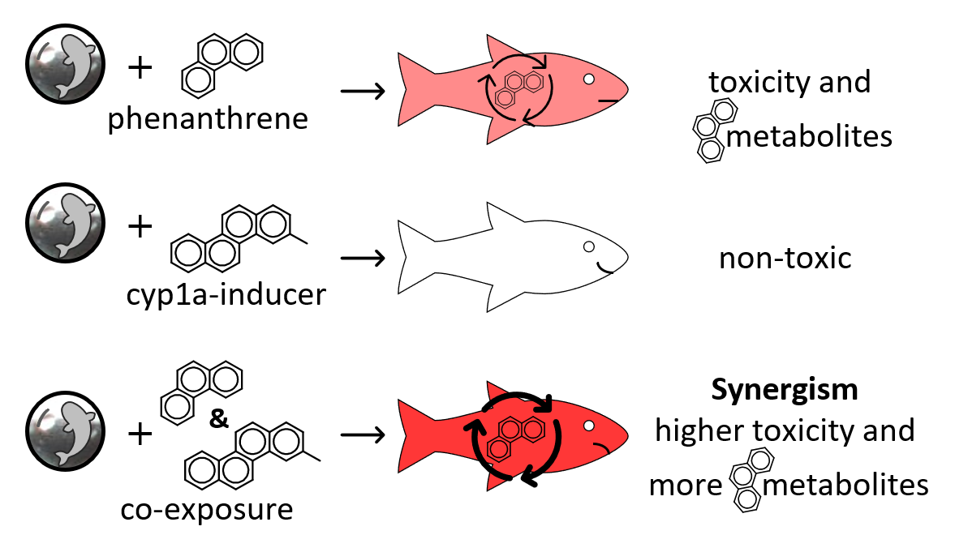

Abstract
PAHs (polycyclic aromatic hydrocarbons) have frequently been suspected of governing crude oil toxicity, because of similar morphological defects in fish. However, PAH concentrations are often not high enough to explain the observed crude oil toxicity. We hypothesize that one PAH can enhance the metabolism and toxicity of another PAH when administered as mixture. Early life stage Atlantic haddock (Melanogrammus aeglefinus) were in this study exposed to phenanthrene in presence and absence of 3-methylchrysene that is known to induce the metabolic enzyme Cytochrome P450 1A via cyp1a gene expression. Uptake, metabolism, and multiple toxicity endpoints were then measured in a time-course study up to 3 days post-hatching. Passive dosing provided aqueous concentrations ≈180 µg/L for phenanthrene and ≈0.6 µg/L for 3-methylchrysene, which resulted in tissue concentrations ≈60 µg/g ww for phenanthrene and ≈0.15 µg/g ww for 3-methylchrysene. The low concentration of 3-methylchrysene led to elevated expression of cyp1a but no toxicity. Levels of phenanthrene metabolites were 5-fold higher and morphological defects and cardiotoxicity were consistently greater when co-exposing to both compounds relative to phenanthrene alone. This work highlights the metabolic activation of PAH toxicity by a co-occurring PAH, which can lead to excess toxicity, synergistic effects and the overproportional contribution of PAHs to crude oil toxicity.

Synopsis
Co-exposure to two petrogenic PAHs in early life stage fish leads to altered biotransformation and synergistic toxicity.

Keywords
mixture toxicity, crude oil, cyp1a, early life stage fish, alkyl-PAHs, haddock, metabolism

Introduction
PAHs (polycyclic aromatic hydrocarbons) have frequently been suspected to be the leading toxicants in crude oil.¹ These compounds, composed of two or more aromatic rings, can induce toxicity through several mechanisms of actions. In early life stages of fish, exposures to crude oil lead to spinal and craniofacial deformities, edema, cardiotoxicity, and mortality.²⁻⁴ Sublethal effects incurred from low level oil exposures at the larval stage can lead to delayed mortality in later life stages.⁵⁻⁷ In Atlantic haddock (Melanogrammus aeglefinus), delayed mortality from sublethal effects occur at concentrations as low as 10 µg oil/L.⁷
Biotransformation of exogenous chemicals like those in crude oil is initiated by the aryl hydrocarbon receptor (Ahr) which acts as a xenobiotic receptor.⁸ Binding with Ahr leads to increased expression of genes that code for metabolic enzymes in the cytochrome P450 1 (Cyp1) family.⁹ When early life stages of fish are exposed to crude oil, cyp1a gene expression correlates closely with developmental toxicity and the PAH content both in the exposure medium and in the organism.¹⁰⁻¹² PAHs with 4-6 rings are potent Ahr agonists that therefore induce cyp1a expression and their own metabolism, while non-substituted 2- and 3-ring PAHs are less active as Ahr agonists.¹³
Biotransformation primarily serves a protective role by starting the process of elimination of oil compounds.¹⁴ Cyp enzymes contribute to Phase I metabolism via oxidation, with further oxidation by epoxide hydroxylase.¹⁵ Phase II involves conjugation to further increase water solubility for effective removal through the urinary and digestive tracts.¹⁶ Phenanthrene, a 3-ring PAH, and examples of its phase I and II metabolites are shown in Figure 1. Despite biotransformation being primarily protective, it can bioactivate compounds instead of detoxifying. Hydroxylated PAH metabolites are reported to be more toxic than their unsubstituted PAH in developing fish,¹⁷⁻¹⁹ via oxidative damage and binding to DNA.²⁰⁻²²
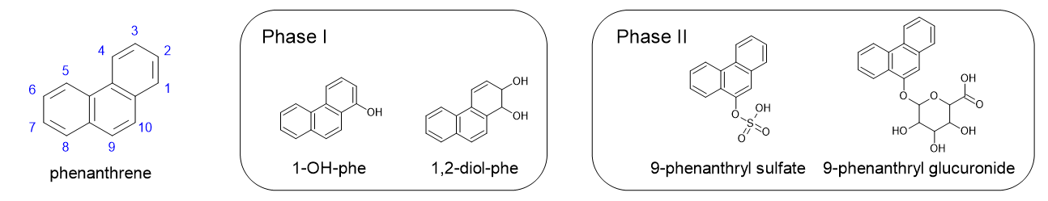
Figure 1. Phenanthrene and examples of phase I and II metabolites. Numbers on phenanthrene indicate the substitution positions. Examples of phase I metabolites include 1-hydroxyphenanthrene (1-OH-phe) and 1,2-dihydroxy-1,2-dihydro-phenanthrene (1,2-diol-phe). Examples of phase II metabolites include 9-hydroxyphenanthrene conjugated with sulfate and glucuronide.
Phenanthrene, as the prototypical 3-ring PAH, is of special interest for several reasons. First, phenanthrene has low affinity to Ahr unlike larger PAHs. Therefore, phenanthrene does not readily induce its own metabolism^{23, 24} even though it is a good substrate for Cyp1a. Second, phenanthrene impacts heart development and function in developing fish.²⁵⁻²⁸ Third, bioconcentration of phenanthrene is less kinetically limited due to its moderate physicochemical properties that give it higher water solubility and a faster uptake rate into biota, compared to larger 4-6 ring PAHs.²⁹ As a result, phenanthrene is major contributor to tissue burden in fish exposed to moderately weathered oil,³ along with alkylated PAHs which dominate in petroleum sources.³⁰ Finally, there is a discrepancy in potency of phenanthrene when it is administered individually compared to the summed levels of PAHs purported to cause toxicity in crude oil.^{1, 23} PAHs make up less than 2% of crude oil, by weight.^{31, 32} If 3-ringed PAHs and alkylated PAHs should continue to be considered the main toxicants in oil, then synergistic effects are needed to account for the discrepancy between effect doses. In this work, a synergistic effect is defined as mixture toxicity that exceeds the expected effect based on concentration additivity.^{33, 34}
In any environmental exposure, an organism is simultaneously exposed to multiple chemicals and stressors. Mixture effects will occur when one or more components modulate the toxicity of other components. A change in metabolism is one proposed mechanism for mixture toxicity.³⁵ For example, altering Cyp1a activity can change the relative abundance of (toxic) metabolites formed, thereby also altering toxicity.^{19, 36} Hawkins, et al. (2002)²⁴ demonstrated that phenanthrene toxicity increases when co-exposed with the model Cyp1a-inducing compound β-naphthoflavone. However, no previous study has documented that a co-occurring, crude oil PAH can change the metabolism and toxicity of phenanthrene.
In this work, we compare the effects of phenanthrene when administered alone and when co-administered with a Cyp1a-inducing PAH also found in crude oil. We hypothesized that 3-methylchrysene (an alkylated, petrogenic, Cyp1a-inducing, 4-ring PAH) can change the metabolism and increase the toxicity of phenanthrene when administered as mixture. The test species is Atlantic haddock, an ecologically and economically important fish that spawns in proposed areas for petroleum production offshore from Norway. The present study used passive dosing for controlled exposures to fertilized eggs. Responses in early life stage fish were measured in a time-course study of uptake and metabolism, with functional and morphometric toxic endpoints measured after hatching. This work documents a specific synergistic mixture effect that can help explain why effective doses of PAHs are lower when part of complex mixtures.

Materials and Methods

Chemicals
Translucent silicone rod with an outer diameter of 3 mm was custom made by Altec Extrusion (Saint Austell, UK). Solvents were chromatography grade or better: methanol (Chromasolv, Honeywell, Seelze Germany) and dichloromethane and n-hexane (Suprasolv/Supelco, Darmstadt, Germany). Phenanthrene was purchased from Sigma Aldrich (St. Louis, USA), and 3-methylchrysene was synthesized at the University of Stavanger.³⁷ Standards for seven phenanthrene metabolites were purchased from Chiron AS (Trondheim, Norway): 1-, 2-, 3-, 4-, and 9-hydroxyphenanthrene (OH-phe), trans-1,2-dihydroxy-1,2-dihydrophenanthrene (1,2-diol-phe), and trans-9,10-dihydroxy-9,10-dihydrophenanthrene (9,10-diol-phe). Phenanthryl-9-O-glucuronide was purchased from Chiron AS. Deuterium-labelled internal standards phenanthrene-d10 and bisphenol-A-d16 (Chiron AS) were used in gas chromatography analysis and liquid chromatography, respectively. Glassware used for gas chromatography samples was heated to 450 ℃ overnight before use.

Exposure preparation
Passive dosing with silicone rods was used to control PAH exposures.³⁸ The rods were cleaned by soaking overnight one time in methanol and two times in ultrapure water. 70 grams of silicone (diameter of 3 mm, surface area of 360 cm²) was used for each 4-L test beaker. They were stored in water, air-dried, and then loaded by equilibrium partitioning from a methanol solution containing one or both PAHs at ≈ 6 mg phenanthrene/mL and ≈ 0.3 mg 3-methylchrysene/mL. The silicone was allowed to dry at room temperature and then wiped with lint-free tissue to remove any residual solid chemical. The loaded rods were placed overnight in ultrapure water to remove residual methanol, which was then replaced with 2 L of autoclaved seawater that was allowed to pre-equilibrate at 8 °C for 4 days. This loading and dosing procedure required a minimum of neat compound, produced less waste, and provided controlled freely dissolved PAH concentrations.

Embryonic haddock exposures
Fertilized eggs were collected from broodstock of Atlantic haddock at the Institute of Marine Research’s Austevoll Research Station, Norway. Following 2.5 days’ incubation (early gastrulation stage) at 7 ± 2 °C, approximately 800 eggs were added to each of four treatment jars: Control; PHE (phenanthrene); 3-MC (3-methylchrysene; and Combo (both phenanthrene and 3-methylchrysene). The exact number of eggs was noted. Exposures lasted for 72 hours, from 2.5 day (25-50% epiboly) to 5.5 days post-fertilization (cardiac cone, 20 somite stage) when they were transferred to clean, autoclaved seawater and allowed to hatch. This exposure window was selected because it matches several previous haddock exposures,^{11, 23, 39} and it was identified as the more sensitive window to oil exposures compared to later in egg stage.³⁹ Dead eggs were removed and counted. Samples for PAH tissue content analysis (2 x 10 eggs), cyp1a expression (3 x 10 eggs), and phenanthrene metabolite analysis (1 x 10 eggs) were collected at 0, 12, 24, 48, 72, 84, 96, 120, and 144 h post-exposure start; all collected samples were in the egg stage, before hatch. Hatching occurred between 10-11 days post-fertilization, or approximately 200 hours post-exposure start. Finally, at three days post-hatch, we assessed morphological endpoints of the larvae using microscopy.

Analytical chemistry
Samples for determining PAH concentrations in water (1.0 mL) were collected in duplicate at 0, 12, 24, 48, and 72 hours and extracted with dichloromethane as described in Donald, et al. (2023)²³. Samples of eggs for tissue content analysis were extracted with 1:1 n-hexane:dichloromethane after Sørensen, et al. (2016)⁴⁰. Phenanthrene and 3-methylchrysene concentrations in water and PAH tissue samples were analyzed with GC-MS/MS as described in Sørensen, et al. (2016)⁴¹ using an Agilent 7890 gas chromatograph/7010c triple quadrupole mass detector. The average mass of one haddock egg, 2.18 mg²³ was used to convert tissue content samples to a wet weight basis (see discussion in Results and Discussion).
Metabolite samples were extracted using methanol as described in da Silva, et al. (2022)⁴². The extracts were split, and half were subjected to enzymatic hydrolysis before quantitative analysis for 7 target phase I metabolite compounds using LC-MS/MS with an Agilent 1290 Infinity liquid chromatography system/electrospray ionizer/6460 triple quadrupole mass spectrometer. For the four samples from the 144 h time point (one from each Control, PHE, 3-MC, and Combo), the non-hydrolyzed portion was screened for phase II metabolites using a Waters Vion travelling wave ion mobility-QTOF-MS. MS responses were compared among treatments in lieu of quantification as standards were not available. Positive detections were confirmed if they met three criteria; mass accuracy of molecular ion [M-H]⁻< 3 ppm, presence of conjugate loss fragment, and no detection in the Control sample and reagent blanks. Instrumental details for all three instrument systems are provided in Supporting Information.

Gene expression of cyp1a
Three samples of 10 eggs were collected from each treatment and timepoint for RNA extraction and real time quantitative PCR. Methods for RNA extraction, cDNA synthesis, and real time quantitative PCR are provided in Supporting Information and Table S3. Transcript abundance values for cyp1a were normalized to the geometric mean of the housekeeping genes (ef1a and rxrba), then normalized to the mean of Control at 0 h. Internal standard responses were within parameters.

Microscopy
Thirty larvae from each treatment were immobilized in 3% methylcellulose for imaging three days after hatching. Images of the whole larval body were collected at 1.6x magnification, and lateral craniofacial images at 6.3x, both in left lateral position. Temperature was maintained at 8 °C with a thermally regulated microscope stage. Cardiac function and morphology were recorded with a 20-second video in ventral position at 6.3x magnification.
The following measurements were made from images: eye size (area), eye-to-nose (ethmoid plate) distance, jaw length, finfold area, standard length, yolk area, and total yolk area (area of yolk including adjacent edema). Yolk sac edema (%) was calculated (total yolk– yolk)/total yolk. Three eye phenotypes were noted, in increasing severity from Normal eye shape (circular or one protrusion from circle), to Eye bulky (two or more protrusions from circular), and Lens out.⁴³ Facial phenotypes were assigned following Sørhus, et al. (2016)⁴, including Normal, Bulldog (reduced upper jaw), Jawbreaker (posteriorly displaced jaw), and Hunchback (severe reduction of jaw structures). Body axis phenotypes were assigned as Normal spine shape, Scoliosis, Lordosis, and/or Curvature.
Cardiac measurements were made from still images of the heart videos. Maximum widths of the atrium and ventricle were measured during systole and diastole. Fractional shortening (FS, %) was calculated in both atrium and ventricle; (diastole width-systole width)/diastole width. “Silent ventricle” and “silent atrium” were noted if FS was less than 1%. The area of the ventricle at diastole was also measured, and heart rate (beats per minute) was counted.

Statistics
Water concentrations from passive dosing are intended to be constant over time, so replicates were pooled (n=10), and treatments were compared using two-sided t-tests. Mortality among the 4 treatments were compared using chi-squared test of independence. Toxicity results among the 4 treatments were compared with all-pairwise comparisons; non-parametric tests were used because of multiple violations of the assumptions of normality and equal variance tested with Shapiro-Wilk test and Levene’s test, respectively. We used Steel-Dwass method for all pairwise comparisons of endpoints with continuous data, e.g. eye area and heart rate. For dichotomous data, we used Fischer’s exact test with Bonferroni post-hoc comparisons, p ≤ 0.05/m, where m=6, the number of total pairwise comparisons. For eye phenotypes, categorical data was condensed to Normal (no effect or eye bend) or Malformed (eye bulky or lens out). Categorical data facial and body axis phenotypes were first condensed to two levels, either Normal or Malformed. Statistics were performed using JMP 16 (SAS, Cary, NC, USA).

Animal welfare and permits
The Austevoll Research Station has permits issued from the Norwegian Directorate of Fisheries to catch and maintain stocks of Atlantic Haddock (H-AV 77, H-AV 78, and H-AV 79). No permits are needed for experiments with embryos and yolk sac larvae.

Results and Discussion

Exposure metrics: water concentrations
Analysis of water samples confirmed exposures in the treatment groups (Table 1). Concentrations of 3-methylchrysene were low but measurable, and they were not different between 3-MC and Combo (p = 0.83). Phenanthrene concentrations were 168 µg/L in PHE, and 203 µg/L in Combo. This minor difference was statistically significant, (p < 0.001), and it likely derives from unequal uptake efficiency during silicone loading. Concentrations of phenanthrene decreased slightly over the 72-hour exposure period (Figure S1). Background levels 3-methylchrysene in Control and PHE were below limits of detection (Table 1), but background levels of phenanthrene were detectable in both Control and 3-MC. We postulate that some phenanthrene, as a semi-volatile compound, was exchanged among the exposure jars that were kept in close proximity during silicone loading and exposures. In the control samples from 48 h, background phenanthrene concentrations were above quantitation limits (Table S5), and we suspect contamination of these samples.
Table 1. Mean concentrations of phenanthrene and 3-methylchrysene in exposure water. Values are the mean ± SD of 10 samples collected on exposure days 0-4. Grey-shaded values are background levels of compounds not part of the exposure regime. The limit of detection is 0.15 µg/L. Complete data are provided in Tables S4 and S5.
 | phenanthrene concentration in water |  | 3-methylchrysene concentration in water
Treatment | µg/L (mean ± SD) | µM (mean) | µg/L (mean ± SD) | µM (mean)
Control | 3.63 ± 8.5 | 0.020 | < 0.15 | < 0.000 62
PHE | 168 ± 14 | 0.943 | < 0.15 | < 0.000 62
3-MC | 0.50 ± 1.1 | 0.003 | 0.57 ± 0.22 | 0.002 36
Combo | 203 ± 14 | 1.143 | 0.55 ± 0.02 | 0.002 27

Exposure metrics: tissue content of phenanthrene and 3-methylchrysene
Tissue content was determined via duplicate egg samples taken at 9 time points during and after the exposure. Mean 3-methylchrysene tissue content concentrations were highest already at 12 h and remained stable over the exposure period before decreasing (Figure 2A, complete dataset in Table S6). During the 72 h exposure period, mean tissue content of 3-methylchrysene was higher in Combo (0.180 µg/g ww) than in 3-MC treatment (0.090 µg/g ww). By the end of the experiment, 3-methylchrysene had been eliminated from 3-MC, but not from Combo. The Combo treatment resulted in approximately twice as much 3-methychrysene tissue content compared to 3-MC, despite having equivalent exposure levels.
It was difficult to remove small amounts of excess water from these samples containing as few as 10 eggs. Therefore, we used the average mass of one haddock egg, 2.18 mg (relative SD = 8%) at 5 days post fertilization²³ (72 h post exposure start in the present study) to convert tissue content samples to a wet weight basis instead of weighing each sample. This error is comparable to the wet weight mass change reported in a closely related species, Atlantic cod (Gadus morhua). Fraser, et al. (1988)⁴⁴ report that the wet weight of a cod egg decreases by 9% from 3 to 9-days post fertilization (from 1.67 to 1.52 mg/egg). That is similar to the range of our sampling period from 0 to 144 hours post exposure start, spanning from 2.5 to 8.5 days post fertilization. Regardless, with this small decrease in mass as the egg develops, the true tissue concentrations may be slightly higher than what we have reported. Moreover, the lipid content changes slightly in cod, from 12.6 µg/egg at 3 days to 12.1 µg/egg at 9 days post fertilization.⁴⁴ We might expect similar changes in haddock which can affect tissue concentrations if they were to be converted to lipid weight basis.

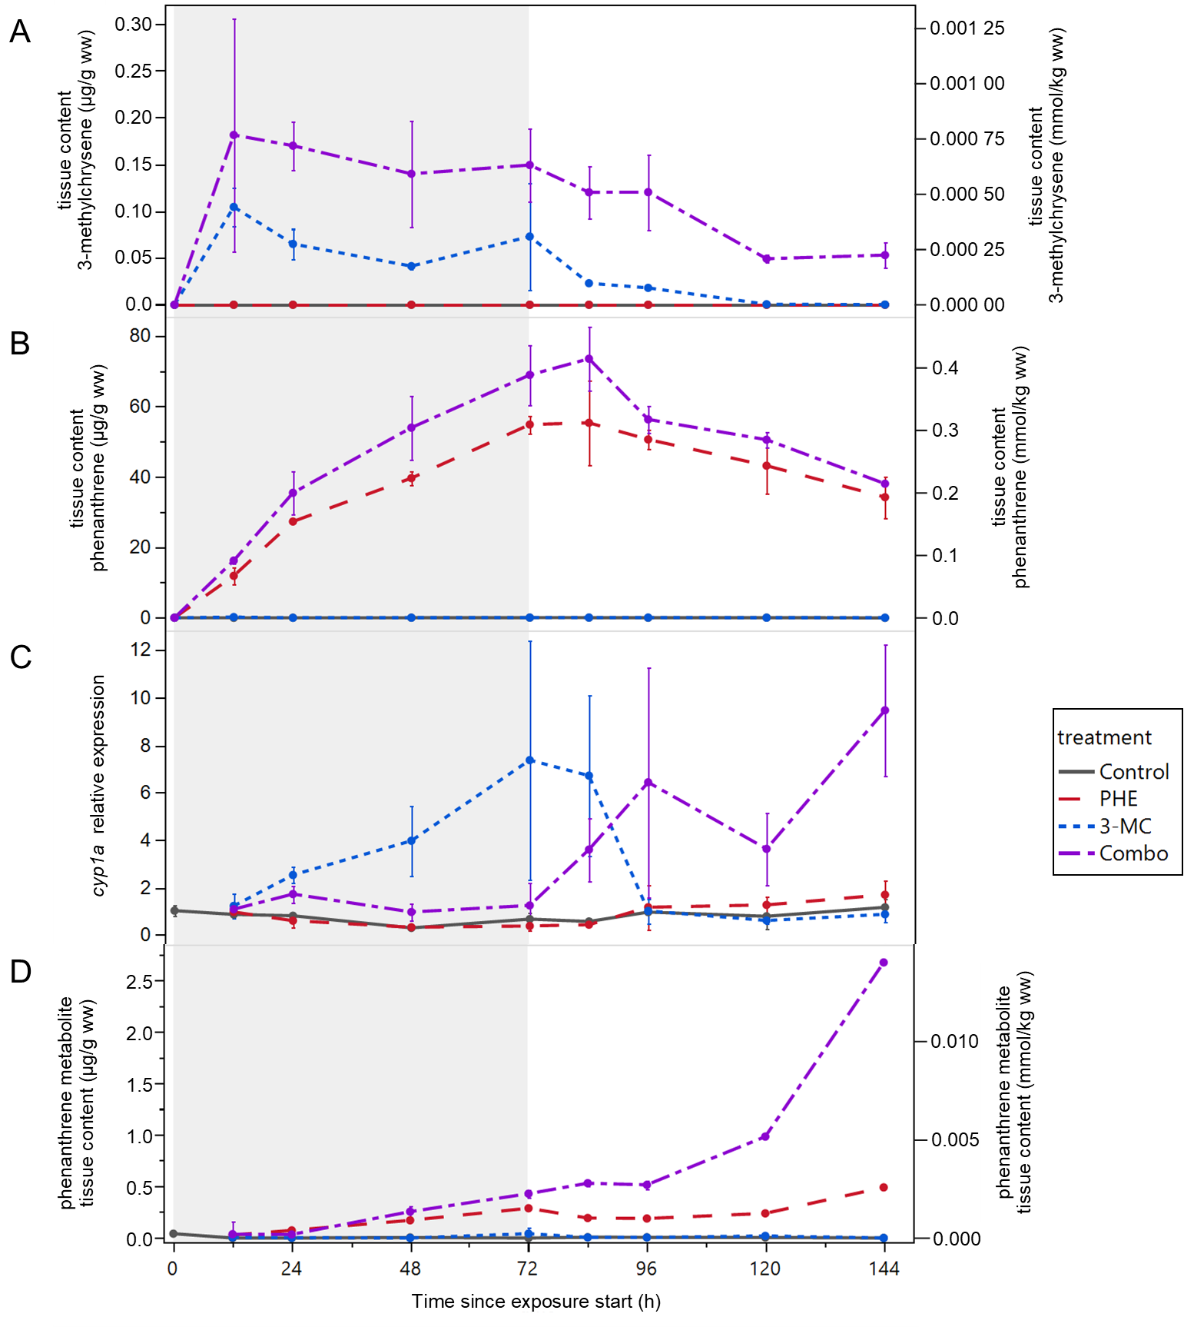
Figure 2. Exposure profiles in haddock eggs over sampling period. Tissue concentrations of (A) 3-methylchrysene and (B) phenanthrene, error bars show range, n=2. (C) Mean expression of cyp1a relative to control at 0 h, error bars are SD, n=3. (D) Sum of phenanthrene metabolites, n=1. Exposures began at 2.5 days post fertilization, and grey shading represents the 72-hour exposure period. Hatching occurred between 10-11 days post fertilization, at what would be approximately 200 h on the x-axis scale.
Tissue content of phenanthrene was increasing steadily over the exposure period with maximum levels at 84 h reaching 73 µg/g ww in Combo and 55 µg/g ww in PHE (Figure 2B, complete dataset in Table S7). The higher phenanthrene tissue content in Combo over PHE is proportional to the inadvertently higher water concentrations in Combo. The relative amounts of tissue burden are consistent with the notion of kinetically-limited bioconcentration;²⁹ phenanthrene is a smaller compound with higher water solubility and faster uptake kinetics, which led to substantially higher tissue burdens compared to 3-methylchrysene. Moreover, 3-methylchrysene can be converted to metabolites that were not included in the analyses.

Evidence of metabolic interactions: cyp1a expression
Expression of cyp1a was elevated only in the two treatments that included 3-methylchrysene: 3-MC and Combo (Figure 2C, complete dataset in Table S8). In 3-MC, the increased expression was faster, reaching its highest measured level (7.4-fold) at 144 h. Soon thereafter, cyp1a expression in 3-MC had decreased to the level of control by 96 hours, at the time that 3-methylchrysene had nearly been eliminated. In contrast, expression in Combo did not become significantly elevated until after the 72-hour exposure period; it then remained high and was increasing throughout sampling. These results suggest that the high presence of phenanthrene affected the rate at which 3-methylchrysene induced cyp1a expression (see further discussion in the next section). Neither the Control nor the PHE treatment resulted in increased expression at any time point. In a closely related species, Atlantic cod (Gadus morhua), 3-methylchrysene has been shown to be an Ahr agonist, while phenanthrene is not.⁴⁵

Metabolic interactions: tissue content of metabolites
Phase I metabolites of phenanthrene accumulated only in PHE and Combo, the two treatments that included phenanthrene (Figure 2D, complete dataset Table S9). Final tissue metabolite content in Combo was 5-fold higher than in PHE, despite having only 21% higher phenanthrene exposure. As the extracts were enzymatically hydrolyzed, the phase I metabolite quantities presented here represent a sum of phase I and hydrolyzed phase II products. The time series suggests an increasing trend past the sampling period for both Combo and PHE. While the decline in phenanthrene was similar for both PHE and Combo, only Combo demonstrated a large increase in metabolites (Figure 3).
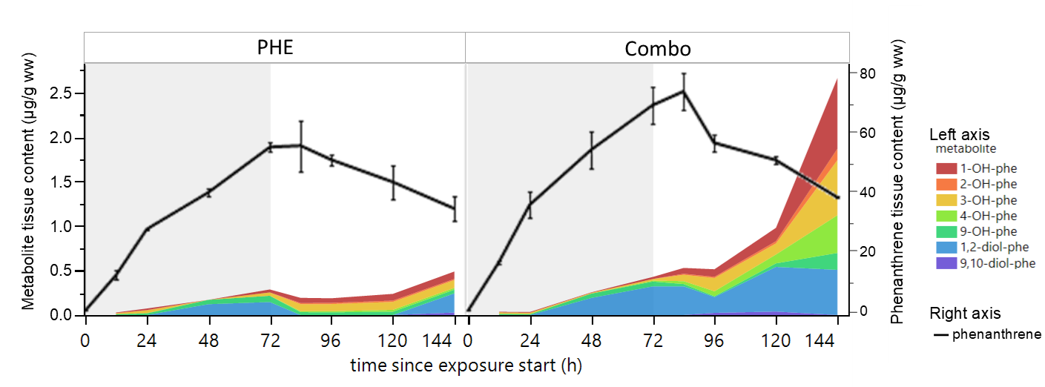
Figure 3. Profile of individually measured metabolites and phenanthrene in haddock eggs from treatments PHE (left) and Combo (right). Metabolite profile data shown here are also depicted in Figure 2D as a sum of metabolites, and the phenanthrene data are also depicted in Figure 2B. Control and 3-MC are not shown because metabolite concentrations were very low, below 0,05 µg/g ww. Exposures began at 2.5 days post fertilization, and grey shading represents the 72-hour exposure period. Hatching occurred between 10-11 days post fertilization, at what would be approximately 200 h on the x-axis scale.
Across the sampling period in both samples, the dihydrodiol 1,2-diol-phe was the most prevalent among the seven phenanthrene metabolite compounds in the hydrolyzed extracts (blue shading has the largest area in Figure 3). This finding agrees with Goksøyr, et al. (1986)⁴⁶, who report 1,2-diol-phe as the dominant metabolite in teleost fish. The dihydrodiol metabolites are formed by epoxide hydroxylase following the initial oxidation by Cyp1a.¹⁵ The contributions of the five monohydroxy-phenanthrene isomers had increased by 144 h in Combo, and account for the large increase in metabolite sum between 120 h and 144 h.
Prior to liver formation in haddock, cyp1a is mainly expressed in skin.⁴ In closely related cod, the liver starts forming at 7 days post fertilization,⁴⁷ which coincides with 130 hours post-exposure start in the present study. The increase in metabolites follows with increased metabolic capacity from the developing liver, where numerous phase I and II compounds are in high abundance,^{48, 49} although we cannot make this connection with tissue-specific analysis. Measurements of 1,2-diol-phe indicate that the epoxide hydrolase enzyme is present before liver formation.
The rate of metabolite production was different between PHE and Combo treatments. At 144 h, Combo had 5-fold higher levels of measured metabolites than PHE, much of which were made up of monohydroxy-phenanthrenes. A key difference between PHE and Combo is therefore the profile of metabolites that are formed (Figure 3). Our hypothesis was based on the idea that increased Cyp1a activity would increase the production of bioactivated, more toxic, metabolites. Our results support the idea that more metabolites were produced, but the study design does not allow for identifying which of those metabolites are most toxic.
The proportion of phenanthrene that was converted to metabolites over the sampling period was small in any treatment. The exact proportion is indeterminate because there are more metabolites beyond the seven that are commercially available and included in the quantitative analysis. Moreover, we did not measure metabolites in water, i.e. metabolites that had been eliminated from the tissue. Regardless, the highest molar amount of phase I metabolites quantified (about 0.01 mmol/kg ww at 144 h in Combo) was only 5% of the amount of phenanthrene at that time point (0.2 mmol/kg ww). This suggests that the majority of phenanthrene removal was not via Cyp1a metabolism. Instead, the concentration decline can be attributed to diffusive elimination.⁵⁰ Despite the low conversion to metabolites, tissue concentrations of phenanthrene decreased at similar rates in both PHE and Combo after being moved to clean water. The embryos depurated phenanthrene after they had moved to clean water, in a similar way as the silicone used as a passive dosing source during exposure. If this experiment were to be repeated, we would recommend collecting water samples even after transfer to clean water to characterize the diffusive loss of phenanthrene.
The presence of the Cyp1a-inducer 3-methylchrysene affected the timing of biotransformation. By 120 h in the 3-MC treatment, 3-methylchrysene was eliminated (Figure 2A) and cyp1a expression levels had returned to control levels (Figure 2C). In Combo however, cyp1a expression increased later, and 3-methylchrysene remained in the tissue even at 144 h. This finding suggests that the high presence of phenanthrene in Combo both a) slowed 3-methylchrysene from inducing cyp1a expression and b) slowed the elimination of 3-methylchrysene enzymes. This theory is supported by Lille-Langøy, et al. (2021)⁴⁵ who report that one of phenanthrene’s metabolites, 1-2-diol-phe, has some Ahr agonist activity, whereas phenanthrene itself may even be a (partial) antagonist. Both the parent phenanthrene and the metabolite can thus bind to the Ahr binding site, preventing the majority of stronger agonist 3-methylchrysene from binding and inducing cyp1a. At 144 h in Combo, for example, the molar ratio of phenanthrene to 3-methylchrysene in tissue was 920:1. We speculate that the lingering 3-methylchrysene kept the cyp1a expression at an elevated level for longer, which is associated with a higher Cyp1a activity and production of phenanthrene metabolites in Combo. Instead of one PAH increasing the biotransformation of the other as we hypothesized, the two compounds appear to have affected each other.

Screening for phase II metabolites
Extracts from 144 h representing phase II metabolites were also screened on a high- resolution mass spectrometry instrument. Sulfate and glucuronide conjugates had mostly higher response in Combo than in PHE (Table 2), a trend that follows the quantitative data of the phase I metabolites. The higher rate of phase II formation in Combo follows with the phase I metabolites, the developing liver, and the high cyp1a expression that results from the sustained 3-methylchrysene tissue content. With only single samples, there is not enough information to make conclusions about the relative contributions of sulfate- or glucuronide-conjugates, nor how and if phase II enzymes were affected by the treatments.
The amounts of phase II metabolites were not specifically quantified in the present study, and we report mass spectrometry (MS) responses for comparative purposes. Evidence for multiple isomers of each candidate phase II metabolite was seen both with multiple chromatographic peaks with unique retention times, and with multiple collision cross section values from ion mobility spectrometry (Table S10 and Table S11). The isomers are likely structural isomers, i.e., where the conjugation occurs at different positions on the phenanthrene molecule. The identity of the isomers could not be elucidated with low responses in these samples and the lack of analytical standards. Samples were also screened for phase II metabolites of 3-methylchrysene, as well as conjugates of glutathione and mercapturic acid, although none were detected; see comments in Supporting Information.
Table 2. Sum of MS responses of phase II metabolites of phenanthrene in haddock eggs at 144 h. Phase II metabolites were more abundant in Combo than in PHE. No peaks were detected in Control and 3-MC, as indicated by nd. Responses for each candidate compound are reported as the sum of all isomers.
 |  |  | MS responses by Treatment
Phase II metabolite | Formula | Phase I derivative | Control | PHE | 3-MC | Combo
Phenanthrene-O-glucuronide | C₂₀H₁₈O₇ | hydroxy-phenanthrenes | nd | 1469 | nd | 2985
Hydroxy-dihydrophenanthrene-O-glucuronide | C₂₀H₂₀O₈ | phenanthrene-dihydrodiols | nd | 5566 | nd | 15988
Phenanthrene sulfate | C₁₄H₁₀O₄S | hydroxy-phenanthrenes | nd | 5528 | nd | 6678
Hydroxyphenanthrene sulfate | C₁₄H₁₀O₅S | dihydroxy-phenanthrenes (diol) | nd | 267 | nd | 1580

Developmental toxicity
Toxicity was greatest in Combo followed by PHE, while no toxicity was observed in 3-MC (Figure 4). Phenanthrene alone caused toxicity, including reduced eye size, jaw length, body length, and ventricle size, along with higher prevalence of body axis deformities (Table 3). All these endpoints were also observed in Combo, in addition to three additional endpoints: shorter eye-nose distance, higher incidence of craniofacial deformities, and higher incidence of silent ventricle. Of the eight significant endpoints in Combo, four were also significant in PHE, but even more severe in Combo (Table 3). Full datasets are available in Figures S3-S10 and Table S12. It should be noted that some endpoints may be intuitively related and therefore correlated, for example standard length and body axis deformity, or ventricle FS and silent ventricle, however we did not formally evaluate these possible correlations. Mortality at 72 h was slightly, yet significantly different among the treatments: 19% in Control, 25% in PHE, 24% in 3-MC, and 17% in Combo; Χ²(3, N=1994) = 13.0, p = 0.005. These mortality rates are artificially inflated, because these data only include the 400-500 eggs in each treatment that had not been sampled by 72 h. Only living eggs (that were floating and non-opaque) were removed during sampling, thus creating a bias towards apparent higher mortality in the remaining eggs at 72 h.
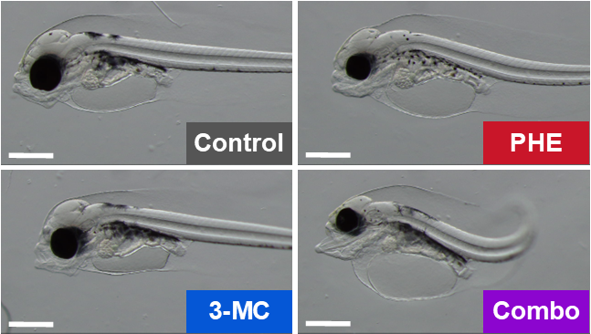
Figure 4. Example microscopy images of haddock larvae from the four treatments at 3 days post hatch. Compared to control, PHE exhibits smaller eye, shorter jaw, and a body axis deformity. 3-MC is similar to control. Combo exhibits smaller eye, and severe craniofacial and body axis deformities. Scale bars are 0.5 mm.
Table 3. Overview of developmental endpoints observed in exposed haddock larvae at 3 days post-hatch. Treatments not connected by the same letter for an endpoint are significantly different. Differences from control are also highlighted with colors: white is not different from control, orange indicates a significant change from Control, and red indicates that the Combo effect was more severe than that caused by PHE alone. Values are mean ± SD for continuous endpoints and connecting letters with pairwise comparisons via Steel-Dwass method. Categorical count data are indicated with *; values are percentage of incidence and connecting letters with pairwise comparisons via Fisher’s exact test with Bonferroni correction for categorical counts, m=6.
Endpoint | Control |  | PHE |  | 3-MC |  | Combo
Eye area, mm² | 0.085 ± 0.011 | A | 0.074 ± 0.013 | B | 0.082 ± 0.012 | A | 0.062 ± 0.014 | C
Eye-to-nose length, µm | 188 ± 23 | AB | 170 ± 36 | BC | 187 ± 43 | A | 159 ± 36 | C
Jaw length, µm | 429 ± 48 | A | 377 ± 67 | B | 419 ± 91 | A | 366 ± 81 | B
Jaw angle, ° | 128 ± 9 | AB | 134 ± 11 | B | 125 ± 8 | A | 135 ± 11 | B
Eye deformity* | 6.5% | A | 17% | A | 6.6% | A | 20% | A
Facial deformity* | 0% | A | 10% | A | 10% | A | 47% | B
Finfold, µm² | 1210 ± 426 | AB | 1310 ± 465 | A | 1190 ± 519 | AB | 912 ± 619 | B
Standard Length, µm | 1160 ± 58 | A | 1090 ± 119 | B | 1130 ± 145 | A | 1030 ± 112 | C
Yolk sac edema, % | 19 ± 7 | A | 21 ± 6 | A | 21 ± 5 | A | 18 ± 6 | A
Body axis deformity* | 3,2% | A | 31% | B | 10% | AB | 77% | C
Atrial FS, % | 20 ± 4 | A | 19 ± 8 | A | 21 ± 6 | A | 21 ± 6 | A
Ventricle FS, % | 16 ± 5 | A | 15 ± 7 | A | 15 ± 5 | A | 10 ± 9 | A
Silent atrium* | 0% | A | 0% | A | 0% | A | 0% | A
Silent ventricle* | 3.4% | A | 6.9% | A | 6.7% | A | 36% | B
Ventricle area, µm² | 9760 ± 1520 | A | 8240 ± 1990 | B | 9680 ± 2240 | AB | 6060 ± 1930 | C
Heart rate, BPM | 87 ± 10 | A | 90 ± 12 | A | 88 ± 14 | A | 88 ± 12 | A
Some cardiotoxicity was observed in PHE but was more severe in Combo. In particular, the ventricle was smaller in PHE, and even smaller in Combo. Functional effects were seen only in Combo, where we observed an increase in the incidence of silent ventricle. Phenanthrene has a documented, acute effect on contractility.^{27, 28} This effect is reversible, and contractility can return after phenanthrene is no longer present in the tissue.^{51, 52} Conversely, circulation effects can lead to downstream malformations that prevent the cardiac function from returning after the toxicant is depleted.²⁵ We measured tissue content in the present study throughout exposure and for three days following, but we do not have measures of tissue content when endpoints were assessed with microscopy. Therefore, we cannot conclude whether the functional cardiac defects are an acute effect of lingering phenanthrene; or if they are a result of irreversible phenanthrene-induced developmental abnormalities.
The increased response in Combo could be attributed to the higher presence of metabolites and/or the different metabolite profile. The present study design cannot address which is occurring. Exposure-response studies of individual metabolites will inform which metabolite(s) were most potent, although mixture effects among metabolites themselves should be considered too. There are several published reports on the toxicity of phenanthrene’s phase I metabolites. Schrlau, et al. (2017)¹⁷ screened several hydroxy-and dihydroxy-phenanthrenes in zebrafish and report effective concentrations (EC₅₀) between 0.0004 and 0.0056 mM, while phenanthrene was not toxic up to 0.06 mM. In another screen Fallahtafti, et al. (2012)¹⁹ report that the position of substitution on phenanthrene affects toxicity; that the relative sensitivities among metabolites vary by endpoint; and that several metabolites have lower effect levels than phenanthrene. One of the five possible hydroxylated metabolites, 9-OH-phe (also called 9-phenanthrol), has a specific mechanism and is frequently used in pharmacological research as an ion channel inhibitor.⁵³ We do not have waterborne concentrations for a direct comparison, but quantitative data from this study suggest correlations among the common phase I metabolites, cyp1a expression, and increased toxicity.
The potential toxicity of PAH metabolites has also been described more generally. Hydroxylated metabolites like those measured in this study are further oxygenated to form epoxides and diol-epoxides. These reactive compounds can cause toxicity through oxidative damage and by binding to proteins and DNA.^{24, 54} Phase II metabolites with sulfate conjugates can lead to DNA damage through the formation of DNA adducts via the benzylic sulfonation pathway; this has been demonstrated with 1-methylpyrene, a 4-ring PAH.^{21, 55}

Mixture toxicity: evidence of synergism
The phenanthrene in the PHE treatment led to some toxicity, while the 3-methylchrysene in 3-MC was non-toxic. Yet, when those doses were combined in Combo, the number and severity of endpoints were greatly increased. This experiment was a component-based approach⁵⁶ designed to mimic a situation where the mixture toxicity cannot be explained by concentration addition. In this study, the amount of 3-methylchrysene in tissue was negligible, at less than 1% of the amount of phenanthrene. A synergistic mixture effect is documented when the toxic response is more extreme that what could be assumed from additivity.^{33, 34} A complete exposure-response curve is not available for mathematically evaluating additivity in the present work, because the two PAHs were administered each at only one concentration. Regardless, the Cyp1a-inducer 3-methylchrysene contributed a negligible amount to the tissue burden in Combo, so we would also expect only a negligible increase in toxicity under the assumption of concentration additivity. Instead, the marked increase in toxicity is evidence for synergism beyond concentration additivity.
The toxicity of PAHs is linked to their rapid metabolism and the wide range of metabolites with varying toxicity through diverse mechanisms.³⁵ As with non-metabolized PAHs, the toxicity of the metabolites can vary greatly among structural isomers.⁴⁹ Phenanthrene is specifically known to be cardiotoxic.^{14, 27, 28, 57} Geier, et al. (2018)⁵⁸ demonstrate that the PAHs and/or their metabolites had different modes of action using a simple mixture of PAHs, but they could not mathematically reject the hypothesis of concentration addition. In another recent binary PAH exposure, Eriksson, et al. (2022)⁵⁹ observed changes in gene expression related to metabolism that related to the resulting body burdens. Our results contribute by demonstrating that the addition of a Cyp1a-inducing compound alters the toxic outcome of phenanthrene, perhaps through the formation of a different metabolite profile.
The synergistic effect we observed may have a threshold level.⁶⁰ For example, it is also possible to have dose-dependent mixture effects, e.g. synergism at low doses, but additivity at higher doses.³³ Synergism and additivity cannot be thoroughly investigated in a study design with only a single exposure level. Our present findings are also distinct from the concept of “solubility addition” presented by Smith, et al. (2013)⁶¹ because both substances were dosed below their respective solubility level.
A limitation of this work is the lack of biological replication. With a limited supply of the synthesized 3-methylchrysene, we could either do a time-course study to show trends over time or have more replication with only one or a few timepoints, but not both. We believed the time course study would provide interesting insights into mechanisms of toxicity, and Figure 2 shows those trends. The initial number of eggs in each jar (800) was enough for nine sampling points, plus a 33% buffer for mortality. We recommend in future experiments showing this interactive effect, that fewer timepoints can be used in lieu of higher replication and an extra focus on the metabolic activity through gene expression, protein activity, and metabolite quantitation.
In conclusion, adding the exposure of a negligible, non-toxic amount of a Cyp1a-inducing PAH with phenanthrene led to altered biotransformation, the formation of more metabolites, and higher developmental toxicity. Except for the simplicity of the two-component mixture, this exposure is environmentally realistic in that we used naturally co-occurring compounds at concentrations well below solubility. The results document evidence for a specific synergistic effect between the two selected waterborne, petrogenic PAHs. The results support previous findings for synergistic effects involving Cyp1a, PAHs, and model compounds that affect Cyp1a.^{24, 35} It is only one example of the multitude of mixture effects that are likely present in exposures to complex mixtures like crude oil. With toxic interactions occurring in even the simplest of mixtures among petroleum compounds, it is doubtful that the toxicity of a petroleum mixture can be modelled by considering the individual contributions of thousands of compounds. We recommend that further studies in understanding crude oil toxicity focus on assessing the whole mixture, for example effect-directed analysis, as well as identifying more compounds, specific biomarkers, and the strongest mixture effects.

Supporting Information
Analytical details for GC and LC methods and cyp1a expression; complete and summarized datasets for water, tissue content, cyp1a expression, phenanthrene metabolites, and toxicity assessments.

Acknowledgements
The authors wish to thank Alysha Cypher and Mathias Brevik for help in data collection and analysis.

Author information
experimental design: SM, CED, ES, PM; chemical synthesis: KBJ; microscopy analysis: ES, PP, CLN, CED; qPCR and chemical analysis: ES, CLN, CED, DdS; interpretation: CED, ES, CLN, AG, PM, SM; writing: all authors

Funding information
The work was funded by the Research Council of Norway (EGGTOX: Unraveling the mechanistic effects of crude oil toxicity during early life stages of cold-water marine teleosts, Project # 267820) and the Institute of Marine Research, Norway. The funders had no role in study design, data collection, analysis, preparation of manuscript, or the decision to publish.

Declaration of competing interests
The authors declare no competing financial interests.

References
1. Meador, J. P.; Nahrgang, J., Characterizing Crude Oil Toxicity to Early-Life Stage Fish Based On a Complex Mixture: Are We Making Unsupported Assumptions? Environ Sci Technol 2019, 53, (19), 11080-11092.
2. Carls, M. G.; Rice, S. D.; Hose, J. E., Sensitivity of fish embryos to weathered crude oil: Part I. Low-level exposure during incubation causes malformations, genetic damage, and mortality in larval pacific herring (Clupea pallasi). 1999, 18, (3), 481-493.
3. Barron, M. G.; Carls, M. G.; Heintz, R.; Rice, S. D., Evaluation of fish early life-stage toxicity models of chronic embryonic exposures to complex polycyclic aromatic hydrocarbon mixtures. Toxicol. Sci. 2004, 78, (1), 60-7.
4. Sørhus, E.; Incardona, J. P.; Karlsen, Ø.; Linbo, T.; Sørensen, L.; Nordtug, T.; van der Meeren, T.; Thorsen, A.; Thorbjørnsen, M.; Jentoft, S.; Edvardsen, R. B.; Meier, S., Crude oil exposures reveal roles for intracellular calcium cycling in haddock craniofacial and cardiac development. Sci. Rep. 2016, 6, 31058.
5. Hicken, C. E.; Linbo, T. L.; Baldwin, D. H.; Willis, M. L.; Myers, M. S.; Holland, L.; Larsen, M.; Stekoll, M. S.; Rice, S. D.; Collier, T. K.; Scholz, N. L.; Incardona, J. P., Sublethal exposure to crude oil during embryonic development alters cardiac morphology and reduces aerobic capacity in adult fish. Proc. Natl. Acad. Sci. U. S. A. 2011, 108, (17), 7086-90.
6. Laurel, B. J.; Copeman, L. A.; Iseri, P.; Spencer, M. L.; Hutchinson, G.; Nordtug, T.; Donald, C. E.; Meier, S.; Allan, S. E.; Boyd, D. T.; Ylitalo, G. M.; Cameron, J. R.; French, B. L.; Linbo, T. L.; Scholz, N. L.; Incardona, J. P., Embryonic Crude Oil Exposure Impairs Growth and Lipid Allocation in a Keystone Arctic Forage Fish. iScience 2019, 19, 1101-1113.
7. Sørhus, E.; Sørensen, L.; Grøsvik, B. E.; Goff, J. L.; Incardona, J. P.; Linbo, T. L.; Baldwin, D. H.; Karlsen, Ø.; Nordtug, T.; Hansen, B. H.; Thorsen, A.; Donald, C. E.; Meeren, T. v. d.; Robson, W.; Rowland, S. J.; Rasinger, J. D.; Vikebø, F. B.; Meier, S., Crude oil exposure of early life stages of Atlantic haddock suggests threshold levels for developmental toxicity as low as 0.1 μg total polyaromatic hydrocarbon (TPAH)/L. Mar. Pollut. Bull. 2023, 190, 114843.
8. Billiard, S. M.; Hahn, M. E.; Franks, D. G.; Peterson, R. E.; Bols, N. C.; Hodson, P. V., Binding of polycyclic aromatic hydrocarbons (PAHs) to teleost aryl hydrocarbon receptors (AHRs). Comparative Biochemistry and Physiology Part B: Biochemistry and Molecular Biology 2002, 133, (1), 55-68.
9. Fujii-Kuriyama, Y.; Mimura, J., Molecular mechanisms of AhR functions in the regulation of cytochrome P450 genes. Biochem Biophys Res Commun 2005, 338, (1), 311-7.
10. Aranguren-Abadia, L.; Yadetie, F.; Donald, C. E.; Sørhus, E.; Myklatun, L. E.; Zhang, X.; Lie, K. K.; Perrichon, P.; Nakken, C. L.; Durif, C.; Shema, S.; Browman, H. I.; Skiftesvik, A. B.; Goksoyr, A.; Meier, S.; Karlsen, O. A., Photo-enhanced toxicity of crude oil on early developmental stages of Atlantic cod (Gadus morhua). Sci. Total Environ. 2021, 807, 150697.
11. Sørhus, E.; Donald, C. E.; Nakken, C. L.; Perrichon, P.; Durif, C. M. F.; Shema, S.; Browman, H. I.; Skiftesvik, A. B.; Lie, K. K.; Rasinger, J. D.; Muller, M. H. B.; Meier, S., Co-exposure to UV radiation and crude oil increases acute embryotoxicity and sublethal malformations in the early life stages of Atlantic haddock (Melanogrammus aeglefinus). Sci. Total Environ. 2022, 160080.
12. Alsaadi, F. M.; Madison, B. N.; Brown, R. S.; Hodson, P. V.; Langlois, V. S., Morphological and molecular effects of two diluted bitumens on developing fathead minnow (Pimephales promelas). Aquat. Toxicol. 2018, 204, 107-116.
13. Barron, M. G.; Heintz, R.; Rice, S. D., Relative potency of PAHs and heterocycles as aryl hydrocarbon receptor agonists in fish. Mar Environ Res 2004, 58, (2-5), 95-100.
14. Incardona, J. P.; Carls, M. G.; Teraoka, H.; Sloan, C. A.; Collier, T. K.; Scholz, N. L., Aryl Hydrocarbon Receptor–Independent Toxicity of Weathered Crude Oil during Fish Development. Environ. Health Perspect. 2005, 113, (12), 1755-1762.
15. Hanna, E. M.; Zhang, X.; Eide, M.; Fallahi, S.; Furmanek, T.; Yadetie, F.; Zielinski, D. C.; Goksoyr, A.; Jonassen, I., ReCodLiver0.9: Overcoming Challenges in Genome-Scale Metabolic Reconstruction of a Non-model Species. Front Mol Biosci 2020, 7, 591406.
16. Dearnley, J. M.; Killeen, C.; Davis, R. L.; Palace, V. P.; Tomy, G. T., Monitoring polycyclic aromatic compounds exposure in fish using biliary metabolites. Crit. Rev. Environ. Sci. Technol. 2020, 1-45.
17. Schrlau, J. E.; Kramer, A. L.; Chlebowski, A.; Truong, L.; Tanguay, R. L.; Simonich, S. L. M.; Semprini, L., Formation of Developmentally Toxic Phenanthrene Metabolite Mixtures by Mycobacterium sp. ELW1. Environ Sci Technol 2017, 51, (15), 8569-8578.
18. Diamante, G.; do Amaral, E. S. M. G.; Menjivar-Cervantes, N.; Xu, E. G.; Volz, D. C.; Dias Bainy, A. C.; Schlenk, D., Developmental toxicity of hydroxylated chrysene metabolites in zebrafish embryos. Aquat. Toxicol. 2017, 189, 77-86.
19. Fallahtafti, S.; Rantanen, T.; Brown, R. S.; Snieckus, V.; Hodson, P. V., Toxicity of hydroxylated alkyl-phenanthrenes to the early life stages of Japanese medaka (Oryzias latipes). Aquat. Toxicol. 2012, 106-107, 56-64.
20. Varanasi, U.; Reichert, W. L.; Le Eberhart, B.-T.; Stein, J. E., Formation and persistence of benzo[a]pyrene-diolepoxide-DNA adducts in liver of English sole (Parophrys vetulus). Chemico-Biological Interactions 1989, 69, (2), 203-216.
21. Bendadani, C.; Meinl, W.; Monien, B. H.; Dobbernack, G.; Glatt, H., The carcinogen 1-methylpyrene forms benzylic DNA adducts in mouse and rat tissues in vivo via a reactive sulphuric acid ester. Arch. Toxicol. 2014, 88, (3), 815-21.
22. Ziech, D.; Franco, R.; Georgakilas, A. G.; Georgakila, S.; Malamou-Mitsi, V.; Schoneveld, O.; Pappa, A.; Panayiotidis, M. I., The role of reactive oxygen species and oxidative stress in environmental carcinogenesis and biomarker development. Chem. Biol. Interact. 2010, 188, (2), 334-9.
23. Donald, C. E.; Nakken, C. L.; Sørhus, E.; Perrichon, P.; Jørgensen, K. B.; Bjelland, H. K.; Stølen, C.; Kancherla, S.; Mayer, P.; Meier, S., Alkyl-phenanthrenes in early life-stage fish: differential toxicity in Atlantic haddock (Melanogrammus aeglefinus) embryos. Environ Sci Process Impacts 2023, 25, 594.
24. Hawkins, S.; Billiard, S.; Tabash, S.; Brown, R.; Hodson, P., Altering cytochrome P4501A activity affects polycyclic aromatic hydrocarbon metabolism and toxicity in rainbow trout (Oncorhynchus mykiss). Environmental Toxicology and Chemistry 2002, 21, (9), 1845-53.
25. Incardona, J. P.; Collier, T. K.; Scholz, N. L., Defects in cardiac function precede morphological abnormalities in fish embryos exposed to polycyclic aromatic hydrocarbons. Toxicol Appl Pharmacol 2004, 196, (2), 191-205.
26. Incardona, J. P.; Linbo, T. L.; French, B. L.; Cameron, J.; Peck, K. A.; Laetz, C. A.; Hicks, M. B.; Hutchinson, G.; Allan, S. E.; Boyd, D. T.; Ylitalo, G. M.; Scholz, N. L., Low-level embryonic crude oil exposure disrupts ventricular ballooning and subsequent trabeculation in Pacific herring. Aquat. Toxicol. 2021, 235, 105810.
27. Brette, F.; Shiels, H. A.; Galli, G. L.; Cros, C.; Incardona, J. P.; Scholz, N. L.; Block, B. A., A Novel Cardiotoxic Mechanism for a Pervasive Global Pollutant. Sci. Rep. 2017, 7, 41476.
28. Kompella, S. N.; Brette, F.; Hancox, J. C.; Shiels, H. A., Phenanthrene impacts zebrafish cardiomyocyte excitability by inhibiting IKr and shortening action potential duration. J. Gen. Physiol. 2021, 153, (2), e202012733.
29. Kwon, J.-H.; Lee, S.-Y.; Kang, H.-J.; Mayer, P.; Escher, B. I., Including Bioconcentration Kinetics for the Prioritization and Interpretation of Regulatory Aquatic Toxicity Tests of Highly Hydrophobic Chemicals. Environ. Sci. Technol. 2016, 50, (21), 12004-12011.
30. Collier, T. K.; Anulacion, B. F.; Arkoosh, M. R.; Dietrich, J. P.; Incardona, J. P.; Johnson, L. L.; Ylitalo, G. M.; Myers, M. S., Effects on Fish of Polycyclic Aromatic HydrocarbonS (PAHS) and Naphthenic Acid Exposures. In Organic Chemical Toxicology of Fishes, 2013; pp 195-255.
31. Bence, A. E.; Kvenvolden, K. A.; Kennicutt, M. C., Organic geochemistry applied to environmental assessments of Prince William Sound, Alaska, after the Exxon Valdez oil spill—a review. Org. Geochem. 1996, 24, (1), 7-42.
32. Sammarco, P. W.; Kolian, S. R.; Warby, R. A.; Bouldin, J. L.; Subra, W. A.; Porter, S. A., Distribution and concentrations of petroleum hydrocarbons associated with the BP/Deepwater Horizon Oil Spill, Gulf of Mexico. Mar Pollut Bull 2013, 73, (1), 129-43.
33. Jonker, M. J.; Svendsen, C.; Bedaux, J. J. M.; Kammenga, J. E., Significance testing of synergistic/antagonistic, dose-level dependent, or dose ratio–dependent effects in mixture does–response analysis. Environmental Toxicology and Chemistry 2005, 24, 2701-2713.
34. Gennings, C.; Carter, W. H. J., Utilizing Concentration-Response Data from Individual Components to Detect Statistically Significant Departures from Additivity in Chemical Mixtures. Biometrics 1995, 51, (4), 1264-1277.
35. Billiard, S. M.; Meyer, J. N.; Wassenberg, D. M.; Hodson, P. V.; Di Giulio, R. T., Nonadditive effects of PAHs on Early Vertebrate Development: mechanisms and implications for risk assessment. Toxicol. Sci. 2008, 105, (1), 5-23.
36. Hodson, P. V.; Qureshi, K.; Noble, C. A.; Akhtar, P.; Brown, R. S., Inhibition of CYP1A enzymes by alpha-naphthoflavone causes both synergism and antagonism of retene toxicity to rainbow trout (Oncorhynchus mykiss). Aquat. Toxicol. 2007, 81, (3), 275-85.
37. Böhme, T.; Egeland, M.; Lorentzen, M.; Mady, M. F.; Solbakk, M. F.; Sæbø, K. S.; Jørgensen, K. B., Regiospecific Photochemical Synthesis of Methylchrysenes. Molecules 2022, 28, (1), 237.
38. Hammershøj, R.; Birch, H.; Sjøholm, K. K.; Mayer, P., Accelerated Passive Dosing of Hydrophobic Complex Mixtures-Controlling the Level and Composition in Aquatic Tests. Environ Sci Technol 2020, 54, (8), 4974-4983.
39. Sørhus, E.; Donald, C. E.; da Silva, D.; Thorsen, A.; Karlsen, Ø.; Meier, S., Untangling mechanisms of crude oil toxicity: linking gene expression, morphology and PAHs at two developmental stages in a cold-water fish. Sci. Total Environ. 2021, 757, 143896.
40. Sørensen, L.; Silva, M. S.; Booth, A. M.; Meier, S., Optimization and comparison of miniaturized extraction techniques for PAHs from crude oil exposed Atlantic cod and haddock eggs. Analytical and Bioanalytical Chemistry 2016, 408, (4), 1023-1032.
41. Sørensen, L.; Meier, S.; Mjøs, S. A., Application of gas chromatography/tandem mass spectrometry to determine a wide range of petrogenic alkylated polycyclic aromatic hydrocarbons in biotic samples. Rapid Commun. Mass Spectrom. 2016, 30, (18), 2052-8.
42. da Silva, D. A. M.; Gates, J. B.; O'Neill, S. M.; West, J. E.; Ylitalo, G. M., Assessing hydroxylated polycyclic aromatic hydrocarbon (OHPAH) metabolites in bile of English sole (Parophrys vetulus) from Puget Sound, WA, USA by liquid chromatography/tandem mass spectrometry (LC-MS/MS). Sci. Total Environ. 2022, 865, 161229.
43. Lie, K. K.; Meier, S.; Sørhus, E.; Edvardsen, R. B.; Karlsen, Ø.; Olsvik, P. A., Offshore Crude Oil Disrupts Retinoid Signaling and Eye Development in Larval Atlantic Haddock. Front Mar Sci 2019, 6, (368), 1-14.
44. Fraser, A. J.; Gamble, J. C.; Sargent, J. R., Changes in lipid content, lipid class composition and fatty acid composition of developing eggs and unfed larvae of cod (Gadus morhua). Mar. Biol. 1988, 99, 307-313.
45. Lille-Langøy, R.; Jørgensen, K. B.; Goksøyr, A.; Pampanin, D. M.; Sydnes, M. O.; Karlsen, O. A., Substituted Two- to Five-Ring Polycyclic Aromatic Compounds Are Potent Agonists of Atlantic Cod (Gadus morhua) Aryl Hydrocarbon Receptors Ahr1a and Ahr2a. Environ Sci Technol 2021, 55, (22), 15123-15135.
46. Goksøyr, A.; Solbakken, J. E.; Klungsøyr, J., Regioselective metabolism of phenanthrene in Atlantic cod (Gadus morhua): Studies on the effects of monooxygenase inducers and role of cytochromes P-450. Chemico-Biological Interactions 1986, 60, (3), 247-263.
47. Hall, T. E.; Smith, P.; Johnston, I. A., Stages of embryonic development in the Atlantic cod Gadus morhua. J. Morphol. 2004, 259, (3), 255-70.
48. Basit, A.; Neradugomma, N. K.; Wolford, C.; Fan, P. W.; Murray, B.; Takahashi, R. H.; Khojasteh, S. C.; Smith, B. J.; Heyward, S.; Totah, R. A.; Kelly, E. J.; Prasad, B., Characterization of Differential Tissue Abundance of Major Non-CYP Enzymes in Human. Mol. Pharm. 2020, 17, (11), 4114-4124.
49. Tanabe, P.; Pampanin, D. M.; Tiruye, H. M.; Jorgensen, K. B.; Hammond, R. I.; Gadepalli, R. S.; Rimoldi, J. M.; Schlenk, D., Relationships between Isomeric Metabolism and Regioselective Toxicity of Hydroxychrysenes in Embryos of Japanese Medaka (Oryzias latipes). Environ Sci Technol 2023, 57, (1), 539-548.
50. Sijm, D. T. H. M.; van der Linde, A., Size-Dependent Bioconcentration Kinetics of Hydrophobic Organic Chemicals in Fish Based on Diffusive Mass Transfer and Allometric Relationships. Environ. Sci. Technol. 1995, 29, (11), 2769-2777.
51. Marris, C. R.; Kompella, S. N.; Miller, M. R.; Incardona, J. P.; Brette, F.; Hancox, J. C.; Sørhus, E.; Shiels, H. A., Polyaromatic hydrocarbons in pollution: a heart-breaking matter. J. Physiol. 2020, 598, (2), 227-247.
52. Sørhus, E.; Meier, S.; Donald, C. E.; Furmanek, T.; Edvardsen, R. B.; Lie, K. K., Cardiac dysfunction affects eye development and vision by reducing supply of lipids in fish. Sci. Total Environ. 2021, 800, 149460.
53. Burris, S. K.; Wang, Q.; Bulley, S.; Neeb, Z. P.; Jaggar, J. H., 9-Phenanthrol inhibits recombinant and arterial myocyte TMEM16A channels. Br J Pharmacol 2015, 172, (10), 2459-68.
54. Cantrell, S. M.; Lutz, L. H.; Tillitt, D. E.; Hannink, M., Embryotoxicity of 2,3,7,8-tetrachlorodibenzo-p-dioxin (TCDD): the embryonic vasculature is a physiological target for TCDD-induced DNA damage and apoptotic cell death in Medaka (Orizias latipes). Toxicol Appl Pharmacol 1996, 141, (1), 23-34.
55. Monien, B. H.; Müller, C.; Engst, W.; Frank, H.; Seidel, A.; Glatt, H., Time Course of Hepatic 1-Methylpyrene DNA Adducts in Rats Determined by Isotope Dilution LC-MS/MS and 32P-Postlabeling. Chem. Res. Toxicol. 2008, 21, (10), 2017-2025.
56. van Gestel, C. A. M.; Jonker, M. J.; Kammenga, J. E.; Laskowski, R.; Svendsen, C., Mixture Toxicity. Society of Environmental Toxicology and Chemistry: Pensacola, 2011.
57. Brown, D. R.; Clark, B. W.; Garner, L. V.; Di Giulio, R. T., Zebrafish cardiotoxicity: the effects of CYP1A inhibition and AHR2 knockdown following exposure to weak aryl hydrocarbon receptor agonists. Environ. Sci. Pollut. Res. Int. 2015, 22, (11), 8329-38.
58. Geier, M. C.; James Minick, D.; Truong, L.; Tilton, S.; Pande, P.; Anderson, K. A.; Teeguardan, J.; Tanguay, R. L., Systematic developmental neurotoxicity assessment of a representative PAH Superfund mixture using zebrafish. Toxicol Appl Pharmacol 2018, 354, 115-125.
59. Eriksson, A. N. M.; Rigaud, C.; Krasnov, A.; Wincent, E.; Vehniainen, E. R., Exposure to retene, fluoranthene, and their binary mixture causes distinct transcriptomic and apical outcomes in rainbow trout (Oncorhynchus mykiss) yolk sac alevins. Aquat. Toxicol. 2022, 244, 106083.
60. Bjergager, M. A.; Dalhoff, K.; Kretschmann, A.; Nørgaard, K. B.; Mayer, P.; Cedergreen, N., Determining lower threshold concentrations for synergistic effects. Aquat. Toxicol. 2017, 182, 79-90.
61. Smith, K. E.; Schmidt, S. N.; Dom, N.; Blust, R.; Holmstrup, M.; Mayer, P., Baseline toxic mixtures of non-toxic chemicals: "solubility addition" increases exposure for solid hydrophobic chemicals. Environ Sci Technol 2013, 47, (4), 2026-33.

