A combination of genetic and phenotypic characterization of spring- and autumn-spawning herring suggests gene flow between populations
Florian Berg^{1,2*}, Hedda D. Østgaard¹, Aril Slotte², Leif Andersson^{3,4,5}, Arild Folkvord^{1,2}
¹University of Bergen, Department of Biological Sciences, Post box 7803, 5020 Bergen, Norway
²Institute of Marine Research (IMR), Post box 1870 Nordnes, 5817 Bergen, Norway
³Science for Life Laboratory, Department of Medical Biochemistry and Microbiology, Uppsala University, SE-751 23 Uppsala, Sweden
⁴Department of Animal Breeding and Genetics, Swedish University of Agricultural Sciences, SE-750 07 Uppsala, Sweden
⁵Department of Veterinary Integrative Biosciences, Texas A&M University, College Station, Texas 77843-4458, USA
* Corresponding author: Mailing address: Post box 1870 Nordnes, 5817 Bergen, Norway; telephone: +47 94209887; e-mail: florian.berg@hi.no
ORCID
Florian Berg: 0000-0003-1543-8112
Arild Folkvord: 0000-0002-4763-0590

Abstract
Atlantic herring (Clupea harengus) has complex population structure and dynamics including diverse life histories and spawning times with spring- and autumn-spawning as the most common modes. Originally, spawning herring were phenotypically identified based on their maturity development or otolith microstructure by determining seasonal specific larval growth patterns. Recently, genetic markers have revealed clear genetic differentiation between spring- and autumn-spawning populations. All three methods were applied to herring caught at the same locations during spring and autumn to determine the coherence of methods. In a selected subset, most herring (~77%) had an otolith microstructure and genetic assignment coinciding with the phenotypically assigned spawning season. Non-spawning herring (<5%) that were classified as belonging to the current spawning season using genotyping and otolith-typing were assigned as skipped spawners. For ~8% of spawning herring, the genetic and otolith assignment contradicted the phenotypically assigned spawning season, characteristic of straying individuals. Otolith-typing contradicted the genetic and phenotypical assignment in ~7% of the cases, potentially representing individuals reuniting back to the spawning season favoured by their genotype. Although the viability of offspring from these individuals remains undocumented, it is suggested that the observed switching of spawning season may contribute to gene flow between herring populations.

Keywords: population structure, otolith microstructure, phenotypic plasticity, population discrimination, SNP, skipped spawning

Introduction
The general aim of fisheries management is the long-term maintenance of diversity of fish populations (Smedbol and Stephenson, 2001; Baguette and Schtickzelle, 2003). Conducting reliable stock assessments are absolutely dependent on correct population identification and discrimination (Begg et al., 1999). Still, many populations are separated based on a priori assumptions that fish populations rigidly follow artificial geographical boundaries. This might induce a mismatch between management areas and population distribution. Overexploitation of unique populations could be the consequences when population mixing is disregarded (Kerr et al., 2017). Therefore, population discrimination methods with high classification accuracy are essential to assign individuals from mixed fisheries to their original population (Cadrin et al., 2014).
Especially for marine fish species, population discrimination methods are continuously developing and are mainly based on morphology, behaviour, life history, or genetic differentiation (Cadrin et al., 2014). One major prerequisite of discrimination methods is the independence of a population as a reproductive group with a unique spawning timing and location (Iles and Sinclair, 1982). The most rapid development in recent years has occurred through genetic studies, where newly developed methods such as genotyping-by-sequencing (GBS), restriction site-associated DNA sequencing (RADseq), double digest RADseq (ddRAD; Andrews et al., 2016 and references herein) or whole-genome sequencing (Fuentes-Pardo and Ruzzante, 2017) can resolve the population structure of several species.
The interaction of an individual’s genotype with the environment it experiences is commonly defining a set of observable characteristics known as the phenotype. If genetic methods fail to discriminate populations, other methods, e.g. based on phenotypic characteristics, are required (Svedäng et al., 2010; Imsland et al., 2014). In that case, discrimination methods using phenotypic characteristics rely on the assumption that populations have experienced different environments throughout their life cycle. This ability of a genotype to have a set of phenotypes in response to varying environments is known as phenotypic plasticity (Via et al., 1995).
Atlantic herring (Clupea harengus) is one of the most abundant marine fish species on Earth (Feng et al., 2017) and is known for its phenotypic plasticity (Geffen, 2009). Since the days of Hjort (1914), the population structure and dynamics of herring have been investigated and are still debated (Reiss et al., 2009; Martinez Barrio et al., 2016). It has been documented that herring can consist of spatially discrete populations (Iles and Sinclair, 1982) or are comprised as metapopulations (Johannessen et al., 2009; Eggers et al., 2014). One of the major life-history traits of herring is their fidelity to a specific spawning season, mainly autumn or spring (Husebø et al., 2005; Brophy et al., 2006), although spawning can be observed throughout the year at various locations. Coherent genetic differences among spring- and autumn-spawning herring were recently documented at both sides of the Atlantic (Lamichhaney et al., 2017; Kerr et al., 2019). At the same time, mixing of different populations occur and these mixed aggregations are also targeted by fisheries (Stephenson et al., 2009; Clausen et al., 2015). Splitting of autumn and spring spawners in mixed catches is applied through various discrimination methods (ICES, 2019). Nonetheless, knowledge of coherence among discrimination methods, especially including newly developed genetic approaches, is missing.
Given the necessity of accurate discrimination methods, our aim was to compare three methods to distinguish between autumn- and spring-spawning herring. Herring were collected at the same locations during both autumn and spring spawning. Firstly, herring were discriminated based on maturity development, i.e. if herring were in spawning conditions or not. Secondly, we used genetic markers to discriminate autumn and spring spawners. Thirdly, we applied otolith microstructure analysis, the major splitting method used in current assessment (ICES, 2019), to determine the season of hatching. Finally, we evaluated whether a combination of all three methods would improve discriminations and provide new insight into the underlying population structure and dynamics of Atlantic herring.

Material and Methods
Study area and sampling design
Atlantic herring were caught by gillnets in a semi-enclosed and rather shallow (6-25 m) area inside the fjordic coastline of Norway, approximately 26 km northwest of Bergen (60°34'11.2"N 5°0'18.9"E). Sampling was conducted during spring (March-May) and autumn (September-October), from autumn 2016 to autumn 2018 (Table 1, for detailed overview see Table S1). For each sample, we used gillnets with three different mesh sizes (29, 31, 34 mm) to ensure that spawning and non-spawning herring were caught. However, both non-spawning and spawning herring were collected simultaneously in gillnets of all three mesh sizes.
The total number of herring analysed was mainly limited by the total catch, but a maximum of 100 herring were analysed per sampling. For all herring, total length (to the nearest 0.1 cm below), total weight, and gonad weight were measured. Maturity stages were determined by visual inspection of gonads according to the following scale: immature = 1-2, maturing = 3-4, ripe = 5, spawning = 6, spent/recovering = 7-8, abnormal = 9 (Mjanger et al., 2017). Otoliths were extracted for age determination (counting winter rings) and microstructure analysis. Fin clips from each herring were stored in ethanol for genetic analysis.
Discrimination of spring and autumn spawners
In this study, we used three different methods to discriminate the spawning type of Atlantic herring. First, we discriminated herring using maturity development, to determine spawning season phenotype (hereafter spawning phenotype). Herring in maturity stages 5-8 were assumed to spawn in the season they were caught. Stage 8 herring were only found at the end of the spring spawning season (mainly May, Table S2), therefore, we interpreted these fish as early spring spawners rather than autumn spawners (see Discussion). The remaining herring (stages 3-4) were assumed to spawn in the opposite season as they were caught. In addition, herring in stages 5 with a gonadosomatic index (GSI) ≤15% were assumed to spawn in the opposite season of capture (Fig. S1). The GSI was calculated as follows:
$$GSI= \frac{100 ×gonad weight}{somatic weight}$$
where the somatic weight is the difference between total weight and gonad weight. Herring in stages 5 with a GSI ≤15% were solely found in autumn samplings. Usually, herring caught along the Norwegian coast in stage 5 caught in autumn (September-December) have a GSI ≥15% (Fig. S1B). We assume that these herring in stages 5 with a GSI ≤15% were misclassified and were actually in stage 4. Therefore, we used this as a threshold to discriminate herring to the opposite season. Immature herring (stages 1-2) or herring with abnormal maturity development (stage 9) were not included in this study.
Secondly, DNA samples were used to genetically identify spring- and autumn-spawning types of herring by genotyping two diagnostic SNPs using a Custom TaqMan® Assay Design Tool. The two SNPs (sequences used are given in Table S3) were identified by Lamichhaney et al. (2017) as the most differentiating in the spring- vs. autumn-spawning contrast. Spring-spawning herring tend to be homozygous T (thymine) or A (adenine) at a specific SNP locus on scaffold481_2824_F or scaffold1420_137_F, respectively, whereas autumn-spawning herring tend to be homozygous C (cytosine) in both cases. Herring were classified as either spring or autumn type when both SNPs were homozygous for the associated SNP allele. If one SNP was homozygous and the second SNP heterozygous, herring were still assigned to the spawning type corresponding to the homozygous SNP. If both SNPs were heterozygous the herring were denoted heterozygous. If both SNPs were homozygous but not for the same spawning type the herring were referred to as ambiguous. DNA samples with low or poor DNA quality were dismissed from the following analysis (N = 4).
Thirdly, we used the otolith microstructure phenotype (hereafter termed otolith for short) according to Clausen et al. (2007) to discriminate herring of spring or autumn hatching origin. In contrast to the two other methods, the otolith microstructure revealed information of the hatching season of herring. The rationale is that otoliths of herring hatched in spring initially have wider increments that rapidly increase in width outwards from the nuclei (core) of the otolith, whereas autumn hatched otoliths have “close-to-constant” widths between increments (Clausen et al., 2007). This method can also be applied to discriminate winter spawners, which was not attempted in this study since no samples of winter spawning were available from the study area. However, during the discrimination process, we noted otoliths with potentially winter spawning microstructure pattern, but assigned them as autumn type (Table S4). Otoliths were ground and polished until the core was visible. A series of digital images was taken of each otolith during the grinding procedure with a Nikon DS-Fi2 digital camera attached to a Leica DMLB light microscope (Leica Microsystems, Wetzlar, Germany). Otoliths were investigated by two independent readers and assigned to either spring- or autumn-spawning/hatching type. In case of discrepancy between the readers, the second otolith was analysed. If the readers could not agree on one type (5.8%), the otolith was not included in further analysis. For quantitative documentation of the otolith discrimination method, daily increments were detected, and widths measured using the Caliper function in Image Pro-Plus® version 7.0 (Media Cybernetics, USA) to reflect the underlying differences between potential populations. Daily increments were registered from the core up to a distance of 200 μm from the core.
Statistical analysis
All statistical analyses and plotting were conducted in the R software (R Core Team, 2019). For all tests, we used p<0.05 as the level of significance. In total, we analysed a random subset of 577 herring (Table 1), but we discriminated only a selected subset of 213 herring to spawning type using all three methods. The selected subset was limited by the number of herring analysed for otolith microstructure. In the selected subset, all potential autumn spawners (based on spawning phenotype and genetics) were analysed, but not all potential spring spawners. Potential spring spawners were randomly selected and limited to max. 20 individuals per sample. Therefore, the shown proportion of the selected subset will not reflect the real population proportions or dynamics. All statistical analyses were conducted using the selected subset of 213 herring that well represents a non-biased subset in terms of length distribution (Fig. S2).
To investigate the population dynamics during autumn and spring in the study area we estimated the catch per unit effort (CPUE = Total catch/Number nets). Further, we estimated the fraction of autumn and spring spawners among the 577 analysed herring. First, we used individuals with concordant assignment based on all three methods (N = 164). If the assignments were inconsistent, herring with homozygous genetics were used (N = 264). If genetics were heterozygous/ambiguous, we used assignments from otoliths (N = 20). For the remaining herring, we used the spawning season phenotype (N = 129). These resulting fractions of spring- and autumn-spawning fish were in the following weighted with the CPUE of each sampling season and used to estimate the fraction (i.e. relative population size) in the area at time of sampling.
After discriminating herring with three methods we tested for their independence using a loglinear model. If the three discrimination methods were independent the frequency distribution would be equal (Fig. S3A). To visualize the frequencies between expected and observed counts we used a mosaic plot (Friendly, 1994). To corroborate the results from the visual inspection of otoliths, we estimated the mean increments widths corresponding to an early (at 35-65 μm otolith radius) and late (at 115-145 μm otolith radius) larval phase of each herring. According to Folkvord et al. (2009) the age of herring during the early larval phase would be 30-40 days post hatching. Considering the mean increment average for spring (~2.2 µm) and autumn (~1.8 µm) hatched larvae within the time between the two phases, herring would be approximately 36 and 45 days older, respectively, during the late larval phase. Further, we estimated the difference between the mean width of the early and late larval phase to indicate the assumed increasing or constant growth pattern for spring and autumn types, respectively. We also compared the relationship between mean increment widths for the early larval phase and the calculated differences between the early and late larval phase to confirm our initial visual assessment of hatching season.
To validate that herring discriminated as autumn and spring by all three methods are forming different populations, we compared additional biological parameters between concordant autumn and spring spawners. We compared the length-weight relationship of these two types using log-transformed values, and the common slope of both seasonal types was not different from 3 (ANCOVA: p<0.001). We, therefore, estimated Fulton’s somatic condition factor K_{s}:
$$K_{s}=100×\frac{somatic weight}{{total length}^{3}}$$
K_{s} of spring and autumn type herring was compared using an ANOVA, but only herring in spawning conditions (spawning phenotype coherent with sampling season) were included. Length-at-age data, used as a proxy for growth of herring, were fitted to the von Bertalanffy growth model (VBGM; Bertalanffy, 1934):
$$L_{t}=L_{∞_{Type}}\left(1-e^{-K_{Type}\left(t-t_{0}\right)}\right)$$
where L_{t} is the average length at age t, and t₀ is the intercept on the age axis. L∞, the asymptotic maximum length, and K the von Bertalanffy growth rate coefficient were all specific for each spawning type (Type).

Results
Comparison of discrimination methods
Discriminating herring based on all three discrimination methods (spawning phenotype, genetics, and otolith) resulted in seven different combinations (Table 2). In the selected subset, the majority were discriminated as spring or autumn spawners by all three methods, hereafter referred to as concordant spawners. Concordant spring spawners included all herring in stage 5 affected by the threshold of a GSI ≤15% (Table S2). The smallest fractions were either genetically heterozygous/ambiguous or potential skippers (Table 2). Skippers were defined as non-spawning herring (stage 3-4) with coherent otolith type and genetics, but the spawning phenotype did not match. Otherwise, spawning herring with coherent otolith type and genetics but non-matching spawning phenotype had switched their spawning season and are defined as straying herring. In some cases, genetics and otoliths were inconsistent but spawning phenotype was always coherent with genetics; these herring are defined as reuniters (Table 2). We only found reuniters with autumn type otoliths. We found no herring with coherent spawning phenotype and otoliths but contrasting genetics. Herring in stage 8, only found in late spring, were mainly concordant or heterozygous spring spawners (N = 9) or autumn type based on genetics and otoliths (N = 4). The loglinear model demonstrated that discrimination methods were dependently favouring coherence between all methods for both, spring and autumn types (Fig. S3B).
In general, the proportion of herring with discrepancies between methods was slightly higher during spring sampling (Fig. 1), than during autumn sampling. When herring were discriminated as the same type based on spawning phenotype and genetics the probability that otoliths revealed the same type were highest, 100% and 90% for autumn and spring type, respectively (Table 3). Herring discriminated based on spawning phenotype and otoliths as autumn or spring type were always discriminated as the same type or heterozygous/ambiguous based on the genetics. Coherent autumn assignments based on otoliths and genetics resulted in relatively low agreement (74%) with spawning phenotype assignments. Genetically heterozygous/ambiguous herring were always characterised to the same spawning type based on spawning phenotype and otolith analysis (Fig. 1, Table 3).
Otolith analysis
In general, for spring type otoliths the increment widths clearly increased with increasing distance from the core, while they were rather constant for autumn type otoliths (Fig. 2A). The increment widths of autumn type otoliths started to increase approximately at 130 μm from the core. At the same distance from the core, increment widths of spring otoliths became more stable. The difference between mean increment widths during the early and late larval phase was, as expected, larger for spring type than autumn type otoliths and decreased for both otolith types when the mean increment width at the early larval phase increased (Fig. 2B). Autumn type otoliths tend to have very limited differences between late and early increments (overall mean differences = 0.01 μm; Fig. 3), while it was larger for spring type otoliths (overall mean = 0.44 μm).
Biological parameters and population dynamics
Concordant autumn spawners had better condition factors compared with concordant spring spawners (ANOVA: p<0.001; Fig. 4A). Both types differed in their growth patterns, having a common theoretical age at size 0 (t₀ = -2.6). Concordant autumn spawners are characterised by a higher growth (K = 0.4) but smaller maximum length (L∞ = 32.8) in comparison to spring spawners (K = 0.3, L∞ = 36.9; Fig. 4B). Comparing the length-weight relationship demonstrated that autumn type herring were heavier at the same length than spring type herring (ANOVA: p<0.001; Fig. 4C). There were no obvious trends in the maturity stage composition within each spawning season (Fig. S4). The age distribution among herring sampled at different spawning seasons was similar (Fig. S5), and the mean age of concordant spring and autumn spawners did not differ (Table S2). However, herring with discrepancies between methods were in general older. The catch per unit effort (CPUE) was clearly higher in spring than in autumn (Table 4). Spring spawners dominated the catches in both sampling seasons and their total proportion is approximately 11.6 times larger than those of autumn spawners. This proportion was 3.8 and 15.3 in autumn and spring, respectively (Table 4).

Discussion
This is, to our knowledge, the first study comparing three different discrimination methods (spawning phenotype, genetics, and otolith data), to distinguish autumn- and spring-spawning Atlantic herring. The agreement between discrimination methods and the resulting spawning season fidelity is generally high and most herring are defined as either concordant spring or autumn spawners. Due to the combination of discrimination methods, discrepancies between the methods were identified allowing for additional ecological interpretations than concordant spawners. Non-spawning and spawning herring are characterized of skipped spawning or straying to another spawning season, respectively, when genetic and otolith assignments were coherent with opposite spawning phenotype assignment. Some herring were found to reunite back to spring-spawning according to their genetic constitution although their otolith data showed that they hatched in autumn. Further, herring with heterozygous/ambiguous genetics but coherent spawning phenotype and otolith indicated interbreeding of genetically typed spring- and autumn-spawning herring. These herring could potentially be offspring of straying fish suggesting considerable gene flow between populations.
The benefit of combining several discrimination methods is the more precise identification of a variety of herring spawning types. Even though each of the three methods has its pitfalls that need to be considered when interpreting the results (Table 5), the identified herring types are valid and not result of methodological issues. It is rather an exception than the rule that the following described pitfalls affect the results. Discriminating autumn- and spring-spawning herring by applying genetic approaches is relatively new, but robust (Bekkevold et al., 2016; Martinez Barrio et al., 2016; Lamichhaney et al., 2017). In a recent study using 66 SNPs, Kerr et al. (2019) could discriminate autumn and spring spawners with a 100% cross-validation accuracy and suggested that only six SNPs are needed to achieve such high accuracy. Further, Kerr et al. (2019) also found a small number of heterozygous herring. Increasing the number of SNPs in our study would increase accuracy to some extent but we have selected the loci that show the strongest association with spawning type. Also, allele frequencies at these loci are strongly correlated with other loci associated with spawning time (Lamichhaney et al., 2017). Since all genetically heterozygous/ambiguous herring had coherent otolith and spawning phenotype an increased number of SNPs is not expected to change the results significantly. Further, we found no case where otoliths and spawning phenotype were coherent but not the genetics, therefore, a misclassification as autumn or spring type is unlikely in this dataset.
In contrast to the new genetic approach, otolith microstructure analyses have a long history in discriminating autumn- and spring-spawning herring (Moksness and Fossum, 1991; Mosegaard and Madsen, 1996). An advantage of this method is that also winter spawners can be discriminated (Clausen et al., 2007). Herring with potentially winter spawning microstructure were discriminated as concordant autumn spawners, skippers, strayers or reuniters (Table S4). Since we have not collected samples during winter, we cannot confirm the existence of “real” winter spawners in this area. Also, no single SNPs exist at the present to identify winter spawners. Whether the winter microstructure is representing true winter spawning, or just a consequence of late autumn/early spring spawning experiencing colder temperatures and having slower growth patterns needs to be followed up. However, for this study we expect that herring with potential winter microstructure and autumn genetics (Table S4) are correctly discriminated because we did not observe a single herring with spring otolith but autumn genetics. In case of reuniters with winter microstructure, misclassification might occur because their daily growth patterns were closest to the spring type otoliths (Fig. 2B).
Discrepancies between spawning phenotype assignments and coherent otolith and genetic assignments were largest (~12%). This visual maturity staging method is dependent on a high level of experience because the stages will develop during the spawning season and are not fixed like genetics or otolith microstructure. The additional threshold of a GSI ≤15% has strengthened the spawning phenotype assignment since all herring affected were concordant spring spawners (Table S2). Another source of misclassification are recovering herring (stage 8) in the spring spawning season because autumn spawners can also stay in stage 8 until summer and have a much faster maturation curve than spring spawners (van Damme et al., 2009). We therefore have to be cautious when interpreting stage 5 or 8 herring as strayers solely based on incoherent spawning phenotype when genetics and otoliths were in accordance since a discrimination failure of spawning phenotype is more likely (Table S2).
The present study proposes the occurrence of at least two discrete populations in this local vicinity separated by their spawning times; either spring or autumn. The dynamic ratios and CPUE (Table 4) between sampling seasons are an indication of non-stationarity with varying proportions of local and migratory herring. Considering the higher CPUE in spring, the numbers of autumn-spawning herring in the two seasons are at comparable levels suggesting that this population is more stationary. Also, relatively many spring-spawning herring were found during autumn indicating non-migratory for some part of this component. The higher abundance of spring spawners during spring compared to autumn demonstrates the occurrence of a migratory component. Previous studies have also suggested the occurrence of two different “types” of spring-spawning herring in this area (Lamichhaney et al., 2017; Berg et al., 2019). Migratory individuals are presumably Norwegian spring-spawning (NSS) herring being the dominating population in the Norwegian Sea.
Overall, spring spawners are approximately 11-12 times more abundant than autumn spawners in the study area (~60° N). In higher latitudes (~67° N), Norwegian autumn-spawning herring (NASH) are recognized (Pampoulie et al., 2015) and its proportion is assumed to be 1:200 compared to NSS herring (Husebø et al., 2005). In the North Sea, south of the study area, an opposite situation with dominating autumn spawners is observed. Light is assumed to be a limiting factor for visual foraging planktivorous organisms such as larval herring during autumn in higher latitudes (Sundby et al., 2016). Warming under future climate change scenarios in light-limited conditions at high latitudes may thus represent an additional metabolic challenge, favouring larger and higher condition larvae and early juveniles of spring spawners over autumn spawners during winter months.
Further, the measured increment widths of spring type otoliths are in accordance with other studies that analysed daily growth pattern of spring spawners along the Norwegian coast, but the growth is slower compared to herring spawned later in spring (Clausen et al., 2007; Berg et al., 2017; Slotte et al., 2019). On the other hand, autumn type otoliths had a larger growth compared to North Sea autumn spawners (Moksness and Fossum, 1991), but similar growth compared to Norwegian summer/autumn spawners (Husebø et al., 2005). This, in combination with the differences in biological characteristics, strengthens the existence of two or more discrete populations and the occurrence of migratory NSS in the study area.
Besides the majority of concordant spring and autumn-spawning herring, we observed herring where the discrimination methods were not in accordance and misclassifications due to potential pitfalls related to the discrimination methods are unlikely. Skipped spawning is known to occur in NSS herring, but with <2% not a common feature (Kennedy et al., 2011). In our study, herring with characteristics of skipped spawning occurred among both spawning types and accounted for <5% of the selected subset. Further, we observed few reuniting and straying herring, both defined by inconsistent hatching season (based on otoliths) and spawning phenotype, respectively. The majority of these herring shifted from autumn hatching to spawning in spring which is also more plausible considering the maturation development and reproductive strategies of herring (van Damme et al., 2009; dos Santos Schmidt et al., 2017). Also, other studies demonstrated high spawning season fidelity with a limited amount of straying from hatching to spawning season (Husebø et al., 2005; Brophy et al., 2006). McQuinn (1997), however, found that a relatively large proportion of herring hatched in spring (based on otoliths) ended up spawning in autumn (based on maturity development). This potential straying of herring and consequently interbreeding could explain the appearance of genetically heterozygous herring. The effect of these heterozygous herring on the population structure and the following biological and ecological consequences are unclear (Lamichhaney et al., 2017; Kerr et al., 2019). However, switching of spawning season and interbreeding will contribute to the complexity and diversity of herring populations. Experimental common garden studies have revealed that autumn-spring hybrid larvae had higher overall survival than concordant autumn spawned offspring, especially at relatively poorer feeding conditions (Folkvord et al., 2009). These results suggest that hybrid offspring of spring- and autumn-spawning herring do not have impaired survival potential.
Knowing the population structure and dynamics of marine fish and how to discriminate them is important for their assessment and management. At present, herring management units (stocks) are mainly separated by geographical areas and discriminated based on otolith microstructure or numbers of vertebrae in case of mixing (ICES, 2019). According to the results of this study, a change to more objective and precise methods, like genetics, can potentially increase the discrimination accuracy. However, the results combining genetics and otolith microstructure analyses will be even more reliable and informative. “Real-time” assessment could improve the estimation of population proportions in mixed catches in a time-efficient manner (Dahle et al., 2018). Thus, genetic tools are expected to become increasingly important in the future when applying population discrimination for fisheries assessment.
Considering the pitfalls of different discrimination methods, their comparison still reveals new insight into the population structure and dynamics of spring- and autumn-spawning herring in a coastal area of the northeast Atlantic. Herring showed high spawning season fidelity, however, low rates of straying could be demonstrated. Further, skipped spawning was observed to a limited extent for both spawning types as well as potentially reuniting of individuals back to the spawning season in line with their genetic constitution. A consequence of straying herring is the occurrence of spring/autumn heterozygous herring. The evidence of straying between spawning types suggest gene flow consistent with the observed lack of genetic differentiation between spring and autumns spawners at selectively neutral loci (Martinez Barrio et al., 2016; Lamichhaney et al., 2017). However, a clear coherence is confirmed between the spawning phenotype and genotype associated with spawning season.

Supplementary material
The following supplementary material is available at ICESJMS online. The material includes further information on the selected subset, the loglinear model, the discrimination of herring based on maturity stages, and the age distribution.

Acknowledgments
We are grateful to Christel Krossøy, Frank Midtøy, Heikki Savolainen and Julie Skadal from the UiB for their efforts in sampling the data material. This work was funded by the RCN project 254774 (GENSINC).

References
Andrews, K. R., Good, J. M., Miller, M. R., Luikart, G., and Hohenlohe, P. A. 2016. Harnessing the power of RADseq for ecological and evolutionary genomics. Nature Reviews Genetics, 17: 81-92.
Baguette, M., and Schtickzelle, N. 2003. Local population dynamics are important to the conservation of metapopulations in highly fragmented landscapes. Journal of Applied Ecology, 40: 404-412.
Begg, G. A., Friedland, K. D., and Pearce, J. B. 1999. Stock identification and its role in stock assessment and fisheries management: an overview. Fisheries Research, 43: 1-8.
Bekkevold, D., Gross, R., Arula, T., Helyar, S. J., and Ojaveer, H. 2016. Outlier loci detect intraspecific biodiversity amongst spring and autumn spawning herring across local scales. PLoS ONE, 11: e0148499.
Berg, F., Husebø, Å., Godiksen, J. A., Slotte, A., and Folkvord, A. 2017. Spawning time of Atlantic herring (Clupea harengus) populations within a restricted area reflects their otolith growth at the larval stage. Fisheries Research, 194: 68-75.
Berg, F., Slotte, A., Andersson, L., and Folkvord, A. 2019. Genetic origin and salinity history influence reproductive success of Atlantic herring. Marine Ecology Progress Series, 617-618: 81-94.
Bertalanffy, L. v. 1934. Untersuchungen über die Gesetzlichkeit des Wachstums. Wilhelm Roux' Archiv für Entwicklungsmechanik der Organismen, 131: 613-652.
Brophy, D., Danilowicz, B. S., and King, P. A. 2006. Spawning season fidelity in sympatric populations of Atlantic herring (Clupea harengus). Canadian Journal of Fisheries and Aquatic Sciences, 63: 607-616.
Cadrin, S. X., Kerr, L. A., and Mariani, S. 2014. Stock Identification Methods, Academic Press, San Diego. 566 pp.
Clausen, L. A. W., Bekkevold, D., Hatfield, E. M. C., and Mosegaard, H. 2007. Application and validation of otolith microstructure as a stock identification method in mixed Atlantic herring (Clupea harengus) stocks in the North Sea and western Baltic. ICES Journal of Marine Science, 64: 377-385.
Clausen, L. A. W., Stæhr, K. J., Rindorf, A., and Mosegaard, H. 2015. Effect of spatial differences in growth on distribution of seasonally co-occurring herring Clupea harengus stocks. Journal of Fish Biology, 86: 228-247.
Dahle, G., Johansen, T., Westgaard, J.-I., Aglen, A., and Glover, K. A. 2018. Genetic management of mixed-stock fisheries “real-time”: The case of the largest remaining cod fishery operating in the Atlantic in 2007–2017. Fisheries Research, 205: 77-85.
dos Santos Schmidt, T. C., Slotte, A., Kennedy, J., Sundby, S., Johannessen, A., Óskarsson, G. J., Kurita, Y., et al. 2017. Oogenesis and reproductive investment of Atlantic herring are functions of not only present but long-ago environmental influences as well. Proceedings of the National Academy of Sciences, 114: 2634-2639.
Eggers, F., Slotte, A., Libungan, L. A., Johannessen, A., Kvamme, C., Moland, E., Olsen, E. M., et al. 2014. Seasonal dynamics of Atlantic herring (Clupea harengus L.) populations spawning in the vicinity of marginal habitats. PLoS ONE, 9: e111985.
Feng, C., Pettersson, M., Lamichhaney, S., Rubin, C.-J., Rafati, N., Casini, M., Folkvord, A., et al. 2017. Moderate nucleotide diversity in the Atlantic herring is associated with a low mutation rate. eLife, 6: e23907.
Folkvord, A., Høie, H., Johannessen, A., and Solbakken, T. 2009. Effects of prey concentration, light regime, and parental origin on growth and survival of herring larvae under controlled experimental conditions. ICES Journal of Marine Science, 66: 1702-1709.
Friendly, M. 1994. Mosaic displays for multi-way contingency tables. Journal of the American Statistical Association, 89: 190-200.
Fuentes-Pardo, A. P., and Ruzzante, D. E. 2017. Whole-genome sequencing approaches for conservation biology: Advantages, limitations, and practical recommendations. Molecular Ecology, 26: 5369-5406.
Geffen, A. J. 2009. Advances in herring biology: from simple to complex, coping with plasticity and adaptability. ICES Journal of Marine Science, 66: 1688-1695.
Hjort, J. 1914. Fluctuations in the great fisheries of northern Europe viewed in the light of biological research. Rapports et procès-verbaux des réunions / Conseil Permanent International pour l'Exploration de la Mer, 20: 1-228.
Husebø, Å., Slotte, A., Clausen, L. A. W., and Mosegaard, H. 2005. Mixing of populations or year class twinning in Norwegian spring spawning herring? Marine and Freshwater Research, 56: 763-772.
ICES 2019. Herring Assessment Working Group for the Area South of 62° N (HAWG). ICES Scientific Reports, 1: 1-936.
Iles, T. D., and Sinclair, M. 1982. Atlantic herring: stock discreteness and abundance. Science, 215: 627-633.
Imsland, A. K., Ólafsson, K., Skírnisdóttir, S., Gunnarsson, S., Oddgeirsson, M., Vandamme, S., Helyar, S. J., et al. 2014. Life history of turbot in Icelandic waters: Intra- and inter-population genetic diversity and otolith tracking of environmental temperatures. Fisheries Research, 155: 185-193.
Johannessen, A., Nøttestad, L., Fernö, A., Langård, L., and Skaret, G. 2009. Two components of Northeast Atlantic herring within the same school during spawning: support for the existence of a metapopulation? ICES Journal of Marine Science, 66: 1740-1748.
Kennedy, J., Skjæraasen, J. E., Nash, R. D. M., Slotte, A., Geffen, A. J., and Kjesbu, O. S. 2011. Evaluation of the frequency of skipped spawning in Norwegian spring-spawning herring. Journal of Sea Research, 65: 327-332.
Kerr, L. A., Hintzen, N. T., Cadrin, S. X., Clausen, L. A. W., Dickey-Collas, M., Goethel, D. R., Hatfield, E. M. C., et al. 2017. Lessons learned from practical approaches to reconcile mismatches between biological population structure and stock units of marine fish. ICES Journal of Marine Science, 74: 1708-1722.
Kerr, Q., Fuentes-Pardo, A. P., Kho, J., McDermid, J. L., and Ruzzante, D. E. 2019. Temporal stability and assignment power of adaptively divergent genomic regions between herring (Clupea harengus) seasonal spawning aggregations. Ecology and Evolution, 9: 500-510.
Lamichhaney, S., Fuentes-Pardo, A. P., Rafati, N., Ryman, N., McCracken, G. R., Bourne, C., Singh, R., et al. 2017. Parallel adaptive evolution of geographically distant herring populations on both sides of the North Atlantic Ocean. Proceedings of the National Academy of Sciences, 114: E3452-E3461.
Martinez Barrio, A., Lamichhaney, S., Fan, G., Rafati, N., Pettersson, M., Zhang, H., Dainat, J., et al. 2016. The genetic basis for ecological adaptation of the Atlantic herring revealed by genome sequencing. eLife, 5: e12081.
McQuinn, I. H. 1997. Year-class twinning in sympatric seasonal spawning populations of Atlantic herring, Clupea harengus. Fishery Bulletin, 95: 126-136.
Mjanger, H., Svendsen, B. V., Senneset, H., Fotland, Å., Mehl, S., and Salthaug, A. 2017. Håndbok for prøvetaking av fisk og krepsdyr. 194 pp.
Moksness, E., and Fossum, P. 1991. Distinguishing spring- and autumn-spawned herring larvae (Clupea harengus L.) by otolith microstructure. ICES Journal of Marine Science, 48: 61-66.
Mosegaard, H., and Madsen, K. P. 1996. Discrimination of mixed herring stocks in the North Sea using vertebral counts and otolith microstructure. ICES C.M. 1996/H:17: 1-8.
Pampoulie, C., Slotte, A., Óskarsson, G. J., Helyar, S. J., Jónsson, Á., Ólafsdóttir, G., Skírnisdóttir, S., et al. 2015. Stock structure of Atlantic herring (Clupea harengus L.) in the Norwegian Sea and adjacent waters. Marine Ecology Progress Series, 522: 219-230.
R Core Team 2019. R: A language and environment for statistical computing (version 3.6.1). R Foundation for Statistical Computing, Vienna, Austria. (http://www.R-project.org).
Reiss, H., Hoarau, G., Dickey-Collas, M., and Wolff, W. J. 2009. Genetic population structure of marine fish: mismatch between biological and fisheries management units. Fish and Fisheries, 10: 361-395.
Slotte, A., Husebø, Å., Berg, F., Stenvik, E. K., Vikebø, F., Folkvord, A., Fossum, P., et al. 2019. Earlier hatching and slower growth, a key to survival in the early life history of Norwegian spring spawning herring. Marine Ecology Progress Series, 617-618: 25-39.
Smedbol, R. K., and Stephenson, R. 2001. The importance of managing within-species diversity in cod and herring fisheries of the north-western Atlantic. Journal of Fish Biology, 59: 109-128.
Stephenson, R. L., Melvin, G. D., and Power, M. J. 2009. Population integrity and connectivity in Northwest Atlantic herring: a review of assumptions and evidence. ICES Journal of Marine Science, 66: 1733-1739.
Sundby, S., Drinkwater, K. F., and Kjesbu, O. S. 2016. The North Atlantic spring-bloom system - where the changing climate meets the winter dark. Frontiers in Marine Science, 3: 28.
Svedäng, H., André, C., Jonsson, P., Elfman, M., and Limburg, K. E. 2010. Migratory behaviour and otolith chemistry suggest fine-scale sub-population structure within a genetically homogenous Atlantic cod population. Environmental Biology of Fishes, 89: 383-397.
van Damme, C. J. G., Dickey-Collas, M., Rijnsdorp, A. D., and Kjesbu, O. S. 2009. Fecundity, atresia, and spawning strategies of Atlantic herring (Clupea harengus). Canadian Journal of Fisheries and Aquatic Sciences, 66: 2130-2141.
Via, S., Gomulkiewicz, R., De Jong, G., Scheiner, S. M., Schlichting, C. D., and Van Tienderen, P. H. 1995. Adaptive phenotypic plasticity: consensus and controversy. Trends in Ecology & Evolution, 10: 212-217.
Table 1 Overview of samples collected from autumn 2016 to autumn 2018. Total number of samples, gillnets used, total catch per sampling time, number of herring that were randomly selected from the catch and analysed (length-weight), and selected herring from length-weight samples discriminated based on all three methods are presented.
Sampling time | No samples | No nets | Total catch | Length-weight sample | Discrimination sample
Autumn 2016 | 4 | 14 | 53 | 53 | 39
Spring 2017 | 2 | 8 | 210 | 133 | 37
Autumn 2017 | 4 | 20 | 119 | 119 | 54
Spring 2018 | 2 | 7 | 620 | 176 | 34
Autumn 2018 | 1 | 4 | 164 | 96 | 49
Total | 13 | 53 | 1166 | 577 | 213

Table 2 Number of herring types within each sampling season and year based on all three discrimination methods. 1st letter = spawning phenotype, 2nd letter = genetic, 3rd letter = otolith. A = autumn, H = heterozygote/ambiguous, S = spring. There are in total seven different three-letter combinations, with ASS and SAA represented twice but interpreted differently depending on sampling time. Concordant means that agreement between all methods existed; Skippers means that genotype and otolith type agree but they do not spawn as expected based on the classification. Strayers denotes herring with coherent otolith type and genetics switch to a new spawning season. Reuniters denotes herring changed from their hatching season (otolith) to a new spawning season that is in accordance with their genetics. Terms in quotation marks represent biological categories not excluding other classifications and interpretations.
Category Sampling time | Concordant |  | “Skippers” |  | “Strayers” |  | “Reuniters” |  | Heterozygous
 | AAA | SSS | ASS | SAA | ASS | SAA | AAS | SSA | AHA | SHS
Autumn 2016 | 6 | 25 |  | 2 | 3 |  |  | 3
Spring 2017 | 1 | 25 | 3 |  |  | 3 |  | 3 |  | 2
Autumn 2017 | 9 | 29 |  | 2 | 4 |  |  | 6 | 3 | 1
Spring 2018 | 1 | 24 | 1 |  |  | 6 |  |  | 1 | 1
Autumn 2018 | 22 | 22 |  | 1 |  |  |  | 2 | 1 | 1
Total | 39 | 125 | 4 | 5 | 7 | 9 | 0 | 14 | 5 | 5

Table 3 Agreement and discrepancy between discrimination methods estimated for A) otoliths, B) genetics, and C) spawning phenotype. Hetero represents genetically heterozygous or ambiguous results.
A) | Spawning | Genetic | Otolith (%) |  | N | B) | Spawning | Otolith | Genetic (%) |  |  | N | C) | Otolith | Genetic | Spawning (%) |  | N
 |  |  | Autumn | Spring |  |  |  |  | Autumn | Hetero | Spring |  |  |  |  | Autumn | Spring
 | Autumn | Autumn | 100 | 0 | 39 |  | Autumn | Autumn | 89 | 11 | 0 | 44 |  | Autumn | Autumn | 74 | 26 | 53
 |  | Hetero | 100 | 0 | 5 |  |  |  |  |  |  |  |  |  | Hetero | 100 | 0 | 5
 |  | Spring | 0 | 100 | 11 |  |  | Spring | 0 | 0 | 100 | 11 |  |  | Spring | 0 | 100 | 14
 | Spring | Autumn | 100 | 0 | 14 |  | Spring | Autumn | 50 | 0 | 50 | 28 |  | Spring | Autumn | - | - | 0
 |  | Hetero | 0 | 100 | 5 |  |  |  |  |  |  |  |  |  | Hetero | 0 | 100 | 5
 |  | Spring | 10 | 90 | 139 |  |  | Spring | 0 | 4 | 96 | 130 |  |  | Spring | 8 | 92 | 136

Table 4 Estimates of catch per unit effort (CPUE = Total catch/No nets), N in length-weight sample, fraction (%) of spring- and autumn-spawning herring caught each season and estimated total number (N_{tot}) of autumn- and spring-spawning herring per sampling season with corresponding ratios of spring:autumn type herring. The total catch was discriminated in autumn or spring spawners, based on available genetic, otolith, spawning phenotype assignments. Numbers in italics in the total row are weighted with the CPUE for each sampling season, representing overall average values.
Sampling season | No nets | Total catch | CPUE | N Autumn | N Spring | % Autumn | % Spring | N_{tot} autumn | N_{tot} spring | Ratio
Autumn | 38 | 336 | 8.8 | 56 | 212 | 20.9 | 79.1 | 70 | 266 | 3.8
Spring | 15 | 830 | 55.3 | 19 | 290 | 6.1 | 93.9 | 51 | 779 | 15.3
Total | 53 | 1166 | 22.0 | 75 | 502 | 7.9 | 92.1 | 121 | 1045 | 11.6

Table 5 Summary table of the main advantages and pitfalls of the three methods (spawning phenotype based on maturity stages, otolith microstructure analysis, and two SNPs as genetic tool) used to discriminate spring- and autumn-spawning herring, as well as the advantages of combining the results of different methods if the results of each individual method are reliable.
Discrimination methods | Advantages | Pitfalls
Spawning phenotype | - Easy to discriminate when running/spawning  - Fast, no extra analysis needed | - Subjective method  - High level of experience needed  - Developing during the spawning season  - GSI as additional information needed  - Same maturity stage (8 = recovering) for autumn and spring herring after spring spawning
Otolith microstructure | - Partly objective method  - Widely used and excepted method  - Fixed microstructure  - Identification of winter spawners | - Experienced readers necessary  - Large variation between early and late spring/autumn spawners  - Hard to define exact objective criteria
Genetics | - Objective method  - Robust and temporal stable  - High accuracy | - Interpretation of heterozygous results
Combination of methods | - Identification of ecological important events, like skip-spawning, switching of spawning season, or reuniting | - Increased complexity in interpretation

Fig. 1 Alluvial plots visualizing the discrimination results for all three discrimination methods of each herring sampled in autumn (left panel) and spring (right panel). The columns represent the percentage of herring discriminated as spring- or autumn-spawning type based on the spawning phenotype (left) and otolith microstructure (right). The genetic spawning type is indicated by colour between the two columns. Hetero includes both, heterozygous and ambiguous genetic assignments.
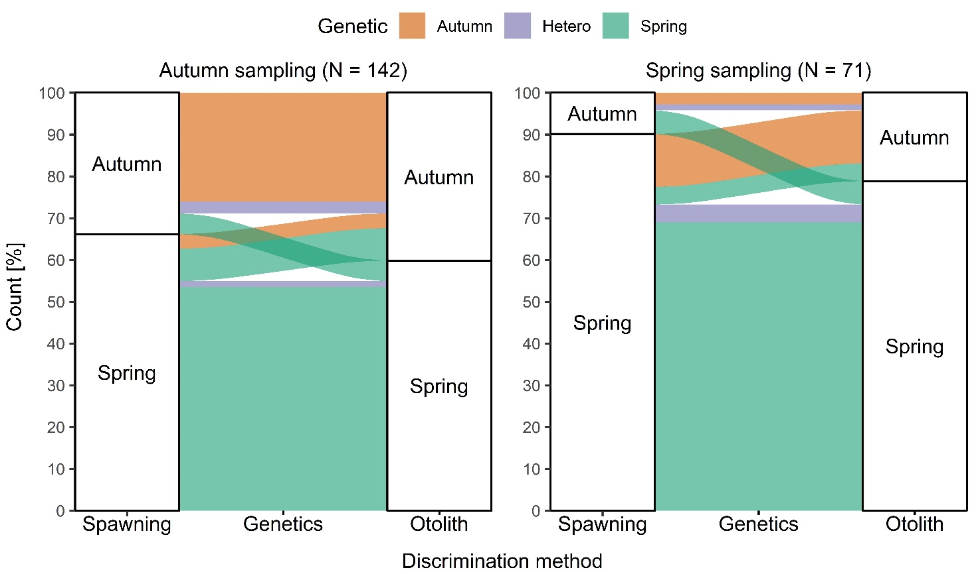
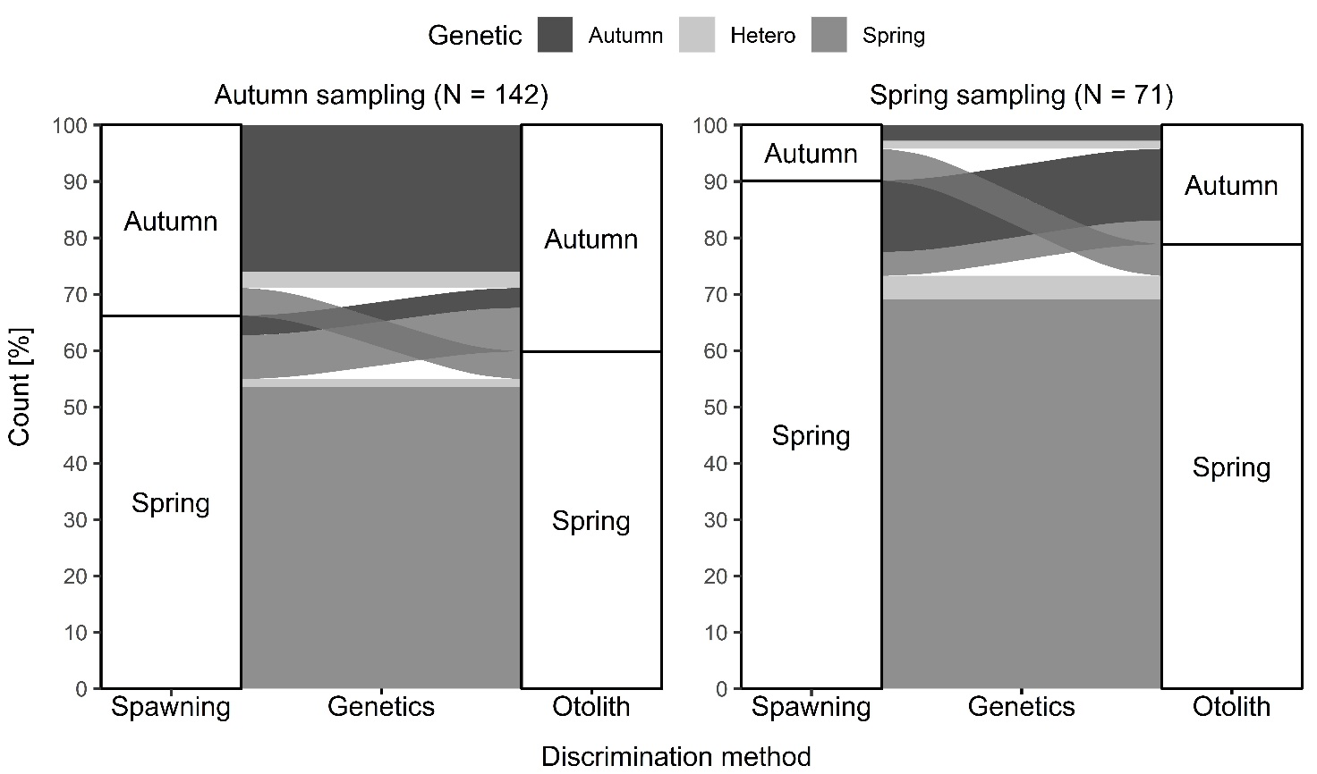
Fig. 2 A) Mean daily growth of autumn and spring discriminated otoliths with 95% confidence intervals. Dashed lines indicate intervals used as early (left, approximate age 30-40 days post hatching) and late (right; approximately 36 to 45 days older) larval phase. B) Mean increment width during the early larval phase and the difference between mean daily increment width between early and late larval phase for autumn and spring type otoliths with 95% confidence ellipses. SSA type herring (see Table 2) are marked with a cross.
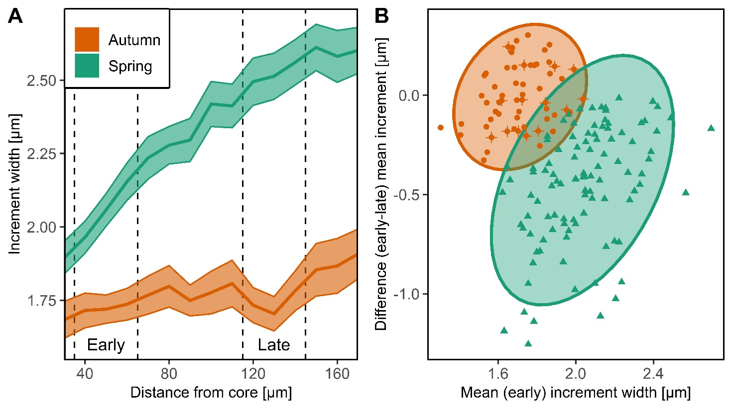
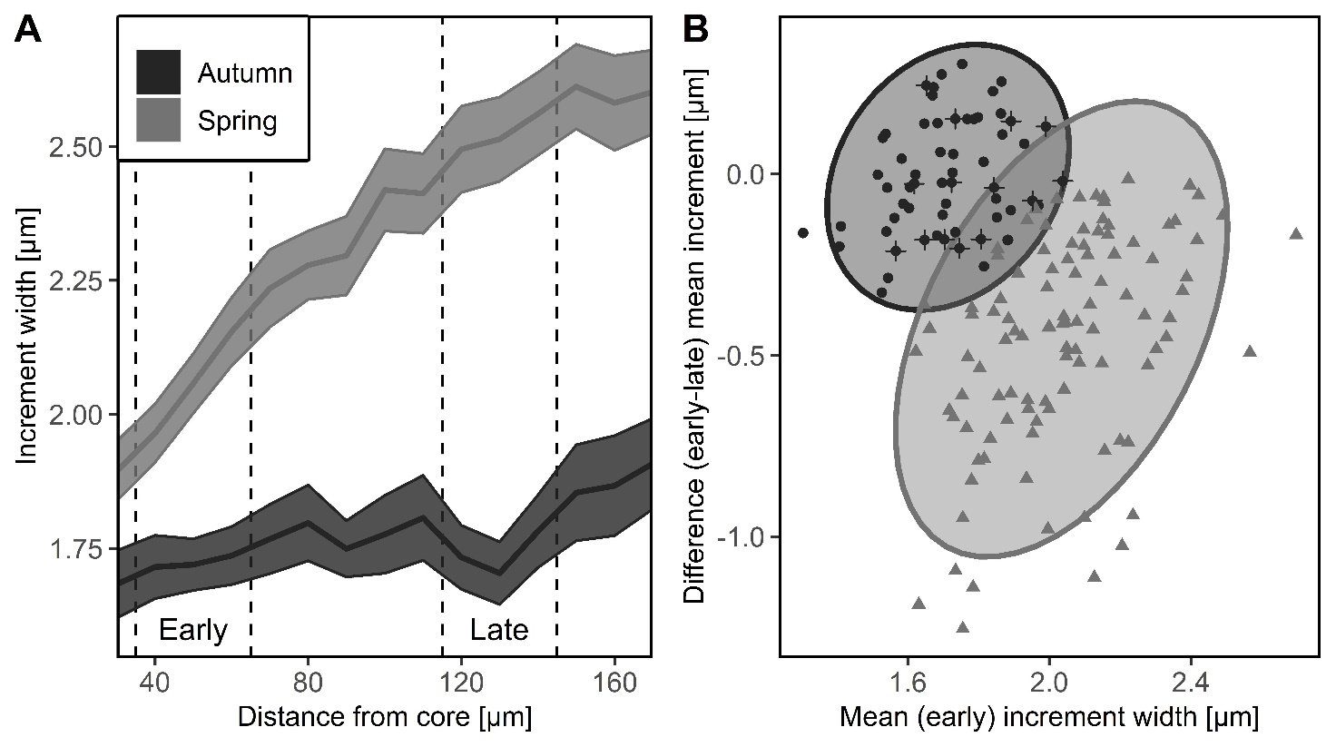
Fig. 3 Differences between mean daily increment width between early and late larval phase for all discrimination methods (Type). 1st letter = spawning phenotype, 2nd letter = genetic, 3rd letter = otolith. A = autumn, H = heterozygote/ambiguous, S = spring.
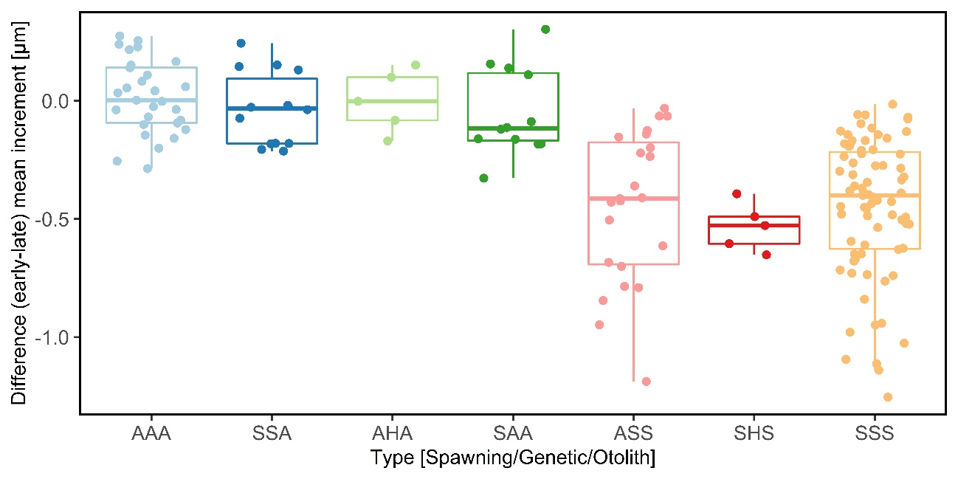
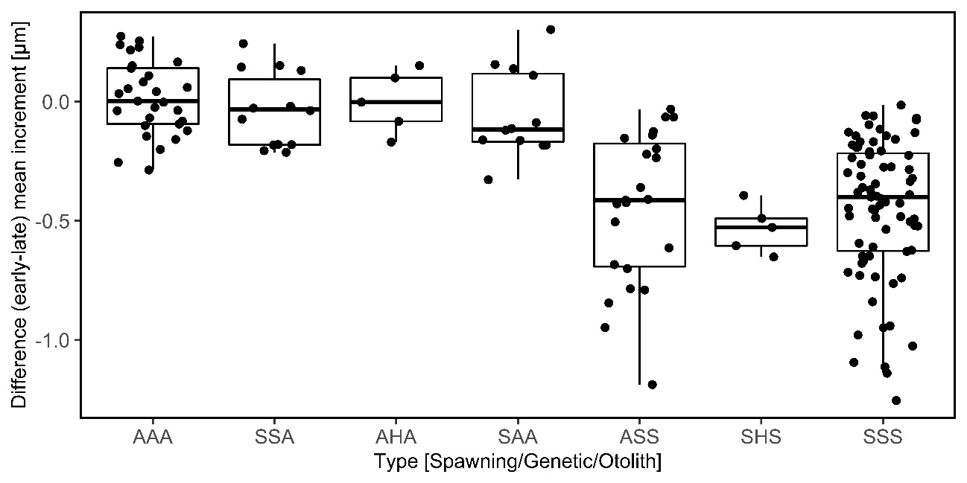
Fig. 4 Differences between herring discriminated as autumn (AAA) and spring (SSS) type by all three methods for A) Fulton’s somatic condition factor, and B) length-at-age data (mean ± 95% confidence interval) fitted to the von Bertalanffy growth model. A) includes only herring in spawning conditions.
